University of Salahaddin
Collage of Agricultural Engineering Science
Department of Soil Science

Practical Physics
2021-2022
First year
By
May Zeki Saddik
Assistance Lecturer

Experiment No. : 1
The experiment name: Finding the velocity of sound.
The purpose of the experiment: Determine the velocity of sound by using graph.
The instruments that used: big water container, a along cylindrical plastic tube with two open ends (length 30cm), set of tuning forks, metric ruler, holder and catcher.
The theory of experiment:
Longitudinal vibrations produced by a tuning fork are transmitted through the air into a glass tube with an adjustable piston at one end. By suitably adjusting the length of the air column, standing waves are produced in it. The locations of the nodes of the
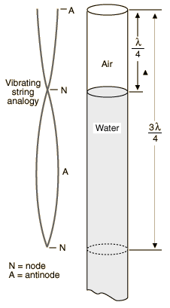
Standing waves are determined by the lengths of the air column required to produce resonance. By knowing the distance between the nodes, the wavelength of the vibration can be found. Since the frequency of the tuning fork is given (it is stamped on the side of the fork), the speed of sound in the air can be calculated.
The velocity with which sound travels in any medium may be determined if the frequency and the wavelength are known. The relationship between these quantities is:
v = f λ
Where:
v = velocity of sound propagation
f=frequency
λ = wavelength
In this experiment the velocity of sound in air is to be found by using tuning forks which has a known frequency. The wavelength of the sound will be determined by making use of the resonance of an air column
We can theoretically calculate the velocity of sound by using this equation:
C= 331√ (237+T)/237 ---------------- (1)
Where:
(C) Is velocity of sound (cm/sec)
Practically, we can extract the velocity of sound by determined the slope of the line of your graph:
Slope= $\frac{PN}{QN}$----------------- (2)
Slope=$\frac{L}{1/f}$ = Lf ---------------------- (3)
C= 4Lf ------------------ (4)
So, we can write the equation as:
C=× 4 slope
Procedure:
- Fill the glass container with water.
- Put the tube inside water vertically by using both, the holder and the catcher.
- Arrange the fork set according to their frequencies, then take the first one and strike it with the piece of wood, then proximate it to the orifice of the tube at the same time, Vary the effective length of the tube by moving the piston up and down slowly till you hear the loud resonance sound.

- Fixed the height of that tube when you hear that sound and Record the distance of air column from the open end of the tube to the water level.
- Record the frequency of the tuning fork.
- Repeat previous steps with other tuning forks of different frequencies
- Arrange your data according to this table below:
F(Hz) | L₁ | L₂ | L_{ave}=L₁+L₂  2 | 1/f(sec) | C=4Lf
- Draw a graph between 1/f (sec) values on x-axis and L (cm) values on Y- axis.
Discussion:
- What is the longest wavelength at which a sound wave will be resonant in a pipe of length L which is open at one end and closed at the other?
- What is the resonance? Explain that.
-------------------------------------------------------------------------

Experiment No. : 2
The experiment Name: Boyle’s Low for measuring the atmospheric pressure.
The purpose of the experiment: Measure the atmosphere pressure by using Boyle’s apparatus.
The instruments that used: Boyle’s apparatus, thermometer and a metric ruler.

The theory of experiment:
Boyle’s law states that at constant temperature for a fixed mass, the absolute pressure and the volume of a gas are inversely proportional. The law can also be stated in a slightly different manner, that the product of absolute pressure and volume is always constant.
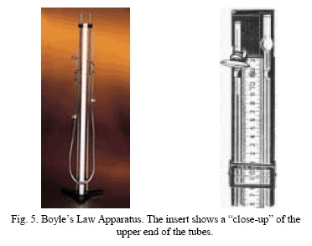
The relation existing between the pressure exerted by a confined gas and its volume is given by what is usually known as Boyle’s law, The temperature remaining constant, the volume V occupied by a given mass of gas is inversely proportional to the pressure P to which it is subjected. In symbols
V ∝ 1/P
or
V = k × 1/P
Whence PV = k-------- (1)
Where k is (numerically) a constant under given conditions.
The actual pressure P may be thought of as consisting of the atmospheric or barometric pressure B plus an added pressure p, the algebraic sign of the added pressure depending upon whether the actual pressure is above or below atmospheric pressure. Eq. (1) may therefore be written
(B + p)V = k ------ (2)
or
B + p = k × 1/V--------- (2a)
By placing 1/V = x, Eq. (2) becomes
B + p = k x---------- (3)
or
p = k x – B--------- (4)
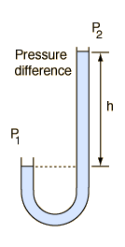
(h) Is mercury column height in (mm).
When you draw a graph between (h) on the Y- axis and (1/L) on the X- axis, the line will intersect the negative axis of (h) and the distance between origin point and the intersection point is the atmosphere pressure in (mmHg).

Procedure:
- Prepare the Boyle’s apparatus and record the room temperature by using a thermometer.
- Make the two sides of mercury level equals and record it.
- Raise the mercury level in the opened part by (5cm), and then measure the height of mercury level in the closed part.
- Repeat the step (3) for five readings.
- Make the two sides of mercury level equals again as in step (2).
- Take another (5) readings in opposite direction or down by (5cm) every time.
- Arrange your data as shown below:
1/ L  cm-¹ | Y-X= h  Cm | A-X= L  Cm | Ruler reading
 |  |  | Y  cm | X  cm | A  cm
Discussion:
- From your results what is the relationship between the pressure and the volume?
- How you can write Boyle’s law in another manner for constant pressure and volume?

Experiment No. : 3
The experiment Name: Ohm’s law applying.
The purpose of the experiment: Determine unknown resistance of electric circle by using graph.
The instruments that used: Power supply, voltmeter, ammeter, unknown resistances, connection wires.
The theory of experiment:
Ohm's law states that if the temperature remains constant, the current flowing through certain conductors is proportional to the potential difference (voltage) across it. In other words, current equals voltage divided by resistance. "I" is current, "V" is voltage, and "R" is resistance in the equation and diagrams.
I=V/R------------ (1) or
V=RI-------------- (2)
"V" (the voltage or the electromotive force - measured in volts) "I" (the current - measured in amperes) and "R" (the resistance - measured in ohm). An ohm is the SI unit of resistance. It is the resistance between two points of a conductor under a certain set of circumstances. There must be a constant difference of potential (the work required to bring a unit of electric charge) of 1 volt applied between these two points, producing the conductor a current of 1 ampere. The diagram below show exactly how Ohm's Law works with a common battery. The yellow light represents a bulb which is powered by the battery.
Resistance is property of any object or substance to resist or oppose the flow of an electrical current. The unit of resistance is the ohm. The abbreviation for electric resistance is R and the symbol for ohms is the Greek letter omega:
R= V/I ----------- (3)
When we draw a graph between V (volt) on the X-axis and I (Ampere) on Y-axis as shown down:
The slope of your line will be:
Slope=I/V
While when you see the equation (3), you can conclude that the resistance (R) is reverse of the slope, so we can write the last equation like that:
R= 1/slope
The straight line graph through the origin indicates that the current is proportional to the potential difference driving it. It is this proportionality which is Ohm's law
Procedure:
- Attach the circuit as shown:
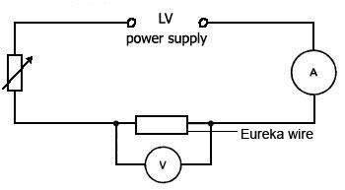
- By adjusting the power supply, you can vary the voltage (0.5 V). The ammeter will show corresponding values of the current through the wire. Keep the current small so that the temperature of the wire does not increase.
V  Volt | I  Ampere | R= V/I  Ω
- Record a series of values of p.d (or V) and current and arrange them as this table:

4- Draw a graph to represent the same data between V and I. From the graph, deduce the slope and then the resistance (R).
Discussion:
- If you plot the graph with the axes in the wrong way round (voltage on the y-axis), is that effect the resistance (R)?
- If the current rises rapidly for a small change in voltage, how the resistances will be change?
------------------------------------------------------------------
Experiment No. : 4
The experiment Name: The focal length for a convex lens.
The purpose of the experiment: Calculate the focal length for a convex lens by using graph.
The instruments that used: Long metric ruler, convex lens, screen, a grate object and source of light.

The theory of experiment:
The most important characteristic of a lens is its principal focal length. The principal focal length of a lens is determined by the index of refraction of the glass, the radii of curvature of the surfaces, and the medium in which the lens resides, the size of an image on film remains constant as the focal length increases
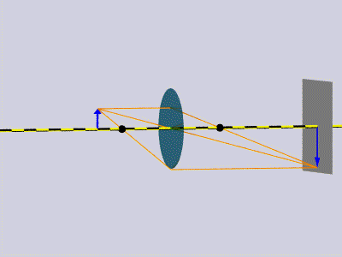
When the object distance (distance from the lens to the object) increases by the same factor as the increase in focal length
The distance between the object (the grid) and the lens is called the Image Distance.
The distance between the image (the screen) and the lens is called the Object Distance.
The principal focus (F) of a thin lens is the point on the principal axis towards which all paraxial rays parallel to the principal axis converge (in the case of a convex lens. Since light can fall on either surface (front or back) of a lens, lenses have two principal foci, one on each side. These are equidistant from the centre of the lens (provided the lens is thin and has the same medium on both sides, e.g., air).
The object distance, u, the image distance, v, and the focal length, F are related by the equation:
1/F = 1/V + 1/U ------------ (1)
When you draw a graph between (1/V) and (1/U), you can see that the straight line will intersect both X and Y axis.
When we apply the equation (1) on the graph (for both X and Y axis), it will be:
1/ F₁ = 1/V (for 1/U axis) and
1/ F₂ = 1/U (for 1/V axis)
Extract the values of both F₁ and F₂, so we will have:
F= F₁+F₂ which is the focal length.
2
Procedure:
- Based the materials as shown below:
- Move the lens towered the object until a perfectly focused image is formed
- Note the distance (v) between the lens and screen, at the same time note the distance (u) which is the distance between the object and the lens.
- Move the lens to a certain distance and repeat the procedure (2and 3).
- The lens to screen distance can be easily calculated by subtraction.
- Repeat that several times and arrange your data as bellow:
V  Cm | U  Cm | 1/V  cm⁻¹ | 1/U  cm⁻¹ | 1/F=1/V+1/U  cm⁻¹

Discussion:
- What is the relationship between, the lens power and the focal length of this lens?
- Why so the eye does not focus light from lamps in the same way as daylight?
------------------------------------------------------

Experiment No. : 5
The experiment Name: Finding the viscosity of water
The purpose of the experiment: Finding the viscosity of water by using graphical method.
The instruments that used: big glass container with a small capillary tube, small test tube, glass container, stopwatch.
The theory of experiment:
Viscosity is an important property of drilling fluids. The more viscous the fluid, the more easily it will suspend cuttings and carry them up to the surface. On the other hand it requires more pressure to pump very viscous fluids and they are harder to wash off the cuttings. Not all liquids are the same. Some are thin and flow easily. Others are thick and gooey. A liquid's resistance to flowing is called its viscosity. Honey and corn syrup are more viscous than water.
The coefficient of viscosity of a fluid can be found from measurements of the volume rate of flow through small tubes. For streamlined flow of a liquid through a tube the volume rate of flow is given by Poiseuille's Formula:

V = π r⁴ * h ----------- (1)
t 8ηL

Where:
(h): is the water height inside the container.
(L): The capillary tube length
(r): radius of capillary tube
So:
V= π r⁴h ---------- (2)
t 8ηL
η= π r⁴hρg ----------- (3)
8 V/t * L
η= π r⁴ρg * h ------------- (4)
8 L v/t
When we draw a graph between (h) values and (v/t) values, the slope of the line will be:
Slope= PN/QN or:
Slope = V ----------------- (5)
t
h
When we return to equation (4), we can write:

When the equation (5) compensate in equation (4), we will have:
η= π r4ρg * 1 / Slope ---------------- (6)
8 L
By using the final equation, we can calculate the viscosity of water.
Procedure:
- Fill the container with water to a certain height and measuring the height (h).
- Make the watch working at the same time of flowing water from the capillary tube.
- By using the stopwatch, calculate the time required to fill the tube to a certain volume (V) (g/cm³).
- Repeat the same processes above for different volumes of the water inside the container.
- Collect more than four readings, you need a chart like the one below to record your results:
h (cm) | t₁ (sec) | t₂ (sec) | t_{ave}= t₁+t₂  2 | Vcm3 | V cm³  t sec

Discussion:
- Is there a progressive change in the times to reach each level of water? Was it similar to the flow at other times?
- Dose the viscosity of liquids affected by temperature?
Experiment No. : 6
The experiment Name: Finding the surface tension of water
The purpose of the experiment: Finding the surface tension of water by using capillary tubes.
The instruments that used: A moving microscope, holder and catcher, glass beaker, three capillary tubes with different radiuses.
The theory of experiment:
Surface tension is due to an attraction between the molecules in water. Water is a polar molecule. At different ends of the molecule, it has positive and negative charges. Water molecules tend to arrange themselves so that the positive end of one is next to the negative end of another. It is the attraction between polar
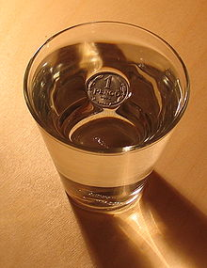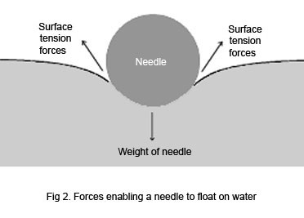
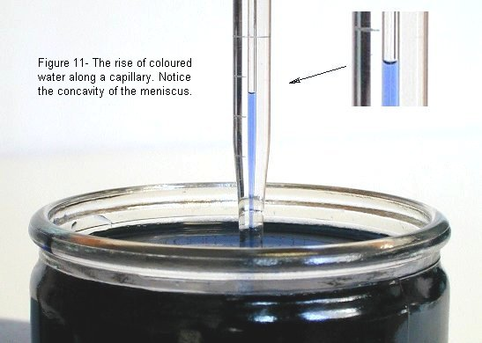
Water molecules that is responsible for what is called surface tension, which causes the surface to act in an elastic manner.
Each molecule of a liquid experiences forces of attraction exerted on it by all its neighbors. A particular molecule in the interior of the liquid experiences a large number of forces in all directions from its neighbors and the net force on it are very nearly zero.
The surface tension of water can be determined by using this equation:
ɣ = ¼ dhρg
Where:
Ɣ is the surface tension of water
d is the diameter of the capillary tube (in cm).
h is water height (in cm).
Ρ is the density of water and it is about (1gm/cm3)
g is the gravity acceleration ( g= 980 cm/sec² or 9.8 m/sec²).
This formula reflects the physical equilibrium situation of a force on the fluid due to a pressure
The viscosity of water at room in S.I. unit could be expressed as N.s.m⁻²
Procedure:
- Clean up the glass beaker and the capillary tubes.
- Fill the glass beaker with water and put the capillary tube inside the beaker.
- Read and record the level of water inside the beaker (h₁) by using the microscope.
- Read and record the level of water inside the capillary tube (h₂) (vertical level), by using the microscope.
- Calculate (h); by subtract the difference between (h₁) and (h₂).
- Measure the diameter of the capillary tube (horizontal level), by moving the pointer of microscope to the upper (d₁) and lower (d₂) level of the diameter.
- Determine (d) by subtract the difference between (d₁) and (d₂).
Discussion:
- What are the differences between adherence and coherence forces? When the liquid tend to wet the surface?
- What is the relationship between the diameter and the height of water column?

