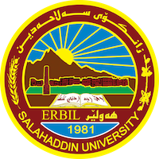
Academic Curriculum Vitae

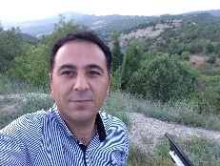
Personal Information:
Full Name:Sulaiman snaan saeed
Academic Title: assistant lecture
Email: (university email) Sulaiman.saeed@su.edu.krd
Mobile:07504554147

Education:
- Graduate in Rizgary high school in 1998-1999
- Graduate in Institute of Technology, Department of Health and Community in 2002-2003
- Graduate in Salaheddin university, history department in 2009-2010
- Obtained the master of Arts (MA) in university of Leicester in 2013

Employment:
- 27-12-2003

Qualifications
- Windows, word, excel very good, PowerPoint medium (course certificate)
- Kurdish mother language, Arabic very good in writing and speaking, English writing and speaking very good. (University of Leicester language course certificate, IELTS certificate 5.5 degree).

Teaching experience:
- Teaching first stage student from last 3 years. General English
- Teaching second stage student in 2017,2018. English text
- Teaching forth and third stage student in 2015 to 2017 . political issue and Kurdish modern history.
- Supervisor more than 60 student for forth stage research from 2015 till date.

Research and publications

Conferences and courses attended

Funding and academic awards

Professional memberships
- Teacher union organization

Professional Social Network Accounts:

It is also recommended to create an academic cover letter for your CV, for further information about the cover letter, please visit below link:
https://career-advice.jobs.ac.uk/cv-and-cover-letter-advice/academic-cover-letter/

