**Cereal Crops - (Practical)**

**3rd Stage**

**Second semester**

**2022 - 2023**

**Cereals**

Cereals are most important source of plant food to the man. They are considered a gift of Ceres-Roman of Agriculture. The cereal plants occur in all parts of the world. Cereal crops are the cultivated grasses grown for their edible starch grains. In general, the larger grains used, as staple foods are cereals such as rice, wheat, maize, barley etc.

Grains in the grass family (Poaceae or Gramineae); are monocotyledonous plants. The seeds of most are edible. This known as one seeded fruit (a caryopsis) has a seed coat fused with the ovary wall.

Grains are of two types: true cereals (grasses) or pseudocereals (nongrasses). True cereals are such as wheat, rice, and barley etc. Pseudo cereals are no grasses that produce similar fruits or seeds, amaranth, buckwheatandquinoa as examples.

**Important features of cereals**

They are:

* + Grown and cultivated for the edible components of their seeds.
  + Provide more food energy than any other type of crop.
  + Staple crops; a food that can be stored for use throughout the year or produced fresh any time of the year and forms the basis of a traditional diet.
  + In their natural form (whole grain) they are a rich source of carbohydrate, vitamins, minerals, fats oils and protein.
  + The water content of the grains is low helps prevent mould growth.

**Classified** **cereal crops:**

Cereal crops are usually classified into the following two groups**:**

1. **Major cereal crops –** these include wheat, barley, rice and maize.
2. **Minor cereal crops –** these include oats and rye.

**Botanical Classification of Grain Crops**

**Kingdom**- Plant

**Division**- Spermatophyta

**Sub**-**division**- Angiosperm

**Class**- Monocotyledon

A- **Order**- Graminaies (Ponalis)

1-**Family**- Gramineae (Poaceae)

**a-** **Tribe**-Hordeae:

1- *Triticum monocoocum* L.

2- *Triticum dicoocum* SCl l

3- *Triticum polonicum* L.

4- *Triticum durum* Deaf.

5- *Triticum aestivum Spelta* L.

6- *Triticum* *aestivum vulgare*

7- *Hordeum vulgare* L.

8- *Hordeum distichum* L.

9- *Secale cereale*

**b-** **Tribe**- Oryzeae : *Oryza sativa* L.

**c-** **Tribe**- Maydeae : *Zea mays* L.

**d-** **Tribe**- Andropoganeae: *Sorghum bicolor* L.

**e-** **Tribe**- Paniceae: *Punicum miliaceum* -*prosomillet* L.

**f-** **Tribe**- Aveneae: *Avena sativa* L.

**Morphological characteristics**

The vegetative parts of a grass plant are roots, stems, and leaves. The flowering (reproductive) part is the seedhead. Brief descriptions and drawings of these parts follow:

**Roots**

Grass roots are fibrous. Size of the root system depends on genetic and environmental factors and on management. In general, grasses that are capable of producing the greatest top growth are also capable of producing the greatest root growth. Soil factors influencing root growth are moisture, temperature, structure, depth, fertility, and chemical reaction.

**Stems**

The stems of grasses range from fully erect to prostrate. The jointed stem (culm) of a grass plant consists of nodes and internodes. The nodes (joints) are solid and usually larger than the rest of the stem. The internodes, the part of the stem between two nodes, are usually hollow.

Branching at the base of the main stem may produce erect shoots; horizontal, above-ground (stolons); or horizontal, below-ground (rhizomes). Both rhizomes and stolons bear roots at the underside of the nodes.

**Leaves**

Grass leaves are borne at nodes along the stem in two ranks. Leaves are parallel veined. The grass leaf consists of three principal parts: Blade, sheath, and ligule. Other parts are collar and auricle.

The blade is the expanded part of the leaf. The sheath is borne at the node and surrounds the stem like a tube. The leaf has a blade and a sheath that surrounds the stem, sometimes called culms.

The ligule, meaning little tongue, usually clasps the stem at the junction of the sheath and blade, preventing dirt and water from getting between them. Some ligules are membranous or papery; some are only a ring of hair.

The collar is on the outside of the leaf at the junction of sheath and blade.

Some grasses have two earlike lobes or appendages, called auricles, which are borne, one on either side, at the base of the blade.

**Seedhead**

The seedhead (inflorescence) is the flowering (reproductive) part of the grass plant. Generally, the seedhead has no leaves.

The spikelet is the basic unit of the seedhead. It may be pediceled (on a pedicel) or sessile (without a pedicel).

The spikelet consists of a rachilla, one to several florets, and two glumes. The florets are borne in two-ranks on the rachilla.

Most grass flowers are perfect. A floret is a superior ovary topped by two feathery stigmas. There are three (occasionally 6) stamens, and three scale like remnants of petals.

Each floret is enclosed in two bracts. The inner is called the palea and the outer the lemma. The nerves of the lemma extend and are called an awn. In place of the petals there are translucent structures called lodicules.

The basic forms of grass seedheads are spike, raceme, and panicle but they may grade from one form to another and may have specialized forms.

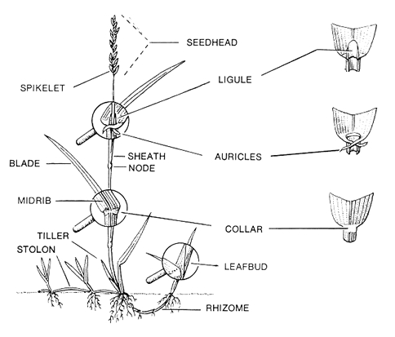

**Growth Stages of Cereal Crops:**

**First: Vegetative growth stage:**

1. **Germination and Seedling Stage**

When the grains imbibe water and become moisture content of up to 30-50% motivated embryo for growth and complex compounds change in the endosperm into simple compounds benefit to embryo. And growing radicle and sheath surrounded him down to form seminal (embryonic) roots.

While elongated plumule and sheath to the top at the same time. The sheath plumule function is to protect the terminal bud and vegetative leaves that surrounded them and work to facilitate the penetration even appear above the soil surface. When the plants are able to be self-reliant in the absorption and metabolism. The seedling emergence may stop on grain depth, distance from the surface of the ground and the soil temperature.

1. **Tillering Stage**

Grow axillary buds for leaves under soil forming branch ( tillers ) in direct planting for seed within sustainable land be the first buds, but the planting when done by seedling in rice be exposed the fourth bud to the bud sixth first about primary tillers at which the lower buds remain static and primary tillers susceptibility give other tillers called secondary, in which turn gives triple tillers.

Observed that main stem longer than tillers and tillers vary in length depending on places they arise. And the plants give tillers after 3-4 weeks of planting when the plant have four leaves or more. And depending tillers number of the plant on a variety, seeding rate, spacing sowing, methods of planting, grain size, and soil fertility.

1. **Elongation Stage**

Above the node directly to an area called active growth be distinguished presence active cells divided longitudinally and causing elongation of origin of the stem or tillers and be slow elongation in the first periods of plant age then increase until reaches the plant stage of the expulsion of spikes ( panicle) when it be less or stopped plant for elongation except the last internode bearing spike ( panicle ). Basal internode be short and grading length internodes as we head to the top.

**Second: Fruit growth stage:**

1. **Flowering stage**

Inflorescence plants usually after the expulsion of spikes grow between 5-6 days and environmental conditions affect in the process of this period and the first of spikes inflorescence is the spike original stem and then followed by spike of basal branch and by order rise and the first spikelets inflorescence is spikelets middle of spike and extends flowering to the top and the bottom, and the last thing inflorescence is spikelet terminal and basal and the first flowers that bloom within each spikelet are basal flowers and then follow upper flower continues flowering throughout daytime, but it is the most intense time 7-9 am.

1. **Ripping stage**

After fertilization of the egg begins the process of grain formation and moving nutrients from the leaves to the grain during the formation and increase the weights of grain during the growth and development. This stage can be divided into several stages:

1. **Milk Ripe Stage**

Ears and stems are of a green color except for the lower leaves are yellow color and grain -filled juice are full of milky color to the presence of starch deployed in and when press the grain comes out milky liquid and be endosperm is not completed while the embryo completely formed and can grow but the seedling result be weak and lean.

1. **Dough Ripe Stage**

Disappears chlorophyll completely and become yellow not dry as contain the leaves and stems on a significant proportion of the moisture and become a grain of thick texture is more like dough to increase the precipitation of starch granules in the endosperm and the less of the presence of water and the grain content dough inclined to the yellow color pale.

1. **Full Ripe Stage**

Harden and dry the leaves and ears and harden glumes and awn of low moisture ratio to a minimum and controlled label of the yellow color perfectly at all field and harden and take fully formation and the maximum size of the field when recommended to harvest at moisture percentage ( 11-13 %).

At low moisture due to delayed harvest below the minimum which controls of plants in label combustion to the intensity of the heat and it tends to brown color and easy to break the stems of the plant and axes spikes and increases harden and lose a lot of grain during the harvest simply touches plants either harvest manual or mechanical.

**Measurement used in growth stage of cereal crops (Zodoks Scale)**

Several measures were used to measure the phases of growth especially in wheat and barley and more acceptance and use of standards developed by the (Zadoks et al.1974). Divide the stages of development to the main stages of a:

**0. Sprouting/Germination Stage**

**1. Seedling growth Stage**

**2. Tillering Stage**

**3. Stem Elongation Stage**

**4. Booting Stage**

**5. Inflorescence Emergence, Heading Stage**

**6. Flowering/Anthesis Stage**

**7. Milk development Stage**

**8. Dough development Stage**

**9. Ripening or Maturity Stage**

**Differentiating between cereals**

During the vegetative stage of plant development features at the collar (where blades attach to the stem at the top of the leaf sheath) can be used to differentiate cereal types. These features include:

1. **Auricles:** Features located at the top of the leaf sheath, at the end of the blade. For certain species can be hairy, smooth, large, small or completely absent.
2. **Blades:** Leaf blades are twisted clockwise or anti-clockwise when viewed from above, depending on the species type.
3. **Ligules:** The ligule is the collar or projection that wraps around the stem and lies between the leaf sheath and stem.

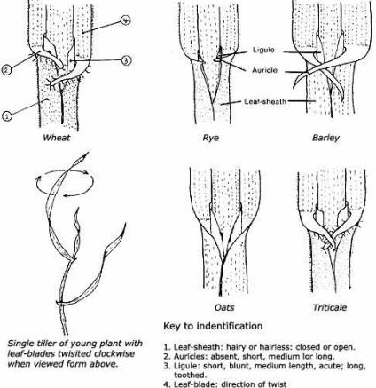

**Figure:** Illustration of the distinguishing features used to identify cereals.

During the reproductive stage of development the defining features of inflorescence which can be used to differentiate cereals include:

a) **Spike:** is a seedhead in which one or more sessile spikelets are borne on the main axis (rachis) like wheat, barley, rye.

b) **Raceme:** is a seedhead in which the spikelets are borne on individual footstalks (pedicels) growing directly on the main axis (rachis).

c) **Panicle:** is a seedhead with it is composed of a number of branches, to which multiple spikelets are attached like oat plant.

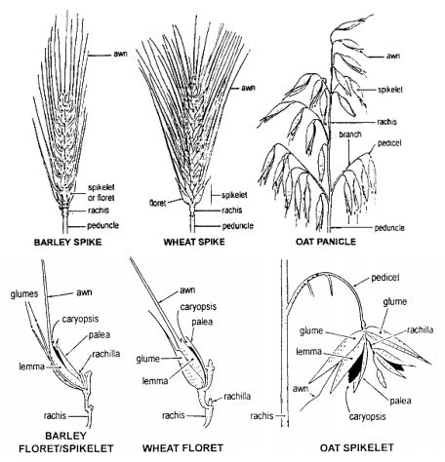

**Wheat**

Wheat is an annual herb plant. The wheat plant has two types of roots, the seminal (seed) roots that initiate after germination, the nodal (crown or adventitious fibrous) roots. Leaves are produced on alternative sides of the culm. The ear of a wheat plant is made up of two rows of spikelets. The spikelet's is enclosed by a pair of glumes and consists of 1-5 florets. The florets are enclosed by a lemma and a palea and three stamens, investing two lodicules, and a single pistil.

The grain or caryopsis of wheat is a dry indehiscent fruit. The caryopsis of the wheat is made up of the bran coat and the endosperm surrounding the embryo. The bran coat consists of three layers, the pericarp, testa and aleurone layer. The distal end of grain has a brush of fine hairs.

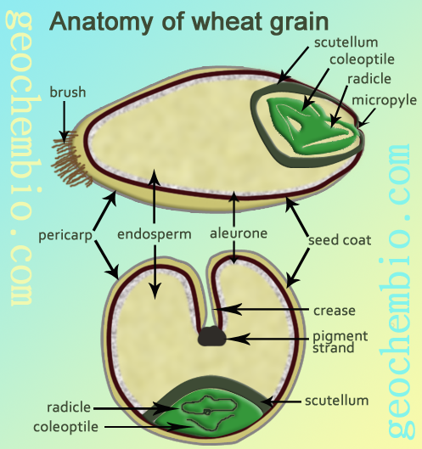

**Wheat Types**

Wheat can be classified according to their tolerance to the temperature degrees:

1. **Winter wheat**

Winter wheat's need to experience a certain period of cold temperatures, between (0- (-4))**°**C, to trigger a switch from vegetative growth to flowering. This cold requirement is known as vernalisation.

1. **Spring wheat**

Type wheat has a very mild response or no response at all to vernalization, and frost resistance is low. They do not have a vernalisation requirement to initiate flowering and so are grown in the warmer regions.

**Economic classification of wheat species**

This classification based on basis of flour characteristic, qualities of uses. Wheat species can be classified according world scale to:

1. **H**ard **R**ed **S**pring **W**heat
2. **H**ard **R**ed **W**inter **W**heat
3. **S**oft **R**ed **W**inter **W**heat
4. **D**urum **W**heat
5. **W**hite **W**heat

**Wheat Species**

There are many species of wheat are grown in the world. This can be classified according their number of chromosome and at same time their uses to:

1. **Einkorn Wheat** (*Triticum* *monococcum*)

This type of wheat is generally mono kernels. *Triticum monococcum* refers to diploid (one genomes) with (2n=14) chromosomes.

2. **Durum wheat** (*Triticum* *durum*)

Kernels of this type of wheat are generally very hard in texture and rather high in protein content. *Triticum durum* refers to tetraploid (genomes A and B) with (2n=28) chromosomes. Most of the durum wheat crop is used for the production of semolina or durum flour for pasta products.

3. **Bread wheat** ( *Triticum aestivum* )

A wide range of wheat quality characteristics is available in *Triticum* *aestivum*. *Triticum aestivum*, refers to hexaploid bread wheat (genomes A, B, and D) have (2n=42) chromosomes. Kernel hardness and protein content vary widely within this species. And outstanding characteristic of this species is its flour.

**Vernalisation:**

A period of cool temperatures (0– (-4) ºC) advances floral development. Vernalisation reduces the duration of the Foundation Phase. Winter wheat varieties respond strongly to vernalisation; spring wheat’s may have a slight response. Two major flowering types of wheat are differentiated by their response to vernalization.

**Lodging**

High plant population density weakens plant anchorage. It also increases shoot height, and decreases stem diameter and stem wall width. This weakens stem bases strength. The benefit of low plant populations is greatest for varieties with poor lodging resistance. Shallow drilling can increase lodging risk.

**Wheat Requirement**

Wheat is adapted to a variety of climates. Wheat can be grown on all kinds of soils except saline or acidic soils and water logged conditions. Moderate annual rainfall of 330-900 mm. is most suitable for the crop. Spacing between rows is20 - 22.5cm recommended and when sowing is delayed a closer spacing of 15-18cm adopted.Seeding rate is 100-130 kg/ha.

**Method of sowing:**

1. **Broadcasting** **–** uniformly broadcast and then covered by harrowing.
2. **Drilling** **–** sown by seed drill by dropping seeds at uniform depth - Results in uniform germination.

**Oat**

Oats probably arose as a weed. The last of the major cereals domesticated in the Near East, perhaps as late as 1000 B.C. Also now a hexaploid oat, Avena sativa. No longer known in the wild. Typically grown in cold areas to feed animals.

**Oat Species**

1. **Species diploid chromosome** (2n=14)
2. Desert oats ( *Avena wiestii*)
3. Short oats ( *Avena brevis*)
4. **Species tetraploid chromosome** (2n=28)
5. Abyssinian oats ( *Avena abyssinica*)
6. Slender oats ( *Avena barbata*)
7. **Species hexaploid chromosome** (2n=42), oat species cultivated followed to:
8. Common oats ( *Avena sativa*)
9. Red oats (*Avena byzantina*)
10. Naked or hull-less oats (*Avena nuda*)

**Roots**

The oat plant has two types of roots, seminal and adventitious. Seminal roots originate during embryo development and consist of a jointed primary root (radical) and branches arising at the first node or joint. Adventitious roots arise at the nodes of the stem and tillers at joints just beneath the surface of the soil.

**Stem**

The oat plant, in its early growth phase, may be erect, semi-erect, or prostrate, generally forming a rosette. The nodes are solid, whereas the elongated internodes, at first solid, become hollow as the parenchyma or pith cells break down just before and during maturation.

The number of tillers depends on the density of seeding (crop stand), genetic features of the cultivar and growing conditions (e.g. Dose of fertilizers applied). The tiller terminates in a large inflorescence called the panicle.

**Leaves**

The leaves of the oat plant are formed acropetally at a point opposite the insertion of the preceding leaf. They are two-ranked (distichous) and sessile. The leaf consists of the sheath, blade, and a membranous appendage, the ligule.

With few exceptions, oat leaves have ligules but they do not have auricles. The ligule is a thin, membranous appendage that is continuous with the inner margin at the juncture of blade and sheath. The ligule extends upward, clasping the stem. The ligule is useful in oat classification.

**Inflorescence**

The inflorescence of the oat is termed a panicle. The main axis of the panicle (the rachis) is a continuation of the stem, terminating in a single pediculate spikelet.

Solitary, alternate florets arise at the subsequent nodes or joints of the zigzag rachilla. Usually only the first and second florets are fertile, although in a few varieties three florets may regularly produce viable seeds. The floret is composed of the lemma, the palea, and the organs of reproduction; namely, the ovary with its bifid style, the plumose stigma, and the three stamens

**Caryopsis**

Oat has elongated caryopsis. Which has two aleurone layers. On the side opposite the embryo, a crease extends the entire length of the caryopsis. The embryo is on the anterior side near the base of the caryopsis. The kernel comprises seed coat layers, starchy endosperm, and the embryo. Oat seed contains 12-13% proteins; 4-5% oils; 66-77% CHO and 12-15% crude fiber (reduce blood sugar by reducing absorption). Oats used more for medicinal value. Have all essential amino acids.

**Soil**

Silt and clay-loam soils having good moisture retention ability are best for oat production. Sandy soils, coarse textured soils, or soils with a shallow surface are not desirable for oats. Oats may be more tolerant of poorer soil conditions, and successful production requires management practices that conserve and store soil moisture.

**Barley**

**Barley Species in world:**

1. **Species diploid chromosome** (2n=14), barley species cultivated followed to:
2. *Hordeum vulgare*

2- *Hordeum distichum*

1. **Species tetraploid chromosome** (2n=28)
2. *Hordeum bulborsoum*
3. *Hordeum jabatum*
4. **Species hexaploid chromosome** (2n=42)
5. *Hordeum nodosum*

**Root**

Barley possesses of shallow and deep roots. The shallow roots emerge near the soil surface and spread out laterally apart 15-30 cm almost at the right angles for the tillers; whereas deep roots extend downwards into deep layers of soil. The depth of penetration varies from75-150 cm.

**Stem (culm)**

The cylindrical stem blade is hairy or the cylindrical possesses 5-7 hollow internodes separated by solid nodes where from the leaves arise. Internodes are short at the base of the plant, and their length increases from the base of the stem to upwards. The number of tillers per plant is influenced by plant density of crop stand, genetic and environmental factors.

**Leaves**

The leaf slightly serrated having usually broader and lighter green colour compared to wheat. Each leaf consists of a sheath, blade, ligule and auricle. The leaf sheath is generally glabrous, but in a few cultivars covered with hair. Auricles are very conspicuous, which partly or entirely clasp the stem and much longer than those in wheat. Two-row barleys have narrower leaves than 6 row barleys.

**Inflorescence**

Barley’s flower called ‘ear’ (spike). In the six-rowed spike, a triplet of spikelets is placed on alternating sides, in a zig-zag manner, at each node of the flat rachis, while in the two-rowed spike, the lateral spikelets of the triplet are either sterile or are more or less rudimentary. The inflorescence is a dense terminal spike. Each spikelet has 2 glumes and a floret. The barley flower has 3 stamens and a pistil with a single ovule and a stigma.

**Kernel (grain)**

The Barley grain is usually invested by a lemma and palea. The caryopsis is composed of the pericarp, endosperms and embryo. The grains normally consist of hull except that of naked cultivar which becomes free after threshing.

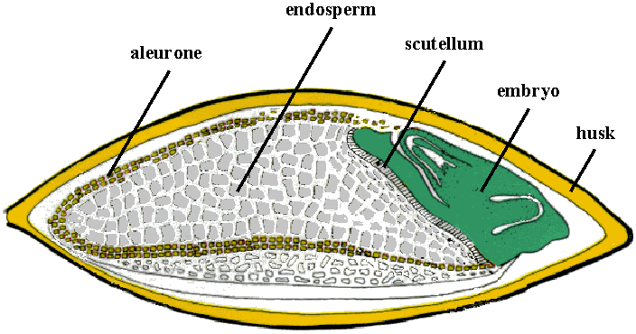

**Classification of barley species**

Based on fertility status and arrangement of spikelet's on rachis, barley is classified into two types:

1. **Six-rowed barley:** All the three spikelet's at a node are fertile. The spikelet's are in six distinct rows arranged at a uniform distance around of the inflorescence. The mature grains are thus also arranged in six rows. Each spike produces 25-60 kernels. Examples: *Hordeum vulgare, Hordeum intermeidium*.
2. **Tow-rowed barley:** Only the central spikelet's are fertile, whereas the lateral spikelet's are sterile. The grains are arranged in two rows on the rachis. Each spike produces 15-30 kernels. Examples: *Hordeum distichon, Hordeum deficiens.*

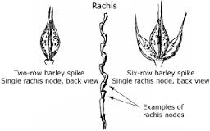 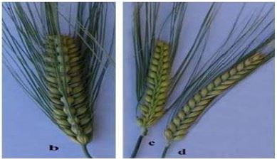

**Figure:** Barley spikes: b: green 6-rowed ear; c: 2-rowed ear with sterile spikelets; d: 2-rowed ear with spikelets.

**Types of barley**

1. **Winter barley**

Winter types require vernalization (exposure for low temperatures for 2-10 weeks) to later produce heads and grain normally. A winter barley is planted in late fall and is harvested the following summer. If you plant winter barley in spring, it will not flower, or it will flower too late. Longer growing season and greater yield.

1. **Spring barley**

Spring barley is planted in the spring and harvested the same summer. If you plant spring barley in the fall, it will die from low temperature injury. Shorter growing season and lower yield. There are three principal physiological traits influence involved: **Vernalization sensitivity**, **Photoperiod sensitivity**, **Low temperature tolerance**.

**Climate requirement**

Barley has wide ecological adaption; it thrives best in cool climate and does not prefer hot and humid areas. It is grown under rain fed, drought prone conditions to mild salinity (7-8pH) and in regions where wheat cultivation is uneconomical. Barley being a long day plant would prefer a photoperiod of 10-12 and 12-14 hours during vegetative and reproductive stages, respectively. The crop matures about 120 days. Seed rate varies according to agro-conditions. In irrigated areas for normal sowing, 75-90 kg/ha is sufficient, the distance between the rows is usually maintained about 25 cm.

**Method** of sowing: 1- **Broadcasting,** 2- **Drilling**.

**Corn (Maize)**

**Classification of maize types:**

A number of maize types can be discerned on the basis of endosperm and kernel composition:

**Flint maize:** Kernels are characterized by their high percentage of hard endosperm around a small soft centre. The kernel is rounded on the top.

**Dent maize:** Is the most commonly grown for grain and silage, and is type grown in the U.S.A. Hard endosperm with soft starch is present.

**Floury maize:** Endosperm is mainly composed of soft starch, making it easy to grind and process into foods. They are like fruit kernels in shape.

**Waxy maize:** The endosperm gives a waxy appearance. Kernels contain almost starch (70% amylopectin and 30% amylose).

**Pod corn:** Is grown almost exclusively for scientific research. Each kernel of pod corn is enclosed in a glumes, or husk.

**Pop maize:** Kernels are small. Pop maize is grown on a small scale compared to other types but popped kernels are consumed world-wide as a snack food.

**Sweet maize:** Is grown for green ears (sweet corn). The developing grain of sweet maize is higher in sugar content due to recessive mutations blocking conversion of sugar to starch.

**Roots**

Normally maize plants have three types of roots, **i)** seminal roots - which develop from radical and persist for long period, **ii)** adventitious roots, fibrous roots developing from the lower nodes of stem below ground level which are the effective and active roots of plant, and **iii)** brace or prop roots, produced by lower two nodes. The roots grow very rapidly, corn root growth up to 60 cm laterally and in depth.

**Stem**

The stem generally attains a thickness of three to four centimeters. The ear bearing inter node is longitudinally grooved, to allow proper positioning of the ear head (cob). The upper leaves in corn are more responsible for light interception and are major contributors of photosynthetic to grain.

**Inflorescence**

The apex of the stem ends in the tassel, an inflorescence of male flowers and the female inflorescences (cobs or ears) are borne at the lateral branches.

The male (staminate) inflorescence, a loose panicle, produces pairs of free spikelet’s each enclosing a fertile and a sterile floret. The female (pistillate) inflorescence, a spike, each of the female spikelet’s encloses two fertile florets, one of whose ovaries will mature into a maize kernel once.

The female flower is tightly covered over by several layers of leaves, and so closed in by them to the stem that they don’t show themselves easily until emergence of the pale yellow silks from the leaf whorl at the end of the ear. The silks are the elongated stigmas that look like tufts of hair initially and later turn green or purple in color.

A unique characteristic of corn is that unlike most plants the kernels are completely enclosed by the outer layer known as the husk or shuck. These are leaf sheaths that tightly surround the kernels en masse. These husks prevent seed dispersal by wind, birds, or other natural means, and are the main reason why corn is so dependent on humans.

**Grain**

The maize grain is a caryopsis, a dry fruit containing a single seed fused to the inner tissues of the fruit case. The germ is the source of maize “vegetable oil” (total oil content of maize grain is 4% by weight). The endosperm occupies about two thirds of a maize kernel’s volume and accounts for approximately 86% of its dry weight. The primary component of endosperm is starch.

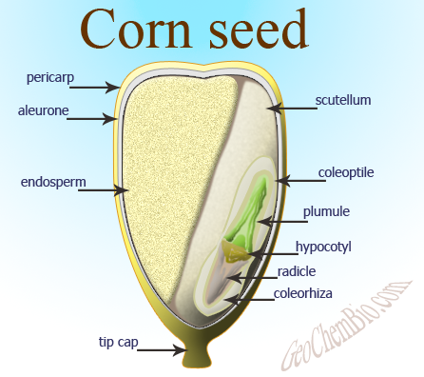

**Climate requirement**

Maize crop is primarily a warm weather crop and it is grown in wide range of climatic conditions. Maize can be grown on a variety of soils, but it grows best on well drained soils which are fertile by adequate supply of manures.

Generally, it does not grow satisfactorily in semi arid regions. Since, it is a short day plant with C4type of photosynthesis; the crop has very efficient utilization of solar radiation. The optimum pH range of soil for maize is 6.5 -7.5. The hybrid varieties take lesser time to mature.

In irrigated conditions is 50-60 kg/ha. In rain fed areas 40-50 kg/ha. Dent type of maize varieties is most suitable for fodder purpose. The distance is 30x15 cm. Plant to a depth of 3 - 4 cm or use a seed drill or sow behind the seed drill and cover with harrow or plough.

**Method** of sowing: **1-** Drilling , **2-** Dibbling

**Sorghum**

**Main Types of Sorghum**

Classified by intended purposesin the following four groups:

1. Grain Sorghum

2. Sweet Sorghum

3. Broom Sorghum

4. Grass Sorghum

Grain sorghum is mainly used as a principal food in tropical areas and often used as raw materials for alcoholic beverages, sweets and glucose. Broom sorghum is used as a material to make brooms, while sweet sorghum is used as a material for sweetener syrup. Grass sorghum is grown for green feed and forage use.

**Root**

The roots of the sorghum plant can be divided into a primary and secondary system. The primary roots are those which appear first from the germinating seed. The primary roots provide the seedling with water and nutrients from the soil.

Secondary roots develop from nodes below the soil surface. The roots are finer and branch approximately twice as much as roots from maize plants. The root band of nodes below or just above the soil surface develops prop roots.

**Stem**

The stem of the plant is solid and dry, to succulent and sweet. The stem consists of internodes and nodes. The internodes are covered by a thick waxy layer giving it a blue-white colour. The waxy layer reduces transpiration and increases the drought tolerance of the plants.

**Leaves**

Sorghum leaves are typically green, glasslike and flat, and not as broad as maize leaves. Sorghum plants have a leaf area smaller than that of maize. These cells can roll up leaves rapidly during moisture stress. Leaves are covered by a thin wax layer and develop opposite one another on either side of the stem.

**Inflorescence**

The inflorescence is a panicle. The shape and colour of the panicle varies between cultivars. Panicles are carried on a main stem or peduncle with primary and secondary branches. Because of the structure of the flower, mainly self-pollination takes place. A small percentage of cross-pollination (6 %) occurs naturally.

**Grain**

Sorghum seed consists of three major anatomic sections - pericarp (outer layer), endosperm (storage organ) and the germ. The pericarp that is expressed from the ovary wall is made of three segments - epicarp, mesocarp and endocarp. The epicarp is the outermost layer and usually covered with a thin waxy film. The thickness of the mesocarp, varies from the very thin cellular remnant of small amount of starch granules to three or four cellular layers containing a large amount of starch granules. The protein of the germ contains high levels of lysine and tryptophan that are excellent in quality.

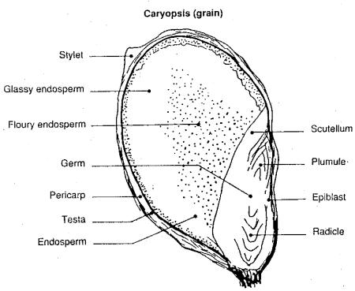

**Climate& Soil** **requirement**

Sorghum is almost unique in its ability to grow over a wide range particularly in climates too hot and too dry than other cereals. Sorghum is a warm-weather crop, which requires high temperatures for good germination and growth. Sorghum is mainly grown on low potential, shallow soils with high clay content, which usually are not suitable for the production of maize.

The crop grows well in neutral pH of 7.0. Sorghum is a short-day plant, which means that the plant requires short days (long nights) before proceeding to the reproductive stage. For irrigated crop is 40 kg/ha, and in rain fed areas 75 kg/ha. Spacingfor sorghum 45x12 - 15cm.

**Method** of sowing:

1. Broadcasting **2-**Drilling **3**- Dibbling **4-**Transplanting

**Rice or Paddy**

**Classification of rice plant types**

The two cultivated species are:

**1**. *Oryza* *sativa* present in Asia, Europe and America

**2**. *Oryza* *glaberrima* present in Africa.

**Botanical characteristics:**

**Roots**

The roots are fibrous, possessing rootlets and root hairs. The seminal roots are sparsely branched. The secondary adventitious roots are produced from the underground nodes of the young culms. As the plant grows, coarse adventitious prop roots often form in whorls from the nodes above ground level.

Roots contain air spaces to conduct oxygen from the air down into the roots. This tissue is called aerenchyma. Root cells are tolerant of ethanol which is the waste product from anaerobic respiration by root cells when oxygen is lacking.

**Stem** **(culm)**

The stem has two parts, underground and aerial. The aerial part, has well defined solid nodes and hollow internodes. Tillers arise from the main culm in an alternate pattern. The primary tillers originate from the lowermost nodes and give rise to secondary tillers. The latter give rise to tertiary tillers.

**Leaves**

The leaves are borne on the culm in two ranks, one at each node. The leaf consists of the sheath and blade. The leaf sheath is continuous with the blade. It envelops the culm above the node in varying length, and tightness. A swelling at the base of the leaf sheath just above the point of its insertion on the culm is the sheath pulvinus.

Auricles are small, paired, ear-like appendages borne on either side of the base of the blade. At the junction of the blade and sheath on the inside is a membranous, glabrous or ciliate ligule. The junction of the sheath and blade is the collar.

**Inflorescence**

The terminal shoot of a rice plant is a determinate inflorescence, the panicle. A spikelet is the unit of the inflorescence. The spikelet's are pedicled on the branched panicle.

The spikelet consists of the two sterile lemmas, the rachilla and the floret. A floret includes the lemma, palea and the enclosed flower. The flower consists of six stamens and a pistil, with the perianth represented by the lodicules.

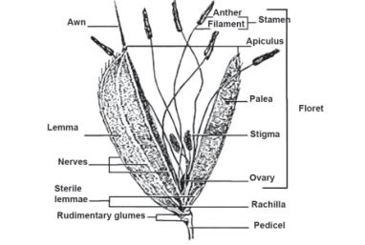

**Grain**

Rice grain, a caryopsis, is a dry one seeded fruit having its pericarp fused with seed coat. The outer protective covering of grain is called the Hull which consists of a lemma, a palea, an awn (tail), a rachilla (grain stem) and two sterile lemmas. Other parts of the grain are the pericarp, seed coat and nucellus; and embryo and endosperm.

The endosperm consists of aleurone layer that encloses the embryo and the starchy or inner endosperm. It is the storehouse of food for embryo. Grains with husk are referred to aspaddy.

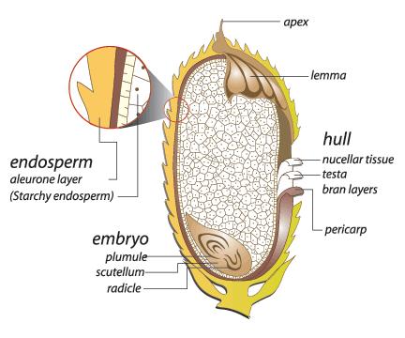

**Paddy climate& Soil** **requirement**

Rice grown over an extremely wide range of climatic conditions. It is best suited to the regions which have high temperature high humidity, prolonged sunshine and assured supply of water.

Rice is grown in all types of soils; the best soils are clay loams. The semi aquatic nature of the crop necessitates a heavy soil through which the irrigation or rain water will not be easily drained away because the demands of rice are more precise for water than soil conditions.

The crop completes its life-cycle within 140-160 days. Seed rate: 60 to 80 kg/ha. Spacing: 20 to 30 cm between rows is recommended conditions congenial for direct seeding.

**Method** of sowing:

1. Broadcasting 2- Dibbling 3- Transplanting

**Cereal Crops**

|  |  |  |  |  |  |  |  |  |  |
| --- | --- | --- | --- | --- | --- | --- | --- | --- | --- |
| **No.** | **Name** | **Botanical name** | **Family** | **Sowing time** | **Seed Amount (kg/Don)** | **Harvesting time** | **Product Amount**  **(kg/Don)** | **Method of sowing** | **Fertilizers (kg/ha)** |
| 1 | Wheat | *Triticum aestivum*  *Triticum durum* | Poaceae | Nov. - Dec. | 20,  25 - 30 | May - Jul. | 200 – 750 | * Broadcasting * Behind local plough * Drilling * Dibbling * Transplanting | 50:30:20 NPK |
| 2 | Barley | *Hordeum vulgare*  *Hordeum sativum* | Poaceae | Oct. - Nov. | 25 - 30 | Apr. - June | 250 – 750 | * Broadcasting * Behind local plough * Drilling | * Compost * 40:25:25 NPK |
| 3 | Rice | *Oryza sativa* | Poaceae | Apr. - Jun. | 25 - 30 | Aug. - Nov. | 500 - 1000 | * Broadcasting * Dibbling * Transplanting | 80:60:45 NPK |
| 4 | Maize | Zea mays | Poaceae | Mar. - Apr.  July | 8 -10 | June - July  Oct. - Nov. | 250 – 700 | * Drilling * Dibbling | * Compost * 120:60:35 NPK |
| 5 | Sorghum | *Sorghum bicolor* | Poaceae | Mar. - Apr. | 40 kg/ha | June -Aug. | 30- 40 tonnes/ha | * Broadcasting * Drilling * Dibbling * Transplanting | 30:40:20 NPK |
| 6 | Millet | *Panicum miliaceum* | Poaceae | April | 4 – 6 | July - Aug. | 250 – 400 |  |  |

|  |  |  |  |  |  |  |  |
| --- | --- | --- | --- | --- | --- | --- | --- |
| **No.** | **Name** | **Method of sowing** | **Fertilizers (kg/ha)** | **Sowing time** | **Seed Amount (kg/Don)** | **Harvesting time** | **Product Amount**  **(kg/Don)** |
| 1 | Wheat | * Broadcasting * Behind local plough * Drilling * Dibbling * Transplanting | 50:30:20 NPK |  | 20,  25 - 30 |  |  |
| 2 | Barley | * Drilling | * Compost * 40:25:25 NPK |  | 25 - 30 |  |  |
| 3 | Rice | * Dibbling * Transplanting | 80:60:45 NPK |  | 25 - 30 |  |  |
| 4 | Maize | * Dibbling | * Compost * 120:60:35 NPK |  | 8 -10 |  |  |
| 5 | Sorghum | * Broadcasting * Drilling * Dibbling * Transplanting | * 30:40:20 NPK | Mar. - Apr. | 1. g/ha | June -Aug. | 30- 40 tonnes/ha |
| 6 | Millet | *Panicum miliaceum* |  |  | 4 - 6 | July - Aug. | 250 - 400 |

**WWWWWWWWWWWWWW**

Some species of grasses branch only at or near the base from axillary buds at the basal nodes. Others branch and rebranch from buds produced at upper nodes, giving the appearance of a dense bouquet.

Stems of most perennial grasses die back to the approximate base of the stem each year. However, in the basal part of the stem, there are from several too many basal nodes with axillary buds capable of initiating new growth.

Stolons are stems or runners that originate at the base of the main stem and grow along the surface of the ground. They have nodes and scales or well-developed leaves. Roots borne at the nodes help to establish and spread the plant and to produce new plants if stolons are broken.

Rhizomes are stems that originate at the base of the main stem and grow horizontally below the ground surface. They have nodes, internodes, and scalelike leaves. Roots grow from the underside of the nodes; shoots (stems and leaves) grow from the topside.

It is characteristically split down one side, making it possible to separate the sheath from the stem without tearing the sheath. In some grasses, the sheath is open-the margins do not come together; in others, it is closed-the margins overlap. Some sheaths are flattened; others are rounded. Because of their different forms and shapes, they are important in identifying a grass.

On some grasses, a sheath like bract, called spathe, encloses or partly encloses the seedhead.

Spike is a seedhead in which one or more sessile spikelets are borne on the main axis (rachis).

Raceme is a seedhead in which the spikelets are borne on individual footstalks (pedicels) growing directly on the main axis (rachis).

Panicle is a seedhead with a main axis and subdivided branches. It may be compact and spikelike or open.

**WWWWWWWWWWWWWWWWWWW**

Cereal root system consists of fibrous roots. Many branch at the base and produce more or less equal sized stems called tillers.

The stems of grasses range from fully erect to prostrate. Many grasses produce horizontal stems, either below ground (rhizomes) or above ground (stolons). The regions where the leaves originate are called nodes. The internodes, or stem regions between the nodes, are usually round in cross section and either hollow or filled with a spongy pith.

The leaf has a blade and a sheath that surrounds the stem, sometimes called culms. At the junction of leaf sheath and blade, designated as the collar of the leaf, and on the side facing the stem, grass leaves bear a ligule, a small flange or ring of hairs, depending on the species, that may have evolved to prevent the entry of water into the leaf sheath.

Grass (Cereal) floral structures are minute and highly simplified compared with the flowers of most other plants. Most grass flowers are perfect. Grass flowers are borne in compound infloresences called spikelets. A floret is an individual grass flower. There is a superior ovary topped by two feathery stigmas. There are three (occasionally 6) stamens, and three scale like remnants of petals. Each floret is enclosed in two bracts. The inner is called the palea and the outer the lemma. The nerves of the lemma extend and are called an awn. In place of the petals there are translucent structures called lodicules.

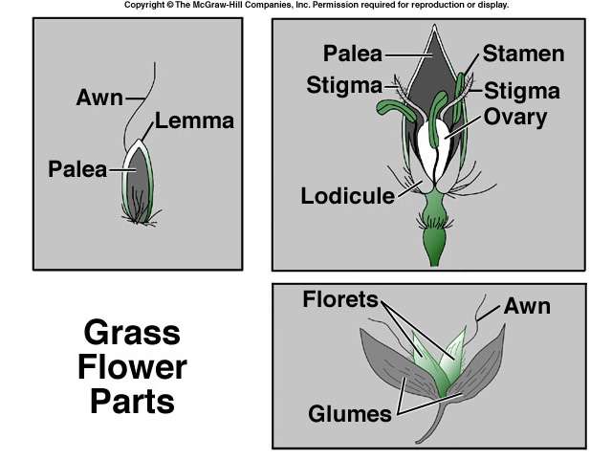

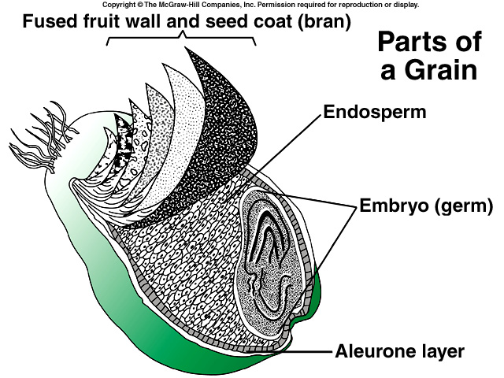

The grain is called a caryopsis. All cereals belong to the grass family and their characteristic fruit is caryopsis in which pericarp remains completely fused with seed coat. The seed itself consists of two major parts, endosperm and embryo. Endosperm is a starchy, storage tissue.

They are relatively low in water (about 10­13%). Many of the nutrients (especially protein and fat) are found in the aleurone layer just inside the bran of the fruit. They are rich in carbohydrates, proteins, oils and vitamins. Moisture contents of cereals are very low and as such they can be stored for long periods without deterioration.

The following will summarize the morphology of auricles, blades and ligules for common cereals:

**Wheat:** Hairy, short, slender and clasping auricles. Blades and sheaths always hairy. Intermediate to long length ligule. Clockwise twisting blades.

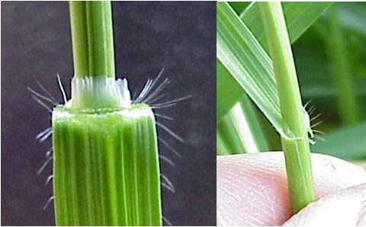

Figure: Photo of wheat plant to show ligule and hairy, clasping auricles.

**Barley:** Hairless, long, clasping auricles that wrap around stem. Typically hairless blades and sheath (sparse on some varieties). Very small ligule. Blades twist clockwise.

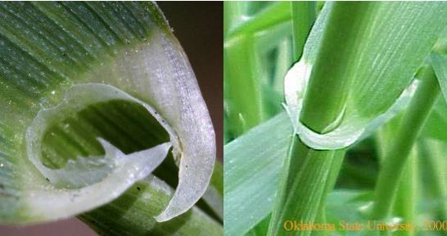

Figure: Photos of hairless ligule and auricles of a barley plant.

**Oats:** No Auricles. Hairless blade and sheath (sparse on some varieties). Intermediate length ligule. Anti-clockwise twisting blades.

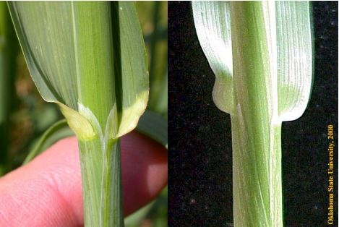

Figure: Photos of oat ligule and collar region without auricles.

**Rye:** Pointy, short and hairless auricles. Hairiness on blades and sheaths variable. Short ligule. Clockwise twisting blades.

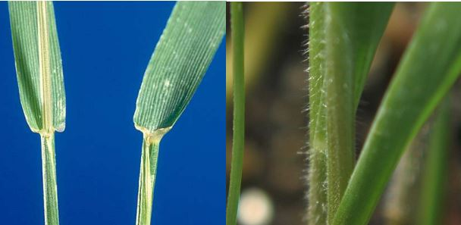

Figure: Photos of rye plants to show ligule and auricles, as well as hairiness on stem.

**(Zodoks Scale)**

The following will provide a description of the main stages of development for cereals (Zodoks, 1974). This can be used to identify the main stages of development for wheat (including spring and winter), oats, barley and rye.

**0. Sprouting/Germination**

For most applications it is not important to identify stages 00 to 08, as these occur when the plant is below the soil surface. At stage 09 the coleoptile penetrates the soil. It is a rigid feature of the plant that contains the tissue of the first leaves.

**1. Seedling growth**

Penetration of the surface by the coleoptile (sprouting), the first leaf of the plant emerges where the first leaf has started to unroll. A new leaf is counted as fully emerged when 50% of the leaf blade has unfolded. Leaves are counted on the main stem of the plant.

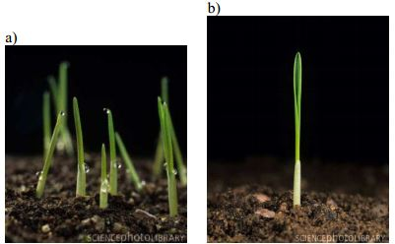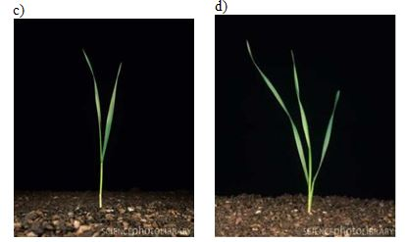

**2. Tillering**

Development of primary tillers usually begins when the fourth leaf emerges from the stem, followed by the second primary tiller when the fifth leaf emerges…

The structure of tillers is similar to the main stem, but these can be differentiated based on the fact that tillers typically have fewer leaves, and are shorter. In most cases you should only count primary tillers that form at the crown, as opposed to secondary and tertiary tillers that develop off of primary and secondary tillers, respectively

Throughout tillering the seed heads or inflorescence start to develop in both tillers and the main stem. Initially the head is microscopic in size, but when the head is completely formed the plant will move in to stem elongation or jointing. At that time most plants will have five fully developed leaves.

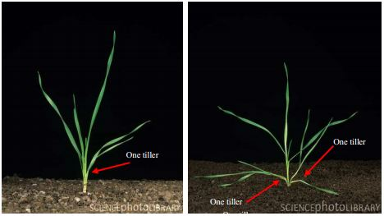

**3. Stem Elongation**

Again, by the time stem elongation begins plants typically have five fully developed leaves. Stem elongation is the process by which internodes lengthen in both the main stem and tillers. This process starts with the upper five or six internodes, which brings nodes above the soil surface. These joints are harder, larger in diameter than the main stem or internodes and solid, compared to the hollow inter-node in most cases.

. 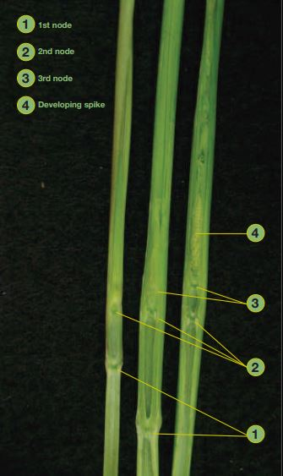

**4. Booting**

At the beginning of booting the flag leaf starts extending. This is when the flag leaf starts to swell. The leaf sheath starts to open, exposing the inflorescence within. Finally the booting stage ends when the awns are visible (in awned varieties) at the top of the boot.

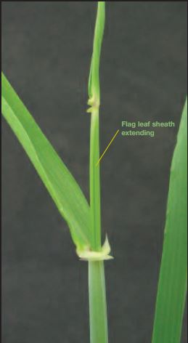

**5. Inflorescence Emergence, Heading**

Heading is the process whereby the seed head emerges from the sheath of the flag leaf, which once contained it. For both wheat and barley the shape of type of head or inflorescence is a spikelet. For oats, the inflorescence is known as a panicle. It should be noted that generally heading occurs a few days later in tillers. At about half of the inflorescence should be visible, or emerged from the flag leaf sheath. In order to see how much of the inflorescence has emerged it will be necessary to split the flag leaf sheath.

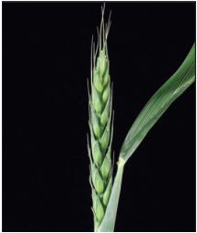 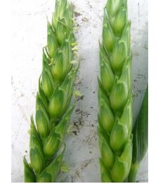

**6. Flowering/Anthesis**

Flowering begins only a few days (2-4) after the inflorescence has emerged unless it is very hot, which causes the heads to remain in the boot at the time of flowering. In most cases it is possible to identify flowering by presence of the anthers. A few anthers on the plant represent the beginning of flowering, where the entire inflorescence should contain anthers. Anthers are used to hold the plants pollen.

**7. Milk development**

In the early milk stage grains are still be green, and you should be able to squeeze a clear liquid from kernels. Into the late milk stage, this liquid will become a milky colour and will also appear thicker.

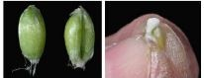

**8. Dough development**

As kernels continue to develop they reach the soft dough stage. If you press your fingernail against a kernel the impression will not hold. Finally when fully ripe it will be difficult to make any impression into kernels.

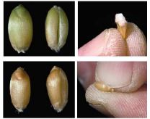

**9. Ripening**

When a crop is harvest ripe, you will not be able to dent kernels at all.

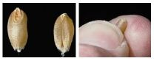

**Fertilizer**

There is a need to increase the efficiency of use of applied nutrients by applying the right form, right quantity at the right time & by the right method. (F Q T M)

Rice stem

The jointed stem of rice, called a culm, is made up of a series of nodes and internodes. The node (nodal region) bears a leaf and a bud. The bud is inserted in the axil between the nodal septum and the base of the sheath. The bud may give rise to a tiller. The septum inside the node separates two adjoining internodes. The mature internode is hollow, finely grooved, and glabrous on the outer surface. The nodal septum and internode may be differentially pigmented.

Rice leaves

The blades are generally flat and sessile. The uppermost leaf below the panicle is the flag leaf. The flag leaf generally differs from the others in shape, size, and angle. Varieties also differ in leaf number.

**Tillers of wheat**

Tillers are lateral branches which are produced off the main stem of the wheat plant. They produce leaves on opposite sides of their central stem in the same manner as the leaves of the main stem are produced and are also able to produce an ear at their terminal. Not all tillers will survive and produce an ear and this is thought to be due to competition for light and nutrients.

**Species & Varieties**

Most important to agriculture are:

*Triticum* *aestivum* (common wheat); *Triticum monococcum* (Einkorn or Europena wheat), *Triticum* *turgidum* & *Triticum* *durum* (durum wheat), *Triticum* *compactum* (club wheat); *Triticum* *dicoccum* (emmer wheat - wild sp. Wheat & closely related to durum wheat).

Table: **Decimal code used to quantify the growth stages in cereals**

|  |  |  |  |
| --- | --- | --- | --- |
| Code | Description | Code | Description |
| **0** | **Germination** |  |  |
| 0.0 | Dry seed | 38 | Flag leaf ligule just visible |
| 0.1 | Start of imbibitions | 39 | Flag leaf ligule just visible |
| 0.2 | Imbibition complete | **4.0** | **Booting** |
| 0.3 | Radicle emerged from seed | 41 | Flag leaf sheath extending |
| 0.4 | Coleoptile emerged from seed | 43 | Boots just visible and swollen |
| 0.5 | Leaf just at coleoptile tip | 45 | Boots swollen |
| **1.0** | **Seedling growth** | 47 | Flag leaf sheath opening |
| 10 | First leaf through coleoptiles | 49 | First awns visible |
| 11 | 1 leaf unfolded | **5.0** | **Ear emergence** |
| 12 | 2 leaves unfolded | 51 | First spikelet of ear just visible |
| 13 | 3 leaves unfolded | 53 | One-fourth of ear visible |
| 14 | 4 leaves unfolded | 55 | One-half of ear emerged |
| 15 | 5 leaves unfolded | 57 | Three-fourths of ear emerged |
| 16 | 6 leaves unfolded | 59 | Emergence of ear complete |
| 17 | 7 leaves unfolded | **6.0** | **Flowering** |
| 18 | 8 leaves unfolded | 61 | Beginning of flowering |
| 19 | 9 leaves or more unfolded | 65 | Flowering half-way complete |
| **2.0** | **Tillering** | 69 | Flowering complete |
| 20 | Main shoot only | **7.0** | **Milk development** |
| 21 | Main shoot and 1 tiller | 71 | Seed water ripe |
| 22 | Main shoot and 2 tillers | 73 | Early milkb |
| 23 | Main shoot and 3 tillers | 75 | Medium milk |
| 24 | Main shoot and 4 tillers | 77 | Late milk |
| 25 | Main shoot and 5 tillers | **8.0** | **Dough development** |
| 26 | Main shoot and 6 tillers | 83 | Early dough (fingernail impression not held) |
| 27 | Main shoot and 7 tillers | 85 | Soft doughc |
| 28 | Main shoot and 8 tillers | 87 | Hard dough |
| 29 | Main shoot and 9 or more tillers | **9.0** | **Ripening** |
| **3.0** | **Stem elongation** | 91 | Seed hard (difficult to divide with thumbnail) |
| 30 | Pseudo-stem erectiona | 92 | Seed hard (cannot dent with thumbnail) |
| 31 | 1st node detectable | 93 | Seed loosening in daytime |
| 32 | 2nd node detectable | 94 | Seed over-ripe; straw dead and collapsing |
| 33 | 3rd node detectable | 95 | Seed dormant |
| 34 | 4* node detectable | 96 | Viable seed giving 50% germination |
| 35 | 5th node detectable | 97 | Seed not dormant |
| 36 | 6th node detectable | 98 | Secondary dormancy induced |
| 37 | Flag leaf just visible | 99 | Secondary dormancy lost |



**Glossary of Terms**

**Anther**: The male portion of a flower which produces and releases the pollen.

**Anthesis**: The time of flowering or pollination.

**Auricles**: A pair of claw-like projections at the junction of the sheath and blade.

**Axillary** **tillers**: The tillers that emerge from the leaf axils.

**Blade**: The flat expanded portion of a leaf.

**Coleoptile**: The round sheath which surrounds and protects the first leaf as it emerges from the seed to the soil surface.

**Coleoptilar** **tiller**: The tiller that emerges from the coleoptilar node at the seed.

**Collar**: The junction of the leaf blade and leaf sheath.

**Crown**: The first node established above the seed shortly after germination. This is the origin of the secondary (main) root system. The growing point is located here until stem elongation begins.

**Endosperm**: The area of starch and protein storage in the kernel.

**Floret**: The flower contained within the spikelet. Each flower has three anthers and a single ovary resulting in one seed upon fertilization.

**Glumes**: The pair of husks that contain the spikelet.

**Growing** **point**: The plant part where differentiation of leaves, tillers and the head occurs.

Internode: The region of the stem between two successive nodes.

**Leaf** **axil**: The junction of the leaf with the main stem.

**Lemma**: The outer, lower bract enclosing the flower in a floret.

**Ligule**: A short membrane or row of hairs on the inside of the leaf at the junction of the blade and sheath.

**Nodes**: The area of active cell division from which leaves, tillers and adventitious roots arise. They are the ‘bumps’ on the elongating stem that are at the base of each leaf sheath.

**Ovary**: The female reproductive structure that develops into the seed.

**Palea**: The inner, upper bract enclosing the flower in a floret.

**Panicle**: An open and branched inflorescence with pediceled flowers, a common character of oats and some grasses.

**Peduncle**: The last elongated internode which supports the head (top internode).

**Plant Growth Regulator**: A chemical used to inhibit peduncle elongation and increase lodging resistance.

**Pollen**: The powder-like grains produced by the anthers which function as the male element in pollination.

Pollination: Fertilization of the egg cell by pollen to give rise to the embyro and the endosperm (seed).

**Primary tiller**: A tiller produced by a node on the main stem.

**Prophyll**: The sheath which encloses the base of a tiller.

**Radicle**: The first root to emerge from the seed.

**Secondary tiller**: A tiller produced on a primary tiller.

**Seminal roots**: The roots originating directly from the seed.

**Sheath:** The tubular portion of a grass leaf that encloses the stem.

**Spike**: Technical name for the head in a grassy plant.

**Spikelet**: Subdivision of the spike that contains the individual florets.

**Stigma**: These are the feathery structures designed to catch pollen for fertilization. Stigmas are connected to the ovary where the seed will form.

**Subcrown Internode**: The internode between the seed and crown. This internode elongates upon germination to place the crown approximately one inch below the soil surface in wheat and barley.

**Tertiary tiller**: A tiller produced on a secondary tiller.

**Tiller:** A shoot that arises from buds at the nodes of a plant.

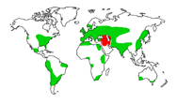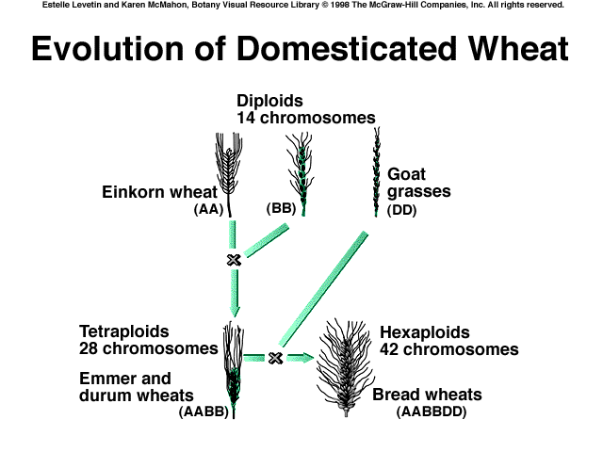

|  |  |  |
| --- | --- | --- |
| **Category** | **Name** | **Characteristics** |
| Kingdom | Plantae | Organisms with rigid cellulose cell walls, chlorophyll a & b, … |
| Division | Anthophyta | Flowering seed plants |
| Class | Monocotyledones | Embryo with one seed leaf |
| Order | Commelinales |  |
| Family | Poaceae | Grass family |
| Genus |  |  |

