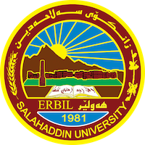
Academic Curriculum Vitae
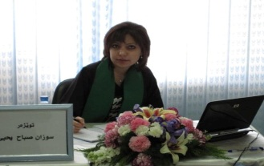
Personal Information:

Full Name: Suzan Sabah Yahia
Academic Title: Assistant lecturer
Email: suzan.alsafar@su.edu.krd
Mobile:009647504797545
Education:
- 2012-2014. M.Sc. in biotechnology - food technology, Agriculture College, salahaddin University.
- 2010-2011. High diploma in food technology, Agriculture College, salahaddin University.
- 1997-2021. B.Sc.in Food Technology, Agriculture College, Baghdad University.

Employment:

- State employment starting from first employment
- 2003 to2005, Agricultural Engineering in agriculture research center, ministry of agriculture-krd.
- 2005 to 2007, Agricultural Engineering in GIS center, college of science, ministry of higher education-krd.
- 2007 to 2014, Agricultural Engineering in food technology department, college of Agricultural Engineering sciences / University of Salahaddin-Erbil.
- 2014 to date, Assistant Lecturer of food technology, Department of Food Technology, College of Agricultural Engineering sciences / University of Salahaddin-Erbil.

Qualifications
- Teaching qualifications
- IT qualifications
- Language qualifications such as TOEFL, IELTS or any equivalent
- Any professional qualification
- You could put any professional courses you have attended

Teaching experience:

Teaching Food biotechnology.
- Industrial fermentation.
- Food safety.
- Principle of food science.
- Food quality control.

Research and publications
- “Extraction and Sepectroscopic Studies of Lecithin Extract from Different Egg Youlk Samples”Zanco Journal of Pure and Applied Sciences Vol.25,No.1 2013. Salahaddin University-Erbil.
- Detection of multidrug resistance Salmonella isolated from chicken meat by multiplex PCR and VITEK2 system.

Web of Science Researcher ID: F-1197-2014
ORCID ID: 0000-0001-6750-0518
Academic Profile: http://academics.su.edu.krd/suzan.alsafar
Scholar Account: https://scholar.google.com/citations?user=f-hy9EYAAAAJ&hl=en

