|  |  |  |  |
| --- | --- | --- | --- |
| **Image result for salahaddin university-erbil logoSalahaddin University-Erbil** |  |  | **Subject: General Ecology** |
| **College of Science** |  | **Exam duration: 1hour** |
| **Department of Biology** |  | **Practical Examination** |
| **3nd Stage** |  |  |
|  | | | |

**Question bank**

**Q1/ Explain the following: (10 Marks)**

1. Importance of Studying Ecology.
2. Types of Ecology.
3. Functions of the Atmosphere
4. The parameter using in limnology
5. The basic sampling analysis
6. Advantage of water current

**B/ Define only (5) of the following criteria: (10 marks)**

1. Omnivores  **2.** Niche **3.** Parasitism **4.** Natality **5.** Adaptation 6. Producer

**Q2:**  **What are the differences between the following, answer (5) only: (20 marks )**

1. Food chain and food web
2. Lentic ecology and lotic ecology.
3. Biotic and a biotic factor.
4. flora and fauna.
5. Ammensalism and mutualism.
6. Climate and weather.
7. Acclimation and Adaptation
8. Metrology and meteorology
9. Turbidity and Transparency

**Q3: Draw and label the following items, and then write the uses of each of them. (10 marks)**

1. Secchi disk with example.
2. Transparency tube

**Q4: A/ Count the following items: (20 marks)**

1. Types of indicators
2. Structure of atmosphere.
3. The types of thermometer.
4. The factors that affect the water current
5. Factors affect the transparency

**Q3/ write the** Name and function of the followings: **(25 marks)**

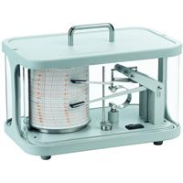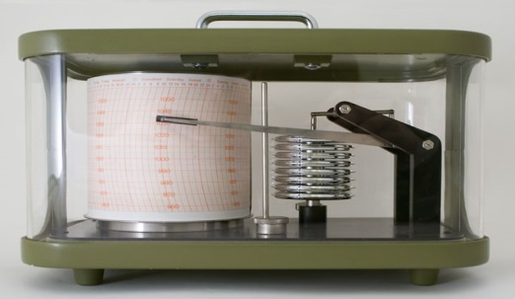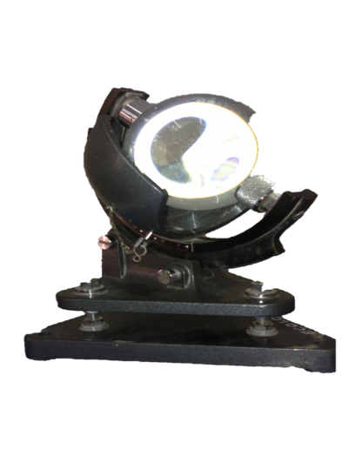

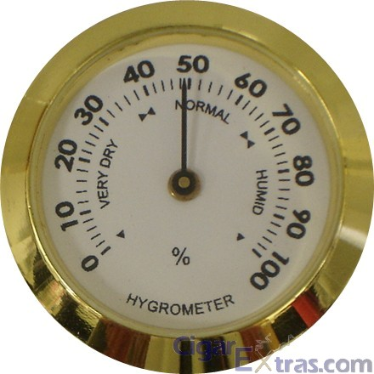[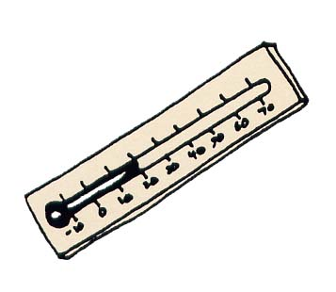](http://www.rockingham.k12.va.us/sound_sorting/initial_diagraphs/th/pages/thermos.htm)

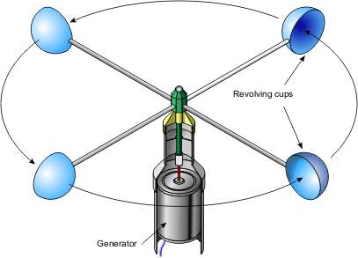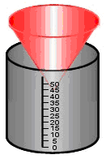

**Q1/ Choose suitable phrases for the following criteria: (5 marks)**

1. The study of ecology of running water (river, and stream):

a) Marine ecology b) Lentic-ecology c) Lotic-ecology

2. An interaction between two organisms in which one organism damaged while the other remained benefited:

a) Parasitism b) Ammensalism c) Mutualism

3. The number of individuals of a species within a unit area:

a) Frequency b) Density c) Abundance

4. This studies the flows of energy and matter through the components of ecosystems.

a) Ecosystem b) ecology c) ecosystem ecology

5. The branch of biology that studies the relationship of plants and animals to their physical and biological environment.

a) Ecosystem b) ecology c) environment

6. Strong swimming animals, like fishes.

a) Aero plankton b) necton c) Benthos

7. A place suitable to the life of a particular organism

a) Aero plankton b) necton c) Benthos

**Q2/ Fill the blanks with suitable sentences: (5marks)**

1. The physical environment includes …………………………….
2. Behavioral Ecology is …………………………
3. Acclimated, acclimating is …………………….
4. Benthos …………………….

**Q3/ Answer the following questions: (5 marks)**

1. What are the Functions of the Atmosphere?
2. Why Stratosphere is very important layer in atmosphere?

**Q1/ Fill the blanks with suitable sentences: (10marks)**

1- Atmospheric pressure measured by ……………………….and ……………….

2- Flora …………………………………

3-………………………..… Estimated by sun shine recorder or cample stock

4- Wind: Is air in motion is measured by ………………………..

5- in the Field work:Visit a grass or forest community and find the ………………………… required to study the community**.**

**Q4/** Find each of the **density, frequency** and **abundance** of each species in a plant community by following the data as given in the table below: **(10marks)**

|  |  |  |  |  |  |  |  |
| --- | --- | --- | --- | --- | --- | --- | --- |
| Species | Quadrate  1,2,3,4,5 | Total number of individual of a species | Quadrate of occurrence species | Total number of quadrate studied | **Density** | **Frequency** | **abundance** |
| **A** | **5** | **3** | **2** | **5** | **X** | **X** | **X** |
| **B** | **5** | **8** | **4** | **5** | **X** | **X** | **X** |
| **C** | **5** | **15** | **2** | **5** | **X** | **X** | **X** |

**Q4/** Find each of the **density, frequency** and **abundance** of each species in a plant community by following the data as given in the table below: **(5marks)**

|  |  |  |  |  |  |  |  |
| --- | --- | --- | --- | --- | --- | --- | --- |
| Species | Quadrate  1,2,3,4,5 | Total number of individual of a species | Quadrate of occurrence species | Total number of quadrate studied | **Density** | **Frequency** | **abundance** |
| **A** | **5** | **3** | **1** | **5** | **X** | **X** | **X** |
| **B** | **5** | **8** | **4** | **5** | **X** | **X** | **X** |
| **C** | **5** | **15** | **4** | **5** | **X** | **X** | **X** |

*Good luck …...*



*Lecturer*: *Tablo .A.Ahmed*