

|  |  |  |
| --- | --- | --- |
| **Ministry of Higher Education and Scientific Research**  **Salahaddin University-Erbil**  **College of Administration & Economics**  **Department: Statistics and Informatics** |  | **Subject: Linear and Non-Linear Models**  **Postgraduate Studies: Ph.D.**  **Time: 2 hours**  **Date: 24 / 1 /2024** |
| **Final Exams - First Semester: First Trial**  **2023 – 2024**    **Theoretical Aspect** | | | |

**Q.1 /** If  and , the best linear unbiased estimator of  is , where  is the least–squares estimator .

Prove this using the following two methods:

(a) Use an approach Gauss–Markov Theorem.

(b) Use the method of Lagrange multipliers.

**(10 Marks)**

**Q.2 /** Show that Scheffe´ prediction intervals for *d* future observations are given by



**(10 Marks)**

**Q.3 /** Show that an alternative expression for the formula

, where , , and  is the *i*th row of the centered matrix  is the following:



Where  is the angle between  and , the *r*th eigenvector of  Thus  is large if  is large or if  is small for some *r*.

**(5 Marks)**

**Good Luck**

|  |  |  |  |
| --- | --- | --- | --- |
| Assist. Prof. Dr. Bekhal Samad Sedeeq  Head of Department |  |  | Prof. Dr. Taha Hussein Ali  Examiner |



q.1:

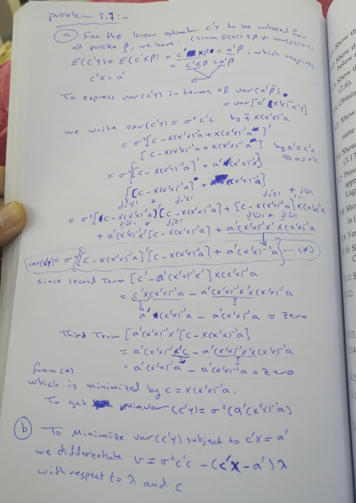

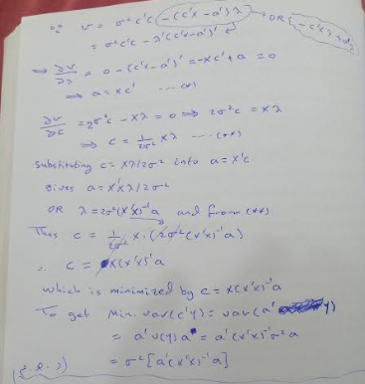

Q.2:

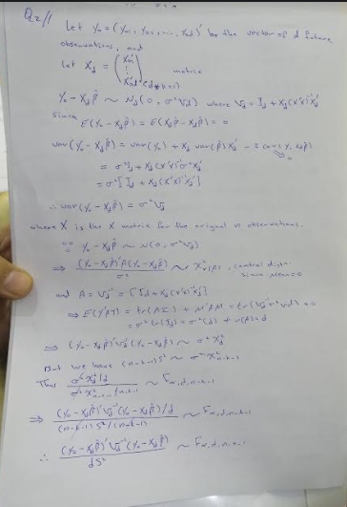

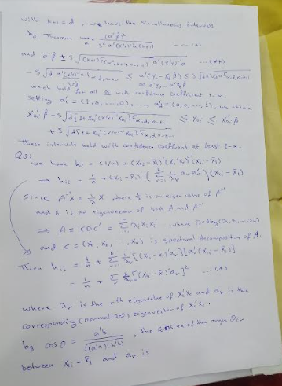

Q.3:



