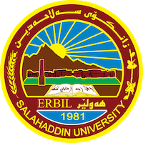

**Academic Curriculum Vitae**

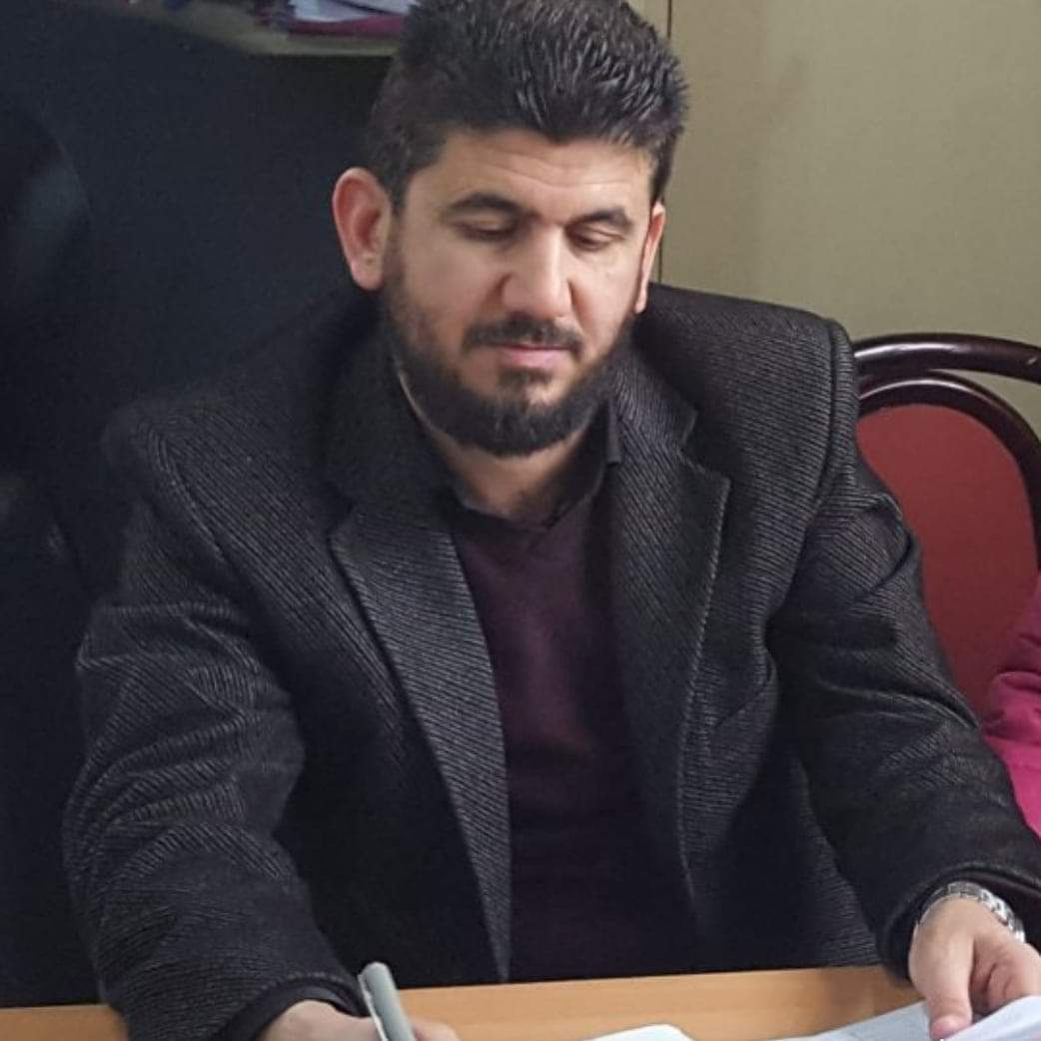

**Personal Information:**

Full Name: Taha Omer Mohammed

Academic Title: Lecturer

Email: (taha.mohemmed@su.edu.krd)

Mobile:07504167083

**Education:**

* B.SC in Dentistry2004-2005

Salahaddin University- College Of Dentistry-Iraq,Erbil

* B.SC in Arabic Language2011-2012

Salahaddin University-College Of Language-Iraq,Erbil

* Master Degree in Arabic Language2015-2016

Allexendra University-College Of Art-Egypt,Allexendra

* Diploma Degree in Islamic Science 2007-2008

Salahaddin University-Islamic Institute-Iraq,Erbil

**Employment:**

* Dentist -Kurdistan Dental Association,

Working as a Dentist at Governmental Hospital in :

Erbil2007-2008

Barzan2008-2009

Erbil-Bnasllawa2009-2011

* Assistant Lecturer

Salahaddin University-College Of Language-Arabic Department

Working as Assistant Lecturer 2015- Continuing.

**Qualifications**

# Participated in course of method of teaching for the Salahaddin university lecturers in 2015.

# participated in a personal strategic plan course for Al-Bayan Foundation for Human Development in 2017.

# Basic program(Microsoft Word ,Excel, power point,…..).

**Teaching experience:**

Lecturer (faculty member) in the Department of Arabic Language, Faculty of Languages / Salahaddin University since 2015 and continues to teach in the same department / He studied the following scientific subjects: (Arabic Syntax, languages Skills, Jahillia Arts, General English, Arabic Retoric ).

**Research and publications**

* Syntactic Cohesion and its Effect in Intertexual Coherence (AL-bayyinah's Surrah as a Case Study).
* Syntactic displacement and its meaning in Mutanabi’s poem“Wa Harra Qalbah.

**Professional memberships**

* Kurdistan Dental Association.
* Islamic Scientists Union of Kurdistan .
* Member of teaching Staffs of Arabic Department -Salahaddin University .

**Professional Social Network Accounts:**

* https://academics.su.edu.krd/taha.mohemmed