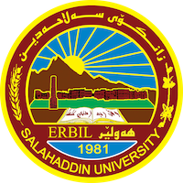
Academic Curriculum Vitae
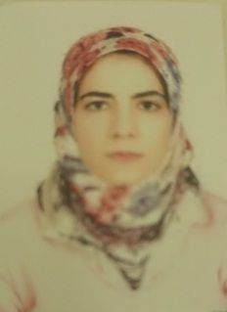
Personal Information:
Full Name: TARA MUHAMAD KHIDHIR
Academic Title: assistant lecturer
Email: (university email) tara.khdir@su.edu.krd
Mobile: . 07504730887

Education:
Bachelor degree at histological department { salahadin university college of art}
Master of history in middle century , and phd student
Employment:
- Sallahadin university college of art

Qualifications

- Word , excel ,access, power point
- Toffle and language English certificate

Computer certificate

Teaching experience:
- Language course and computer course

Research and publications
- State all researches, publication you made.

Conferences and courses attended
- Histological conference 2019

Funding and academic awards
- List any bursaries, scholarships, travel grants or other sources of funding that you were awarded for research projects or to attend meetings or conferences.

Professional memberships
- Member in histological group

Professional Social Network Accounts:

tara.khdiir@su.edu.krd

It is also recommended to create an academic cover letter for your CV.

I have experience with a variety of histological academy and have worked since 2009 as a lecturer in salahadin university college of art , I’m confident in my ability to accurately prepare and analyze histological lecture.

