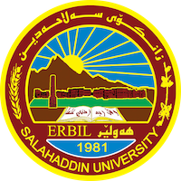
Academic Curriculum Vitae
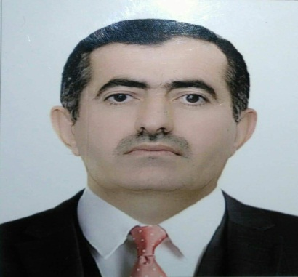
Personal Information:
Full Name: Tareq Taher Abdullah
Academic Title: assistant teacher
Email: (university email): tareq.abdullah@su.edu.krd
Mobile: 07504638341

Education:
- Bachelor's degree from the Ahzam Imam College - Baghdad – (2001).
- Master's degree from Al-Jinan University, Tripoli - Lebanon - Faculty of Arts and Human Sciences/ Department of Islamic Studies/ Fundamentals of Religion in (2013).
- PhD student at Koya University/ College of Education/ Department of Religious Education.
- Assistant Lecturer at the College of Education, Shaqlawa/ Department of Arabic Language.
- Obtaining the scientific title Lecturer / College of Education-Shaqlawa / (7/7/2010).
Employment:
- Date of first appointment / (18/6/2001).
- Self-Director at the College of Education, Shaqlawa (2020).

Qualifications
- English Language Course / Language Center / Salahaddin University (2020).
- Obtaining a certificate (Teaching Methods) from Salah Al-Din University / College of Law / (2014).
- Computer education course at Ibn Al-Haytham College - Baghdad – (2004).
- Computer education course at Nashtman Center - Erbil – (2007).

Teaching experience:
- I have been teaching in the Department of Arabic Language / College of Education - Shaqlawa since 2020 and until now I have studied many subjects with the supervision of many undergraduate students
- Lectured at the Institute of Islamic Sciences for two years (2014-2015).

Research and publications
- (Gradualism in Islam, its legitimacy, and the wisdom behind it) Glai Zanst Magazine / Lebanese French University / Summer 2023, the number (2) ISSN 2518-6566 (Online) - ISSN 2518-6558 (Print).
- (Education of Women in Islam and Models of Kurdish Women Scientists) Glai Zanst Magazine / Lebanese French University / Summer 2021, the number (3) ISSN 2518-6566 (Online) - ISSN 2518-6558 (Print).
- (Corruption and its implications in the light of the Holy Quran and the Sunnah) malang, 9 oktober 2021 (ISSN; 2957-5242).

Conferences and courses attended
- Participation by presenting the research (the importance of learning languages in Islam) at the International Conference on Calligraphy (The Art of Calligraphy in the Service of Human Civilization) State University of Malang in Indonesia, November 8, 2021.
- Participation by presenting the research (Corruption and its Implications in the Light of the Noble Qur’an and the Prophet’s Sunnah) at the Seventh National Conference of the Arabic Language (Creativity and Innovation in Teaching the Arabic Language in Indonesia in the Era of the Covid-19 Pandemic) State University of Malang / College of Arts / Department of Arabic Literature, Indonesia October 9, 2021.

Funding and academic awards
- List any bursaries, scholarships, travel grants or other sources of funding that you were awarded for research projects or to attend meetings or conferences.

Professional memberships
- Member of the Language and Literature Platform / Iraq / Erbil.

Professional Social Network Accounts:

- Tareq Tahir Abdullah‬ - Google Scholar‬‬‬‬‬‬‬‬‬
- tareq.abdullah@su.edu.krd
- https://scholar.google.com/citations?view_op=list_works&hl=en&user=a_Iwd-0AAAAJ
- Aland tareq Abdullah – Researchgate
- tareq.abdullah@su.edu.krd
- https://www.researchgate.net/
- tareq.abdullah@su.edu.krd
- tareq gardi - orcid
- https://orcid.org/my-orcid

