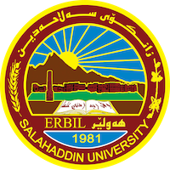
Academic Curriculum Vitae
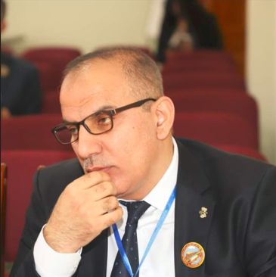
Personal Information:
Full Name: TAREQ MOHAMMED AWRAHIM
Academic Title: Assistant Professor
Email: (tareq.awrahim@su.edu.krd)
Mobile:000000000
Orcid: 0009-0003-9226-9030
Research gate
Google scholar

Education:
I have got the title of Asistant Proffessor in Islamic History on 17-1-2017
Holder of Ph in the Islamic History- History Dept./ college of Arts /Mosul University (2003-2006)
Holder of Master Degree in kurdish Islamic History ; History Dept./ college of Arts /Salahaddin University (1998-2001)
Holder of BA; Degree in Kurdish Islamic History ; History Dept./ college of Arts /Salahaddin University (1992-1996) .
MY M.A thsis entitled (The orientalist Vladimir Minorsky and his writings about Kurds)
My PhD dissertation; entitled (The Civilizational Method in writing tge History , Ahmad Amen as an example).

Employment:
- Assistant Professor in Islamic history department of Salahaddin university college of arts

Qualifications
- Teaching qualifications
- IT qualifications: In computer ( Word , excel , power point)

- Language qualifications such as TOEFL, IELTS or any equivalent
- Any professional qualification
- You could put any professional courses you have attended

Teaching experience:
- I have teached in all stage, of college of arts in salahaddin uneversity. Undergraduate and post graduate
- Courses, trainings, lab supervision, etc.,

Research and publications
کتێبەکان:
١. المستشرق فلاديمير مينورسكى وكتاباته عن الكرد في التاريخ الاسلامي، 2002
٢. رۆژهەڵاتناس مینۆرسکی و نووسینەکانی لەسەر کورد، ٢٠٠٨
٣. المنهج الحضاري في كتابة التاريخ،٢٠١٢
توێژینەوەکان:
- İslam’ın İlk Asrında Vuku Bulan Hadiselere Dair Bediüzzaman Said Nursi’nin Bakışı, Kerkük Ün. Dergisi, 2012, Cilt, 7 , Sayı 1, 205-227 sayfelerı
- Oryantalist Guy Le Strange’nin İslam Tarihine Dair Telifatı, Salahuddin Ün. Dergisi,.2015, Cilt 19, Sayı 2, 97-108 sayfalar
- Seyyid Emir Ali ve İslam Tarihine Dair Yazdıkları, Salahuddin Ün. Dergisi, 2016. Cilt 20, Sayı.2 ,111-130 sayfalar
- Oryantalist W. Barthold ve İslam Medeniyetine Bakışı, Salahuddin Üniversitesi Dergisi, 2016. Cilt 21, Sayı 5, 1-16 sayfeler.
- Tarihçi Fuad Sezgin’in İslam Medeniyetine Dair Tashih Ettiği Kavramlar, Mardin Artuklu Ün. Mukaddime Dergisi. Cilt 8 , Sayı 2 , Oca 2017 , 365 – 386 Sayfalar.
- İslam Kültür Mirasında Salgın Hastalıklarla İlgili Kitaplar. Baghdad Ünivesitesi. Arap Bilimsel Miras Dergisi.Vol.1 No.48. 2021. 107-132 sayfalar.
- Sheikh Muhammad Asaad Effendi Al-Erbili His Life and Effects in Light of Turkish and Local Sources, BİNGÖL ÜNİVERSİTESİ YAŞAYAN DİLLER ENSTİTÜSÜ DERGİSİ, Yıl: 7, Cilt: 7, Sayı: 14 ISSN: 2147-5679
- Writing the biography of the Prophet in Persian , Zanco Journal of Humanity Sciences: Vol. 26 No. 3 (2022)
- Comparative Method of Historian Fuad Sazgin in his book (GAS) Zanco Journal of Humanity Sciences . vol. 26. No 6. 2022.
- The remnants of the Shaddadids in the city of Ani - a historical study، Zaxo university, Kurdish center, May 2023. Devlet u mirgehen kurdi l serdemy navendu nu. Pp57-81.

Conferences and courses attended
- Give details of any conferences you have attended, and those at which you have presented delivered poster presentations.

Funding and academic awards
- List any bursaries, scholarships, travel grants or other sources of funding that you were awarded for research projects or to attend meetings or conferences.

Professional memberships
- List any membership you hold of any professional body or learned society relevant to your research or other life activities.

Professional Social Network Accounts:

- Orcid: 0009-0003-9226-9030
- Research gate
- Google scholar

It is also recommended to create an academic cover letter for your CV, for further information about the cover letter, please visit below link:
https://career-advice.jobs.ac.uk/cv-and-cover-letter-advice/academic-cover-letter/

