Question bank Solid lab

Practical Solid Lab

- In the absent of magnetic field in Hall Effect experiment can we produce Hall Voltage? Explain your answer.
- By increasing temperature what will happen to resistance in metal explain?
- From Bragg's law of reflection and schematic diagram of electron diffraction find the relationship between wavelength (λ) and inter planer distance (d).

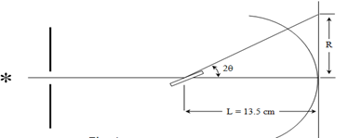

- Impossibility of using visible light to determine crystal structure?
- How is Hall potential produced?
- By increasing temperature what will happen to resistance in metal.
- Name the parameters in the following equations:
- (a) ∆ρ/ρ◦=α∆T (b) a=d√(h^2+k^2+l^2 ) (c) μ=|σ R_H |
- Write the names of two experiments which used to study crystal structure?
- In the absent of magnetic field in Hall Effect experiment can we produce Hall Voltage? Explain your answer.
- Why does wavelength of electron in electron diffraction experiment decrease when the voltage increases from 3.5 kv to 4.5kv?

