**Proposal To Earn M.Sc Degree in the Field of Soil Physics**

**1.Title of the Proposal: Spatial and temporal variations of soil water availability under winter cropping over the dominant plains of Erbil province**

**II. Justification and Overview**

The demand for water is increasing with growing population and industrialization. Water supply is considered to be one of the key factors for rapid development and urbanization. However, the overexploitation of water resources has resulted in a condition of unsustainability and environmental degradation. Hence, the information on spatial and temporal availability of water will be helpful for the optimum utilization of water resources (Singh and Prasad, 2004).

Water availability in semiarid regions is endangered, which is not only due to changing climate conditions, but also to anthropogenic land use changes ( Fries et al., 2020).

The status of water resources in a region can be assessed by study of the water balance between the input of water from precipitation and snowmelt and the outflow of water by evapotranspiration, groundwater recharge and stream flow. Consequently, the Thornthwaite & Mather (TM) model (Thornthwaite & Mather, 1955, 1957) was suggested for the water balance assessment of the temporal and spatial patterns of water surplus and water deficit status. This method has been widely used to analyze water balances because it is easy to use and parameters are readily available. It suits the limitation of data parameter of the study area that could be obtained ( Nugroho et al., 2018).

In a situation, where the soil is at field capacity, actual evapotranspiration will equal potential evapotranspiration (PET) and moisture input will exceed potential evaporation. In such circumstance, the excess rainfall over evapotranspiration is known as water surplus, while water deficit is represented by the condition of excess evapotranspiration over rainfall (Egwuonwu *et al.* 2012).The aridity index helps to identify, locate or delimit regions that suffer from water deficit, a situation that can extremely impact the efficient use of land for agriculture or livestock-farming (Paparrizos *et al.* 2016).

It can be concluded that the practice of rainfed agriculture may not be sustainable in the study area because the rainfall pattern which has been changing over the years. As there has been only limited work on water availability under winter cropping in the region under study. The findings should support governmental decision makers and promote the implementation of sustainable water management projects to guarantee water availability and food production for local and regional populations. Accordingly, the current study will be conducted to achieve the objectives shown in the icoming section.

**III. Objectives**

The main objective of the current study is to offer a solution for soil moisture deficits during the year for winter cropping in the dominant plains within Erbil Governorate through water balance analysis. This goal can be achieved through targeting the following specific objectives:

1)To reveal months of water deficit and water surplus at each plain

2)To determine the temporal and spatial variation of soil water deficit over the study area, particularly for wheat cropping.

3)To guarantee water availability through suggesting sustainable water management projects

**IV. Brief Outlines**

The present study calculates water balance and soil moisture deficits during the year for the dominant plains using limited long-term meteorological station data in combination with field measurements (soil samples). From these data the retention capacity (RC) of the different soil types is estimated, the mean annual and monthly water balance of winter crops ( wheat ) (WB) will be calculated, as well as the monthly soil moisture deficit (Ds) is determined.

Thornthwaite-Mather water balance equation uses the soil moisture capacity to estimate water budgets. The parameters needed for using this method include:

1. Difference between precipitation and potential evapotranspiration (P-PE)

2. accumulated potential water loss (APWL)

3. available water capacity (AWC)

4. difference between soil moisture storage (ΔST) between monthi and monthi+1.

5. actual evapotranspiration (AE)

6. deficit and surplus of the water budget

7. runoff estimation

However, the outline of the study is summarized as follows:

1. A study area will be selected between latitudes 35' 55o N and 36' 33o and between longitudes 43' 43o N and 44' 20o such that covers most of the dominant plains within Erbil governorate such as Erbil , Bardarash, Rovia, Harir, Questapa and Gomaspan plains.

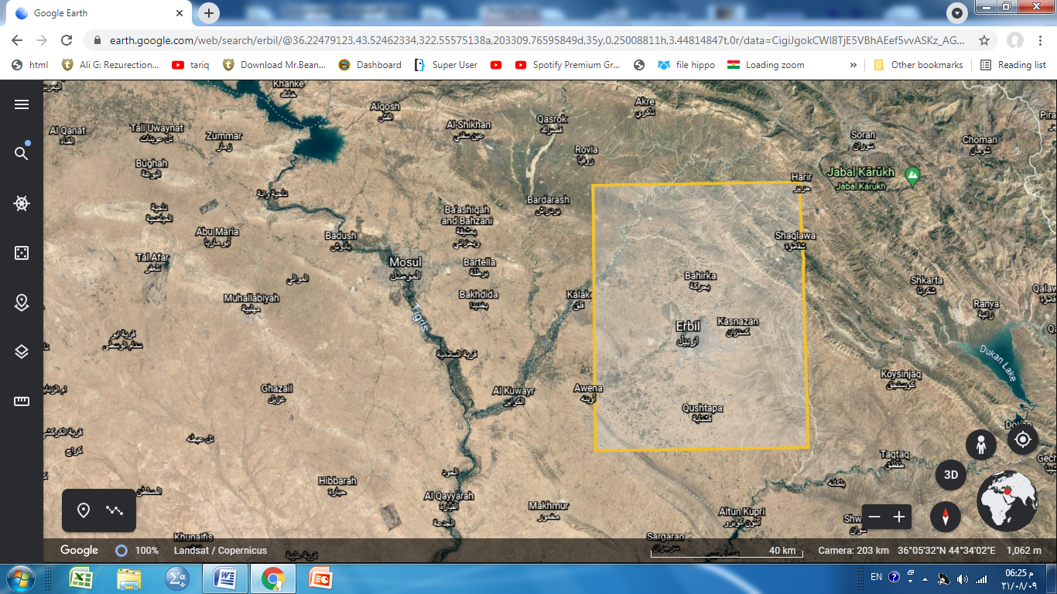 36 33 N 44 20 E 36 33 N 44 20 E

70 km

1. m 35 55 N 43 43 E 35 55 N 43 43 E
2. A grid system will be established with grid spacing of about 20 km x 20 km

|  |  |  |  |
| --- | --- | --- | --- |
|  |  |  |  |
|  |  |  |  |
|  |  |  |  |
|  |  |  |  |

3) The monthly and annual precipitation will be determined at each grid point using data from the existing agro-meteorological stations for a length of record of at least 20 years.

4) Monthly and annual maps of will be established by Kriging interpolation for finding [ P ( x, y) at each grid point.

5) Determination of monthly and annual potential evapotranspiration [ ETo ( x, y) ] at each grid point using modified Blaney- Criddle formula.

6) The necessary soil characteristics to determine the water holding capacity (water retention capacity, RC), specifically bulk density (BD) and soil texture parameters, will be obtained by means of soil samples. Kopecky steel rings with a volume of about 100 cm3 will be used.

7) Composite soil samples will be also taken from the upper stratum in the area surrounding each grid point for soil routine analysis( OM, lime equivalent, EC, pH

8) At each grid point, soil samples will be collected every 20 cm from 0 to 100 cm for soil moisture determination as ground truth. This procedure will be replicated at least three locations surrounding each grid point at the end of each month for ground truth.

9) For each specific soil type, the equation proposed by Karim (1999) will be applied for determining available water based on soil texture.

10) The WB was calculated for each grid cell (x,y), by applying the following equation

WB(x,y) = P(x.y) – Eto( x, y)

11) To calculate the soil moisture retention (Ri) for a specific month (i) at grid cell (x,y), R from the previous month (Ri-1) must be considered and added to the actual monthly WBi :

Ri(x,y) = Ri-1(x,y) + P(x.y)i – ETo( x, y)i

12) The monthly soil water deficit or excess Ds(x,y)i in mm at grid cell (x,y), will be calculated using :

Ds(x,y)i = WB(x,y)i + VR(x,y)i

Where: VR(x,y) i= R(x,y)i - R(x,y)i-1

If Ds are negative, there is deficit, but if Ds are positive, there will be surplus water or:

If Pi –PE­I > 0 and Ci = Pi –PEi + SMi-1 > AWC, there is surplus water

If Pi –PE­I < 0 and Pi –PEi + SMi-1 < 0 , there is water deficit.

Table (1) shows a sample calculation of soil water deficit and water surplus using water balance analysis:

|  |  |  |  |  |  |  |  |  |
| --- | --- | --- | --- | --- | --- | --- | --- | --- |
| **Month** | **PE** | **P** | **PE-P** | **ST** | **DelST** | **AE** | **D** | **S** |
| **Jan** | **0** | **36** | **36** | |  | | --- | | **109** | | **36** | **0** | **0** | **0** |
| **Feb** | **0** | **28** | **28** | **137** | **28** | **0** | **0** | **0** |
| **Mar** | **0** | **23** | **23** | **150** | **13** | **0** | **0** | **10** |
| **Apr** | **25** | **27** | **2** | **150** | **0** | **25** | **0** | **2** |
| **May** | **64** | **36** | **-28** | **122** | **-28** | **64** | **0** | **0** |
| **Jun** | **92** | **46** | **-46** | **76** | **-46** | **92** | **0** | **0** |
| **Jul** | **113** | **30** | **-83** | **0** | **-83** | **106** | **7** | **0** |
| **Aug** | **99** | **27** | **-72** | **0** | **-72** | **27** | **72** | **0** |
| **Sep** | **59** | **20** | **-39** | **0** | **-39** | **20** | **39** | **0** |
| **Oct** | **22** | **22** | **0** | **0** | **0** | **22** | **0** | **0** |
| **Nov** | **0** | **33** | **33** | **33** | **33** | **0** | **0** | **0** |
| **Dec** | **0** | **40** | **40** | **73** | **40** | **0** | **0** | **0** |

13)The spatial variation of soil water deficit and surplus water can be determined by interpolation according to Kriging method.

14) From the plot of monthly precipitation, monthly evapotranspiration and actual evapotranspiration versus month of the year on the same chart, zones of surplus water, soil moisture utilization and soil moisture deficit can be demarcated

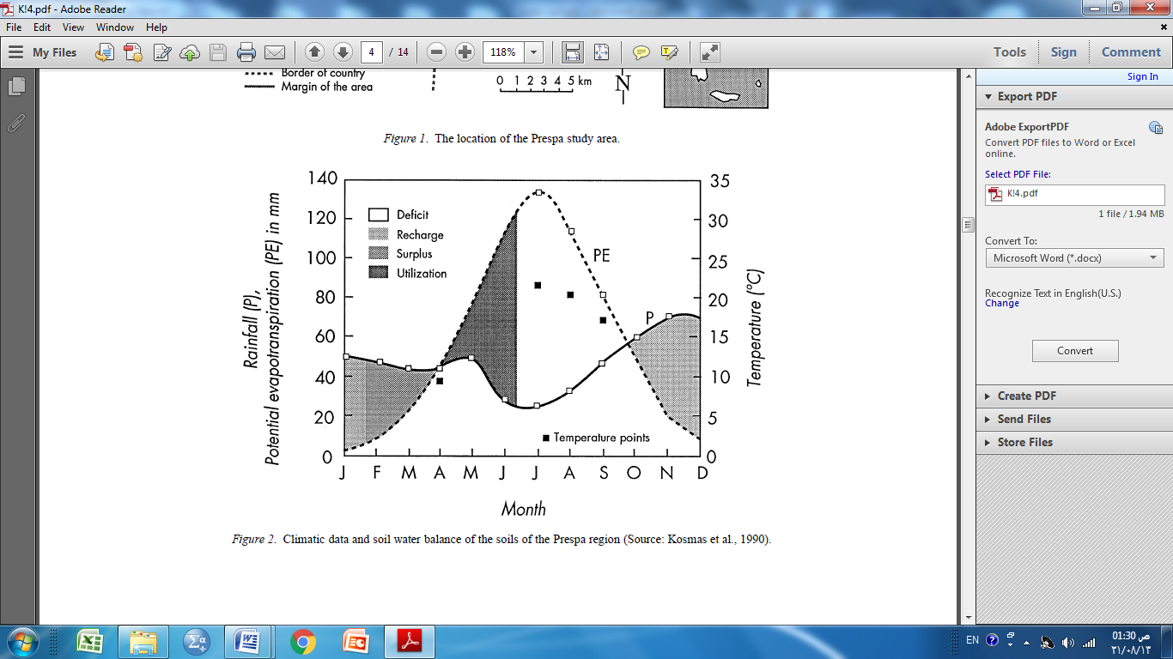



15. To validate Karim(1999) model, the soil water retention at field capacity and wilting points will be measured in the laboratory for the samples obtained from the grid points.

16) Pedeotransfer functions will be built to predict soil bulk density from basic soil properties and soil retention parameters.

17) Specification of aridity level for the purpose of water resources management.

18) Suggesting sustainable water management projects to guarantee water

availability and food production for the local regional and populations.

**V. Requirements**

1. Database for monthly and annual rainfall and air temperature for a desired length of record.

2. GPS for locating geographical coordinates of grid points and sampling sites

3. An auger for soil sampling

4. Aluminum tins with lids for obtaining soil samples for soil moisture determination

5. Cylindrical cores for obtaining undisturbed soil samples

6. Soil moisture characteristic apparatus for determining soil moisture retention parameters.

7. Chemicals for performing some selected physical and chemical soil properties.

8. Pickup for transportation

9. Pegs for locating grid points

**VI. Allocated Money**

Six million I.D. to cover the expense of the investigation

Khalis jalal Dr. Tariq .H. Karim

M.Sc Student The Supervisor