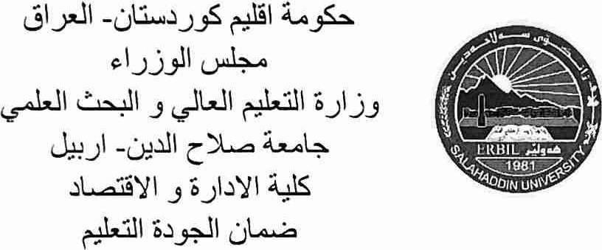
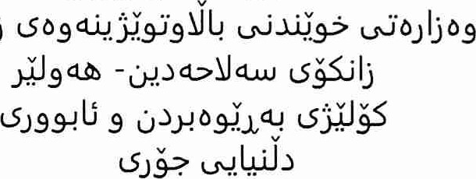
-u liu-JJJ9S tJJ'Q09..S-> U IN. j by Wd-op-i<j u&w-jlj
Kurdistan Regional Government Council of Ministers
Ministry of Higher Education& Scientific Research
Salahaddin University- Erbil
College of Administration and Economics
Date :
Jl.3
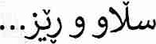
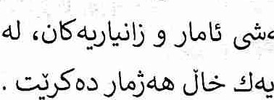
Statistical Software for Data Analysis ) d.J bJ-41*d5 dJ d.S '(is Presently Undergoing a New Stage of Innovation d.z.u+d-o (2024/2/21) ÖdeYdJ
32031.413
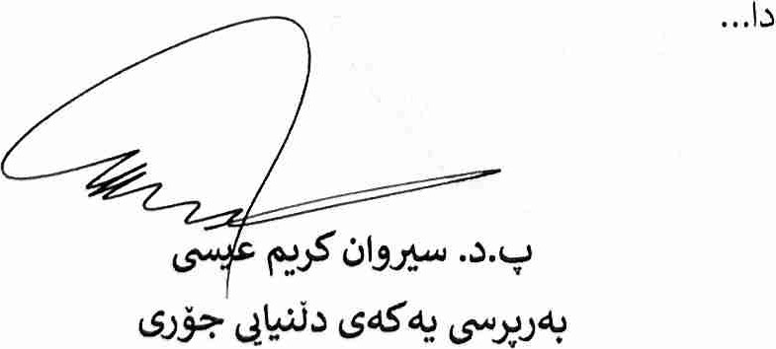cj4S4J
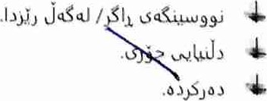
Web-Site: www.su.edu.krq
E-Mail: admin.econ.colleqe@su.edu.krd 00964 (0) 750 4-160462

