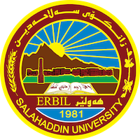
Academic Curriculum Vitae
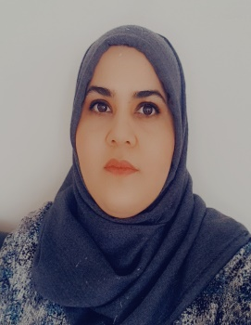
Personal Information:
Full Name: treefa Muhsin Ahmed
Academic Title: assistant lecturer
Email: treefa.ahmed@su.edu.krd
Mobile: 07504140247

Education:
- Master degree of art (Kurdish language- syntax) in 2016.
- Bachelor degree in 2010

Employment:
- employment starting from 11-4-2011 as (ياريده‌ده‌رى توێژه‌ر- معيد)

Qualifications
- Diploma of teaching (academic capacity development). (from 17-7-2016 to 26-3-2017)
- Scientific title (assistant lecturer) 2018
- computer training (ICDL course) from 23-4-2012 to11-6-2012.
- IELTS – academic. (18-8-2018)

Teaching experience:
- ڕسته‌سازى تيۆرى- كۆلێژى په‌روه‌رده‌ى مه‌خموور (2017-2018)
- كوردناسيى گشتى- كۆلێژى ئه‌ندازيارى – به‌شى ئه‌ندازيارى شارستانى (2018-2019) (2019-2020)
- ده‌روازه‌يه‌ك بۆ زمان (كۆليژى زمان- به‌شى كوردى) 2019-2020
- ڕێزمانى گشتى (كۆليژى زمان- به‌شى كوردى) (2021-2020)
- ڕێزمانى به‌راورد (كۆليژى زمان- به‌شى كوردى) (2022-2021) (2023-2022)
- زمانه‌وانيى ده‌رونى (كۆليژى زمان- به‌شى كوردى) (2022-2023)
Research and publications
- State all researches, publication you made.

Conferences and courses attended
- كۆنفرانسى زانستيى نێوده‌وڵه‌تى جينۆسايدى گه‌لى كوردستان (جينۆسايدى كوردى فه‌يلى)

Funding and academic awards
- List any bursaries, scholarships, travel grants or other sources of funding that you were awarded for research projects or to attend meetings or conferences.

Professional memberships
- List any membership you hold of any professional body or learned society relevant to your research or other life activities.

Professional Social Network Accounts:

- Google scholar: https://scholar.google.com/citations?view_op=new_articles&hl=en&imq=Treefa+Muhsin+Ahmed#
- Research gate: https://www.researchgate.net/profile/Treefa-Ahmed
- LinkedIn: https://www.linkedin.com/in/trefa-muhsen-60142a163
- Facebook: https://www.facebook.com/treefa9?mibextid=ZbWKwL
- Word press: https://wordpress.com/me

