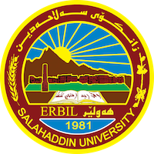
Academic Curriculum Vitae

Personal Information:
Full Name: trifa ahmad othman
Academic Title: phd
Email: (university email) trifa.barzangy@su.edu.krd
Mobile:07507892160

Education:
- State all educations accomplished

Employment:
- State employment starting from first employment

Qualifications
- Teaching qualifications
- IT qualifications
- Language qualifications such as TOEFL, IELTS or any equivalent
- Any professional qualification
- You could put any professional courses you have attended

Teaching experience:
- State all teaching courses you delivered, stating undergraduate or post graduate
- Courses, trainings, lab supervision, etc.,

Research and publications
- State all researches, publication you made.

Conferences and courses attended
- Give details of any conferences you have attended, and those at which you have presented delivered poster presentations.

Funding and academic awards
- List any bursaries, scholarships, travel grants or other sources of funding that you were awarded for research projects or to attend meetings or conferences.

Professional memberships
- List any membership you hold of any professional body or learned society relevant to your research or other life activities.

Professional Social Network Accounts:

- List your profile links of ReserchGate, LinkedIn, etc.

It is also recommended to create an academic cover letter for your CV, for further information about the cover letter, please visit below link:
https://career-advice.jobs.ac.uk/cv-and-cover-letter-advice/academic-cover-letter/

