Plant cell
Plant cell: is the basic unit of life in organisms of the kingdom Plantae. They are eukaryotic cells with specialized structures called organelles that carry out different functions.
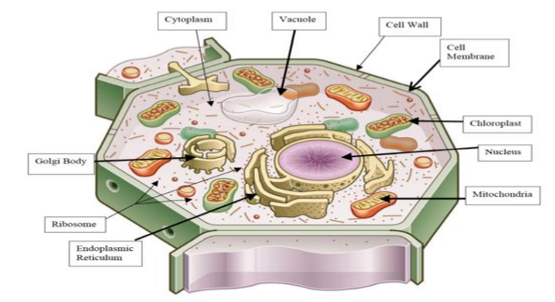
Plant cell organelles
1- Cell Wall
A fundamental difference between plant and animal cells is that the plant cell is surrounded by a rigid cell wall, mostly made of polysaccharides (cellulose, hemicellulose, pectin) and lignin. From the outermost layer of the cell wall, these layers are identified as the middle lamella, primary cell wall, and secondary cell wall. While all plant cells have a middle lamella and primary cell wall, not all have a secondary cell wall. The primary function of the cell wall is to protect and provide structural support to the cell. The plant cell wall is also involved in protecting the cell against mechanical stress and to provide form to the cell.
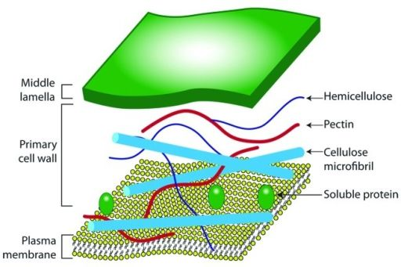
2- Cell membrane (Plasma membrane): It is the semi-permeable membrane that is present within the cell wall. It is composed of a double layer (bilayer) of phospholipids in which proteins are embedded. The cell membrane plays an important role in regulating the entry and exit of specific substances within the cell. It keeps toxins from entering inside, while nutrients and essential minerals are transported across.
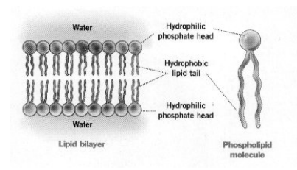
3- Cytoplasm
It is the semifluid gelatinous substance that fills the cell, made up of eighty percent water usually clear and colorless. It is the main arena of various activities of a cell.
4-Nucleus: It is the largest among all cell organelles, may be spherical or ellipsoidal, consist of Nuclear envelope, Nuclear pores, Nucleoplasm and Nucleolus). Its function is controlling all the cellular activities and storing the genetic or hereditary information.
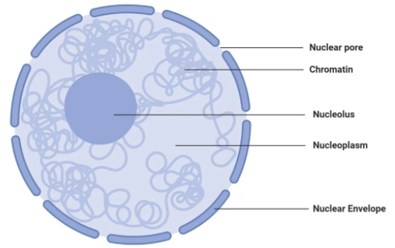
5-Vacuoles: Are large, bounded by a membrane called Tonoplast. The vacuoles contain cell sap, which is a solution of sugars, amino acids, mineral salts, waste chemical. The major function of plant vacuole is to maintain water pressure known as turgor pressure, which maintains the plant structure, stores salts, minerals, nutrients, proteins, pigments and remove the wastes.
6- Mitochondria: They are the double-membraned organelles found in the cytoplasm of all eukaryotic cells. They provide energy by breaking down carbohydrate and sugar molecules; hence they are also referred to as the “Powerhouse of the cell.”
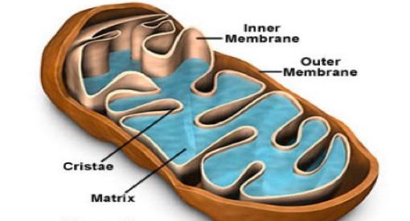
7- Golgi Body (Golgi apparatus): consists of a stack of flattened membranous sacs. located close to the endoplasmic reticulum. The Golgi apparatus receives proteins and lipids (fats) from the rough endoplasmic reticulum.
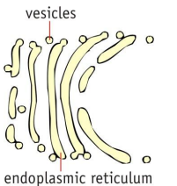

8-Endoplasmic Reticulum: Is associated with nuclear membrane and cell surface membrane. It forms a network in cytoplasm and gives mechanical support to the cell. When ribosomes are present in the outer surface of the membrane it is called (Rough endoplasmic reticulum (RER) which involved in protein synthesis, when the ribosomes are absent it is called (Smooth Endoplasmic reticulum (SER) which are the sites of lipid synthesis.
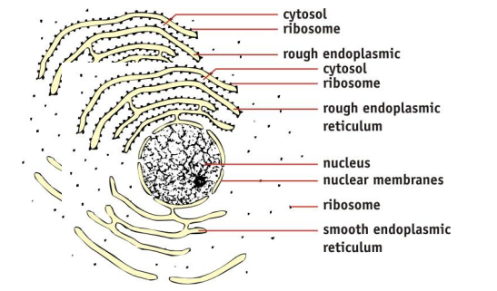
9- Plastids: They are membrane-bound organelles. Have 3 types
a-Leucoplasts: storage of protein, lipid and starch
b-Chloroplasts: photosynthesis process
c-Chromoplasts: provide color to all fruits and flowers.
10-Ribosomes: Ribosomes play an important role in protein synthesis. Plant cells contain 3 distinct types of ribosomes, which occur in cytoplasm, mitochondria and chloroplast.
11- Lysosomes: are membrane-bound organelles and the area within the membrane is called the lumen, which contains the hydrolytic enzymes. The function of lysosomes is digestion and removal of waste, food particles and foreign bodies in the cell.

