Growth and Development
- Growth is Irreversible change in Mass.
- Growth is defined as an increase in the number, size, and volume of cells
- Growth can be defined as an irreversible permanent increase in size of an organ or its parts or even of an individual cell.
Plant growth is measurable
Growth is measured by a variety of parameters some of which are:
a) Increase in fresh weight
b) Dry weight
c) Length
d) Area
e) Cell number ….etc.
Growth Rates
The increased growth per unit time is growth rate. Rate of growth can be expressed mathematically. The two ways of representing growth rates are:
a) Arithmetic growth rate
b) Geometric growth rate
- In arithmetic growth, following mitotic cell division, only one daughter cell continues to divide while the other differentiates and matures.
- In geometrical growth, both the progeny cells following mitotic cell divide and continue to do so.
- During the development of an embryo, both types of growth rates are involved, transforms a single cell zygote into a multicellular organisms.
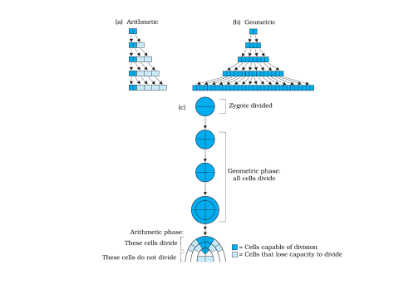
If we plot the increase in cell number (growth rate) against time, a typical S-shape curve is obtained. This is called growth curve or sigmoid curve.
This curve has three phases of growth:
(i) Lag Phase – This is the initial phase of growth when the rate of growth is very slow.
(ii) Log Phase – It shows rapid growth and is maximum for the entire life span.
(iii) Stationary Phase – Here the rate of growth starts decreasing and finally it stops.
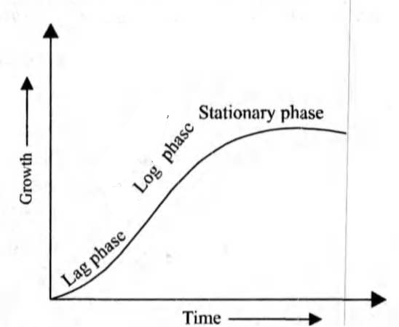
Phases of Growth:
Plant growth is concentrated in localized regions of cell division called meristems.
In a young plant, the most active meristems are called apical meristems; they are located at the tips of the stem and the root. At the nodes, axillary buds contain the apical meristems for branch shoots. Lateral roots arise from the pericycle. Cells usually differentiate into specialized types after they elongate. The phase of plant development that gives rise to new organs and to the basic plant form is called primary growth. Primary growth results from the activity of apical meristems, in which cell division is followed by progressive cell enlargement, typically elongation. After elongation in a given region is complete, secondary growth may occur. Secondary growth involves two lateral meristems: the vascular cambium and the cork cambium. The vascular cambium gives rise to secondary xylem and secondary phloem. The cork cambium produces the periderm, consisting mainly of cork cells.
- The period of growth is generally divided into three phases, namely :
a) Meristematic
b) Elongation
c) Maturation

- Components
1. Cell Division
2. Cell Enlargement
3. Cell Differentiation
Cell Division
- Meristematic Cells
- Primary
  - Shoot Apical Meristem (SAM)
  - Root Apical Meristem (RAM)
- Secondary
  - Vascular Cambium
  - Cork Cambium
  - Pericycle (root)
Cell cycle regulation:
The cell division cycle, is the process by which cells reproduce themselves and their genetic material, the nuclear DNA.

Cell elongation (enlargement) stage
Cell volume increase dramatically as the cell absorbs a great number of water. Combine small vacuoles into a central vacuole so that the nucleus and cytoplasm is sequen to the side toward cell wall. Water is the most important factor for cell elongation. GA, IAA and CTK control cell elongation.
Differentiation- The cells derived from root apical & shoot apical meristems & cambium differentiate & mature to perform specific functions. This act leading to maturation is termed as differentiation.

Dedifferentiation- The living differentiated cells that lost the capacity to divide can regain the capacity of division under certain conditions. This phenomenon is termed as dedifferentiation.
Redifferentiation - A dedifferentiated plant cell once again loses its capacity to divide and becomes mature. This phenomenon is called redifferentiation. For example, secondary phloem and secondary xylem are formed from vascular cambium, and periderm are formed from cork cambium.

Apical growth and differentiation：
Plant grows taller and deeper. Three major tissue systems are found in all plant organs: dermal tissue, ground tissue, and vascular tissue.

Development:
Development includes all changes that an organism goes through its life cycle from germination of the seed to senescence. Development is Irreversible change in state.
Leaf：leaf primordium → young → mature leaf
Root： primordium → young→ root system
Fruit ： fertilized egg → young→ ripened fruit
Development is the sum total of growth and differentiation. It is regulated by extrinsic and intrinsic factors.
Growth, differentiation, and development are closely related events. A plant cannot develop if the cells do not grow and differentiate.

Plant growth regulators
1. Endogenous
a. Substance produced by a plant that affects the pattern of growth and development.
b. Production by the plant is regulated by the environment.
2. Exogenous
a. Substance applied to the plant that alters growth and development in the same way that endogenous substances do.
b. May be the same or different chemically from the endogenous substance
3. Hormone
a. Substance that acts in very low concentration b. Produced in one part of plant and act in another (translocatable)
c. Has the same response in many different plant species.
A. Primary:
1. Auxins 2. Cytokinins 3. Gibberellins 4. Abscisic Acid 5. Ethylene
B. Secondary - newly discovered
1. Jasmonic Acid 2. Brassinosteroids 3. Polyamines 4. Salicylic Acid

