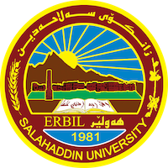
Academic Curriculum Vitae

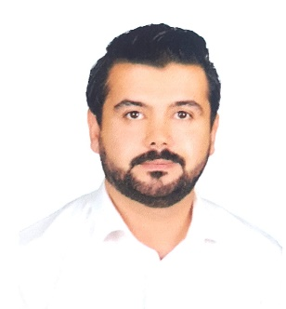
Personal Information:
Full Name: Twana Othman Mohamedamen
Academic Title: Assistant Lecturer
Email: twana.mohamedamen@su.edu.krd
Mobile: 07504859088

Education:
- 23/10/2019 Assistant Teacher Certificate.
- 24/03/2018 Diploma of Teaching
- 19/07/2017 Master degree in Sociology.
- 28/06/2012 Bachelor in Sociology in the University of Salahaddin, employed as teaching assistant due to honor degree.
- 01/10/2007 Bachelor in Chemistry from the University of Salahaddin

Employment:
- 2019 - Current: Teacher in Department of Sociology in the college of Arts at University of Salahaddin-Erbil
- 2019-2022 External Assistant Lecturer in the Department of Sociology in Lebanese French University.
- 2013 - 2014: Employment in Registry office in college of Art - University of Salahaddin
- 2012 - 2013: Assistant research and computer employment in college of Arts at University of Salahaddin
- 2009 - 2012: Teacher of Chemistry Science in Maxmure, Debga and Dwgrdkan.

Qualifications
- Teaching qualifications
- 23/10/2019 Assistant Teacher Certificate.

- IT qualifications
- 03/02/2013 – 13/03/2013: Successfully completed computer training ICDL Course.

- Language qualifications such as TOEFL, IELTS or any equivalent

- 10/11/2022 IELTS pass certificate. (Band Score = 5.0)

- 21/12/2013 - 03/02/2014: Successfully completed English Proficiency Course at the Language Center in the University of Salahaddin -Erbil.
Teaching experience:
- State all teaching courses you delivered, stating undergraduate or post graduate
- 2019 - Current: Assistant Lecturer in the Department of Sociology in College of Arts at University of Salahaddin-Erbil
- 2019-2022: External Assistant Lecturer in the Department of Sociology in Lebanese French University.
- 2017-2018: Assistant Lecturer of Growth psychology in the Department of physics in College of education at University of Salahaddin -Erbil.
- 2009 - 2012: Teacher of Chemistry Science in Maxmure, Debga and Dwgrdkan.

Research and publications
- State all researches, publication you made.
- The Role of the Political Elite in the Development of Society (A theoretical study in the Kurdistan region)
- https://doi.org/10.21271/zjhs.25.4.8

- The effect of globalization on social change. (A Field Study in Erbil City)
- http://journal.lfu.edu.krd/ojs/index.php/qzj/article/view/695

- Incentives for women to work outside the home. (A Field Study in Erbil City)
- https://journal.lfu.edu.krd/ojs/index.php/qzj/article/view/949/961

Conferences and courses attended
- Give details of any conferences you have attended, and those at which you have presented delivered poster presentations.

Funding and academic awards
- List any bursaries, scholarships, travel grants or other sources of funding that you were awarded for research projects or to attend meetings or conferences.

Professional memberships
- Member of Kurdistan Union of Sociologists and Psychologists
Professional Social Network Accounts:

- List your profile links of ReserchGate, LinkedIn, etc.

It is also recommended to create an academic cover letter for your CV, for further information about the cover letter, please visit below link:
https://career-advice.jobs.ac.uk/cv-and-cover-letter-advice/academic-cover-letter/

