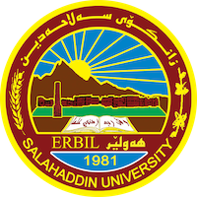
Academic Curriculum Vitae
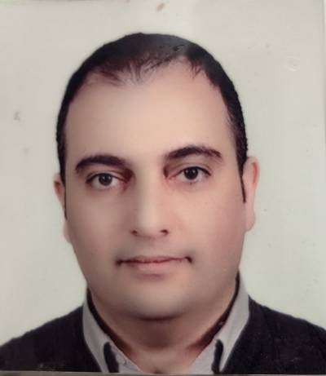
Personal Information:
Full Name: Velar Hikmat Elias
Academic Title: Assistant Lecturer
Email: Velar.Elias@su.edu.krd
Mobile: 07504712766

Education:
From UNIVERSITY OF SALAHADDEN, I have:
• B.Sc degree in Electrical Engineering - Salahaddin University 2002/2003.
• M.Sc. degree in "Information and Communication -Engineering- ICE " Salahaddin University 2007/2008.
Employment:
- 2003-2005 I work as Engineer at Salahaddin University in electronic and communication lab, college of engineering, electrical department.
- 2008 until now (after master degree) as Lecturer at SALAHADDIN University College of Engineering, electrical department.

Qualifications
- Teaching qualifications at 8-7-2010, file number “10046/3/2”
- ( IT-level 3:PC hardware, software, and networking - 2009) International certification from CISCO Network Academy. This level is advance (instructor level).
- (HCIA - Routing and Switching - 2020) International advance level certification from HUAWEI Technologies Co., Ltd
- At 2019, I successfully completed an IELTS course, certified by catholic university Erbil CUE.

Teaching experience:
- (communication-Engineering for third-year electrical engineering students,
- electrical measurements and instrumentation for Forth, third, and second-year electrical engineering students,
- mechanical engineering for first-year electrical engineering student,
- Analog communication for third year Physics Science students,
- and digital signal processing for fourth-year Physics Science students).
- Data-Base (Data Modeling) Forth class electrical engineering
- MATLAB for fourth-year electrical Engineering
- Digital Electronics for third-year electrical Engineering
- Data Communication (PC-Networks) for fourth-year electrical engineering
- Statistics and Probability for second year electrical engineering

Supervising and lecturing experiments in LAB
- Analog communication lab. supervising and lecturing experiments for third-year electrical engineering students
- Electronic lab. supervising and lecturing experiments for second-year electrical engineering students
- Electronic lab. supervising and lecturing experiments for Third-year electrical engineering students
- Digital communication lab. supervising and lecturing experiments for forth-year electrical engineering students

And I supervise many graduation projects fourth-year electrical engineering students projects like
- Image compression using wavelet transform-MATLAB,
- Performance evaluation of ADSL-MATLAB,
- Electronic library Networks Design-PACKET TRACER,
- Comparison between gray code system and binary code system-MATLAB,
- Performance enhancement using wavelet denoising over AWGN channel-MATLAB,
- Real-time motion detection-MATLAB.
- Smart homes using CISCO packet tracer
- Image analysis using MATLAB
- IOT for smart office
- High speed network design and implementation for companies

Research and publications
- Performance Evaluation of DWMT Downlink Scheme over UTP-3 Cable, ELEKTRIKA, Universiti Teknologi Malaysia, vol.11, no.2, pp. 20-26, 2009
- Modeling and Simulation of Discrete Wavelet Multi-Tone, Journal on Software Engineering, vol.2, no.3, pp. 1-5, 2008
- Wavelet Filter Bank-based nonuniform Multi-Tone Transceiver for Digital Subscriber Line, IEEE 11th International Conference on Computer and Information Technology CIT, Cyprus, August 2011.
- Real-Time Motion and Color Detection, is accepted by Journal of Zankoy Sulaimani – Part A (JZS-A), published in Vol. (17), No.(4), (2015).)

Professional memberships
- Kurdistan Academic Union from 2005
- Kurdistan Engineers Union from 2003

Professional Social Network Accounts:

- https://academics.su.edu.krd/velar.elias/
- https://scholar.google.com/citations?view_op=new_profile&hl=en&authuser=3
- https://www.researchgate.net/profile/Velar-Elias
- https://www.linkedin.com/in/velar-hikmat-478082166/

