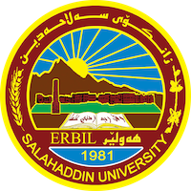
Academic Curriculum Vitae

Personal Information:
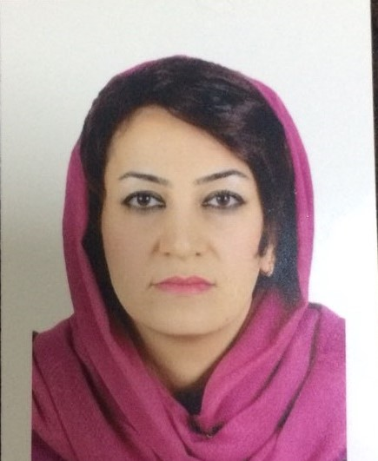
Full Name: Dr. Vian Dler Ali
Academic Title: Lecturer
Email: (university email): vian.ali1@su.edu.krd
Mobile: 07504904902

Education:
Degrees | Department | University | Country | Date of Completion
BSc | Plant Production | Salahaddin | Kurdistan Region/ Iraq | 2006
MSc | Forestry and Horticulture | Salahaddin | Kurdistan Region/ Iraq | 2010
PhD | Field Crop and Medicinal Plant | Salahaddin | Kurdistan Region/ Iraq | 2023

Employment:
Year | Department | Collage | University
2008- 2010 | Forestry and Horticulture | Agriculture | Master student  Salahaddin University
2010-2015 | Horticulture | Agriculture Technical Institute - Khabat | Polytechnic University
2019-2023 | Field Crop and Medicinal Plant | Agriculture engineering science | PhD student  Salahaddin University
2015-Until now | Horticulture | Agricultural Engineering Sciences | Salahaddin University

Teaching experience:
Course Teaching | No.
Plant Physiology
Plant Growth regulator
Plant Ecology
Botany

Research and publications
No | Research Title
 | Response of Some Chemical Content of Pepper (Capsicum annuum L.) to Foliar Application of Boron and Zinc under Plastic Hose Condition.
 | Response of Some Cucumber Hybrid Cultivars (Cucumis sativus L.) Grown in Plastic House.
 | Seed Germination of (Gundelia tournefortii L.) under Different Dormancy Breaking Treatment.
 | Effect of Dust Metals and Compost on Growth of (Gundelia tournefortii L.) and the Chemical Composition of its Edible Portion.
 | Interaction Effect of Chemical and Organic Fertilizers on the Yield and Yield Composition of (Gundelia rosea L.) at Different Plant Densities in the Field
Conferences and courses attended
The 1st International Virtual Conference of Climate Change: Resent Aspects of Climate Changes and Multidisciplinary Sciences. Biosciences Research Support Foundation.
4th International Virtual Conference of Nanotechnological Science Under the Theme: Nanotechnology and Our Daily Life. Biosciences Research Support Foundation
Scientific translation, simplification of science and improvement of research skills. BRSI.
تطوير زراعة المحاصيل الاستراتيجية (محصول الحنطة) في العراق نموذجا). جامعة تكريت و جامعة سامراء
التقانات الحديثة وكفاءة التسويق ادوات لدعم الاقتصاد الزراعي. جامعة تكريت

Funding and academic awards
- List any bursaries, scholarships, travel grants or other sources of funding that you were awarded for research projects or to attend meetings or conferences.

Professional Social Network Accounts:

- List your profile links of ReserchGate, LinkedIn, etc.

Profile link | Social Account | No.
https://scholar.google.com/citations?user=UKtyG6EAAAAJ&hl=en | Google Scholar
https://www.researchgate.net/profile/Vian-Ali | ReserchGate
https://www.linkedin.com/in/vian-ali-276614121/ | LinkedIn
https://orcid.org/0009-0008-3526-9727 | Orcid

