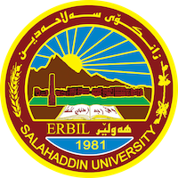
Academic Curriculum Vitae
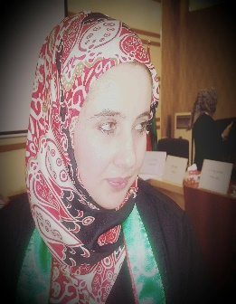
Personal Information:
Full Name: Waran N. Abdullah Agha
Academic Title: Assistant Lecture
Email: (university email): waran.agha@su.edu.krd
Mobile: 07504198268

Education:
- Salahaddin University: College of Agriculture Engineering Sciences: Erbil, Iraq BSc in Plant Protection 2011.
Got the first rank among the students of the Plant Protection Department and 4th rank among the students of the college.

- Salahaddin University: College of Agriculture Engineering Sciences: Erbil, Iraq. MSc in Plant Protection_ Entomology: Control of Insect Pests that Infect Some Stored Dried Fruits via Using a Microwave and Some Plant Extracts, October 2016.

Employment:
- From November 2011 to December 2014: worked as an assistant Agricultural Engineering (Assistant researcher) in the Salahaddin University_ Erbil, Iraq, College of Agriculture Engineering Sciences: Plant Protection Department.

- From January 2015 to October 2016: I become a MSc student in Plant Protection_ Entomology in the Salahaddin University.

- From August/2020 to the present: worked as an assistant lecturer in the Salahaddin University in Plant Protection Department.

Qualifications
- Teaching qualifications, 3 years of teaching in Plant protection Department, related to insect subjects
- IT qualifications: Microsoft word, Word, Excel, Power point
- Language qualifications such as IELTS: 5
Kurdish: Mother language
Arabic: medium
English: Good

Teaching experience:
- Integrated Pest Management (IPM) _ Entomology.
- Biological Control Pest_ Entomology.
- Stored Product Pests.
- Insect Physiology

- lab supervision
Lab of entomology / plant protection department

Research and publications

Molecular Identification of Three Stored Product Insect Species on Dried Fruits and Their Control with the Use of Some Aqueous Plant Extracts. Science Journal of University of Zakho. June 2017.

- Entomocidal activity of microwave energy & some aqueous plant extracts against Tribolium castaneum Herbst & Trogoderma granarium Everts. 6th International Conference and Workshops on Basic and Applied Sciences, AIP Conf. Proc. September 2017.

- Molecular identification and morphological study of European Hover fly Erstalis pertenax (scopoli,1763) (Diptera: Syrphidae) from erbil governorate Kurdistan region- Iraq, 2022. Chinese journal of medical genetics, 32 (4) :710 – 716).
- Molecular identification and morphological study of Ground beetle, Cyminds and rea, menetries,1832 (coleoptera: carabidae) from Erbil governorate Kurdistan region- Iraq. 2022. Annals Forest research, 65 (1): 4808-4818.

- Redescription of Hybosorus illigeri Reiche 1853 (Coleoptera: Hybosoridae) from Erbil Governorate, Kurdistan region-Iraq. 2023. Journal of Survey in Fisheries Sciences 10(3S) 5269-5276.
Conferences and courses attended
- 6th International Conference and Workshops on Basic and Applied Sciences, AIP Conf. Proc. September 2017. As a researcher and published our research.
- Attendance to International Collaborative Conference Of modern agricultural technologies (ICCMAT 2023)

Professional Social Network Accounts:

- Academic Profile: https://academics.su.edu.krd/profile-admin/index.php

- Research gate: https://www.researchgate.net/?ref=logo&_sg=AM8c2oFks1jqPLpbAcdv0UU0fh4FGBWMl1GwU3PEcxx4KqX-3OlyrB72PJ_UidIVeEEqW0sJK1rbQ2Q.

- Linkedin : https://www.linkedin.com/in/waran-n-abdullah-agha-1278b3135/?lipi=urn%3Ali%3Apage%3Ad_flagship3_feed%3BK4AmFMVxSUORUA1QpO2DiA%3D%3D

- Google scholar: https://scholar.google.com/schhp?hl=en

It is also recommended to create an academic cover letter for your CV, for further information about the cover letter, please visit below link:
https://career-advice.jobs.ac.uk/cv-and-cover-letter-advice/academic-cover-letter/

