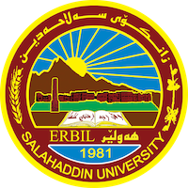
Academic Curriculum Vitae

Personal Information: 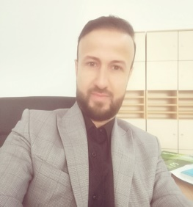
Full Name: Yassen Muhammad Awla
Academic Title: Assistant lecture
Email: (university email) yassen.awla@su.edu.krd
Mobile: 0750 4882578

Education:
- 2004-2008: (BA. in English Language and Literature). Department of English, College of Languages, Salahaddin University-IRAQ
-I graduated from Salahaddin University college of Languages in 2009 (Ranked second in English Language Department).
-MA Degree in Applied Linguistics at the University of Liverpool and TESOL in the UK (The Use of Metaphors in political Discourse) in 2013.
-Now I am member of academic staff in college Agricultural Engineering Science plant protection department /Salahaddin University. And Specialized in Teaching academic and general English

Employment:
- 2009-2012 Assist. Teaching Assistant at Department of English College of Languages/ University of Salahaddin.
- 2017-2019 interpolator and legal Translator.
- 2019-2020 Lectures at Knowledge University in ELT department
- 2019 Assist. Lecturer of English at / University of Salahaddin. Plant protection department

Qualifications
- Teaching qualifications (Advanced Teacher Training program in the USA in 2015)
- IT qualifications
- Language proficiency test IELTS (7.0)
- Any professional qualification

Teaching experience:
- Teaching English at Cambridge College of English from 2017-2020 evening classes
- Teaching TEFL Listening and Speaking in 2016 at TISHK international University
- Teaching English for specific purpose (petroleum engineering) Hayat University
- Teaching English for media 2021 at Gasha Technical Institute
- Teaching IELTs preparation courses at BIA academy 2022

Research and publications

- Error Analysis in Translation: A case Study at Tishk international Univerity. (Zanco Journal for humanity,2022).
- Extensive reading in Kurdistans’ High schools ( Published in Journal of Educational Science in 2017) from Erbil Governorate Kurdistan Region – Iraq.

- Published a book entitled (a step to translation) in 2018

Funding and academic awards
- I was awarded a scholarship by the US department of state in Baghdad as a teacher trainee in 2015. I was involved in eight-week intensive program developing curriculum, methodology and assessment of EFL education program.

Professional memberships
- KELTPN member for teachers

Professional Social Network Accounts:
- http://academics.su.edu.krd/yassen.awla
- Yassen Awla | Salahaddin University - Erbil, Erbil | SUH | College of Agriculture | Research profile (researchgate.net)
- https://www.linkedin.com/in/yassen-muhammad-awla

