زانكؤي سةلاحةدين – هةوليَر
Salahaddin university– Erbil

Optical properties for pure PVA and doped with Cobalt Chloride

Submitted to the department of (physics) in partial of the requirements for the degree of BSc .In(physics)

By:
Sahd Hamad Hussien

Abdulrahman Dilshad Saeed

Supervised:
M. Zahra Ali

May - 2022

Chapter one

Public introduction and previous studies

- Introduction

  - Polymer science and technology :
Polymer science and technology has developed tremendously over the last few decades ,and the production of polymers and plastics products has increased at a remarkable pace. By the end of 2000, nearly 200 million tons per year of plastic materials were produced worldwide ( CarraherJr, C.E., 2007).
  - History of polymers:
The old human was used natural polymers prior to hundreds of centuries where he used wool, cotton, silk, animal leather and other in the manufacture of his clothes and dwelling, as well as vegetable oils and animal grease, and the natural resins have been used as anesthetic and adhesive since thousands of years such as gum and animal and plantations and used as phalt in boat coating. In the eighteenth century, polymers were classified as high molecular weights compared to other materials and this concept remained until Rault and Hoff in 1880 were discovered ways to set molecular weight and then measured the molecular weights ranging from (10,000- 40,000),These measurements have made the idea of the presence of large molecules. and the scientist (Staudinger) received the Nobel Prize in 1953 in proving the hypothesis of large molecules.and has contributed to prove the hypothesis the scientists (Carothers) in 1929 and (Flory) in 1937(Young, R.J. and Lovell, P.A., 2011).

  - Using dissolved polymers in water:
Water soluble polymers that show in figure (1-1) have a wide range of industrial applications like food, pharmaceuticals, paint, textiles, paper, constructions, adhesives, coatings, water treatment, etc. the water soluble polymers have been divided into two categories (1) Synthetic and (2) Natural(Kadajji, V.G. and Betageri, G.V., 2011).
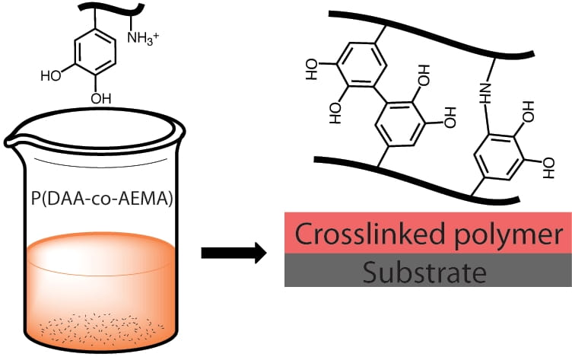

Figure (1-1) Water soluble polymers

1-4 polymer:
A polymer such that showen in figure (1-2) is a substance composed of molecule characterized by the multiple repetition of one or more species of atoms or groups of atoms (constitutional repeating units) linked to each other in amount sufficient to provide a set of properties that do not vary markedly with the addition of one or a few of the constitutional repeating units. The word polymer originates from the Greek words poly meaning many and 'mer meaning part (Gedde, U.L.F., 1995)
The natural polymers are generally condensation polymers made by
addition of monomer such that shown in figure(1-3) units one at a time to the ends of growing polymer chains. Polymerization of all chains stops at identical
molecular weights.(Webster, O.W., 1991).
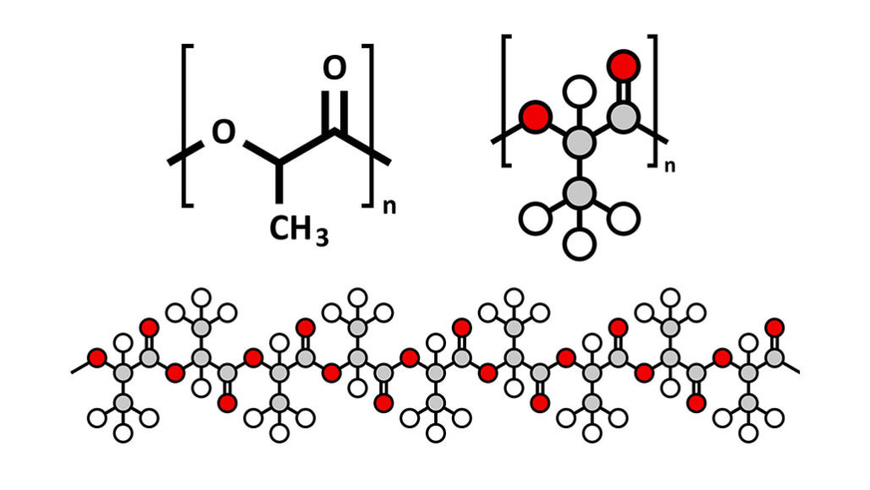
Figure (1-2) polymer
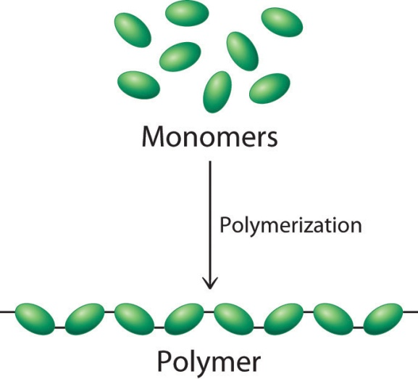
Figure(1-3) polymerization

1-5 Previous studies:
- Films were prepared from polymethyl methacrylate (PMMA ) tainted with 1 % potassium iodide salt (KI ) by casting method and at room temperature for the purpose of studying the effect of thickness on optical properties recorded the absorbance and transmittance spectra of five different thikness (80,140,210,250,320 nm )وThe study was extended to include changes in each of the energy gap coefficient, refractive index, damping coefficient, absorption coefficient with increasing thickness(Hamad, T.K. and Musa, W.A., 2011).
- Films of pure polyvinyl alcohol were prepared ( PVA ) with nickel nitrate NiNO3 prepared by the method of pouring the solution with different percentages of distortion. The optical properties were studied by recording the transmittance and absorption spectroscopy within the length range 200-800 nm ,it was found that the optical energy gap decreases with the increase in the concentration of nickel nitrate. Also, the optical constants represented by the refractive index (n), the attenuation coefficient (k), the dielectric constant in its real and imaginary parts were studied, and that all these optical constants have changed with an increase in the concentration of nickel nitrate (Ahmed, H., Rabee, B.H., Hussein Hakim, A.H. and Salman, S.R.,)
- Polyvinyl alcohol transparent films were prepared with different concentrations of sodium iodine using the casting method, optical absorption measurements were performed for all samples at room temperature and within wavelengths (190-1100) nm. The study included changes in optical parameters including bandwidth and energy gap for all samples. It was found that optical absorption is caused by direct and indirect transitions, and the energy gap values ​​change to the minimum levels with the increase of sodium iodine concentrations and for all transitions, a spectrum has been studied absorption and after staining the samples at a temperature of 80 degrees Celsius for a period of (3) hours. In addition, the study of the complex refractive index showed the dependence on the concentration of doping.(Mustafa, F.A., 2013)
- Pure and doped PVA films were prepared with different concentrations of nickel chloride (NiCl2) by casting method. the effect of adding different concentrations of nickel chloride (NiCl2) on the optical properties of PVA films was studied by recording the absorption and transmittance spectra within the wavelength range (200-1100) nm. It was found that there are direct and indirect optical transitions, through which it was clear that the optical energy gap of the films decreased with an increase in the concentration of nickel chloride (NiCl2).(Abdullah, O.G. and Saber, D.R., 2012)
- The effect of adding potassium chloride (KCL) on the optical properties of PVP films at different concentrations was studied using the casting method. The optical properties were studied within the wavelength range (300-200 nm). The experimental results showed that each of the absorbance (A), absorption coefficient (α), refractive index (n), real and imaginary part of the dielectric constant (ԑ₂,ԑ₁) have increased with increasing Potassium chloride (KCL) concentration and the optical energy gap of PVA films decreases with increasing potassium chloride concentration.(Habeeb, M.A., Ridha, A.R.A. and Hashim, A)
- , alizarin yellow GG (AYGG) e CuCl2 doped with polyvinyl alcohol (PVA) has been successfully synthesized. This composite has spherical shape particles with amorphous structure. Thermal analysis indicates that there is an endothermic change, which is related to the glass transition(Khalil, M.M., El-Sayed,et.al., 2021)
- The optical properties of the films of the composite composed of polyvinyl alcohol were studied ( PVA_BaSo4_5H2O) Within the wavelength range of ( 190 – 850 ) nm The experimental results showed that each of the absorption coefficient ( X ),refractive index ( n ),damping coefficient ( K ), real and imaginary part of the dielectric constant (ԑ₂,ԑ₁) increased with increasing concentration of ( BaS40_5H2O )(Ahmed, Z.S., Hashim , A.,et.al., 2012)
- The effects of calcination on the synthesis of polymer (P) assisted zinc ferrite (${zn}_{0.5 }p_{x}{fe}_{2-x}o_{4}$)nanoparticles by the biological thermal method were investigated. The zinc ferrite synthesized was doped with 0.1g in situ by polyvinyl alcohol (PVA), Polyvinyl Pyrrolidone (PVP) and Polyethylene glycol (PEG) respectively. The properties of the formulated nano particles were determined by various characterization techniques(Aisida, S.O., Ahmad, I. et.al ., 2020)
- Ternary blend films were prepared with different ratios of starch/polyvinyl alcohol (PVA)/citric acid. The films were characterized by field emission scanning electron microscopy (FE-SEM), thermo gravimetric analysis, as well as Fourier transform infrared (FTIR) analysis. The influence of different ratios of starch/polyvinyl alcohol (PVA)/citric acid and different drying times on the performance properties, transparency, tensile strength (TS), water vapor permeability (WVP), water solubility (WS), color difference (∆E), and antimicrobial activity of the ternary blends films were investigated(Wu, Z., Wu, J., et.al., 2017).

1- 6 Aim of the study:
Due to the importance of polymers at the present time and the use of their applications in the electric field through modifying electrical properties to transform from insulating materials to conductive and even super conducting materials to provide an integrated mixture that combines physical and mechanical qualities (lightness, weight, hardness, flexibility and endurance to external conditions) on one hand, and optical properties on the other hand, with many practical applications for polymer. In the current research, an attempt will be made to prepare polymeric films from polyvinyl alcohol by chemical casting method and study the effect of impurities on the optical properties of transmittance, absorption, optical power gap, refractive index, damping coefficient and dielectric constant with its real and imaginary parts for polymer (PVA).

Chapter Two
The theoretical part

2- Structure properties of polymers
2-1 Melt viscosity
It is important to note that there is critical threshold molecular weight below which there is little if any entanglement of polymer chains. Melt viscosity is a measured of the tendency (speed) of melted materials to flow The melt viscosity of a polymer increases as the molecular weight increases and is proportional to the molecular weight up to the critical threshold molecular weight. The melt index is a measure of flow inversely related to melt viscosity and is often cited in particular terms such as the time for ten grams of a material to pass through a standard orifice at a specified time and temperature. Above this value, the melt viscosity is related to the molecular weight raised to the 3.4th power. The critical threshold chain lengths corresponding to the threshold molecular weights of polymethyl methacrylate (PMMA), polyisobutylene, and polystyrene (PS) are 208, 610, and 730 repeating units, respectively Most industrial polymers have average chain lengths above critical threshold value. In general, the physical properties improve rapidly as the threshold value is approached and then tend to level off above this value (Carraher Jr, C.E. and Seymour, R.B., 2012).
2-2 Isomerism
Isomerism is the phenomenon where by certain compounds , with same Molecular formula , exist in different forms owing to their different organization of atoms. Isomerism is the existence of two or more molecular that have same molecular formula, same number of atoms but a different arrangement within the molecular or it can be said different configuration (Mishra, S.P., 2016).and isomers are two type such that shown in figure (2-1).
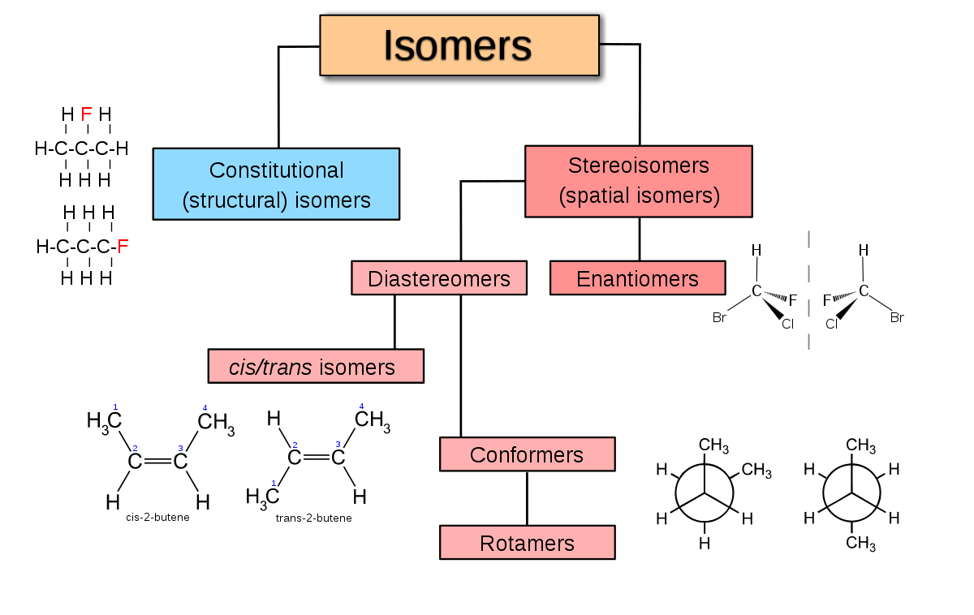
Figure (2-1) isomers
2-2-1 Chain Isomerism
The different arrangement of carbon atoms gives rise to chain isomerism. Chain isomers possess different length of carbon chains(straight or branched). Such isomerism is shown by each and every family of organic compounds.(kota C.,2020)
Butane : $C_{4}H_{10}$
${CH}_{3}-{CH}_{2}-{CH}_{2}-{CH}_{3}$ n-butane
${CH}_{3}-{CH}_{ }-{CH}_{3}$ iso butane
${CH}_{3}$
n-pentane , isopentane, and neopentane possess the chain of five, four ,and three carbons , respectively , hence they are chain isomers (kota C., 2020).

2-2-2 Isomer in Vinyl polymer chains
Although there is a vast variety of synthetic polymers, we shall be mainly concerned with vinyl and diene polymer (and copolymer) chains , since these present the most intriguing structural problems (Bovey, F., 2012). Such as shown is figure (2.2) consider the types of isomerism that may be implied in the deceptively simple reaction:
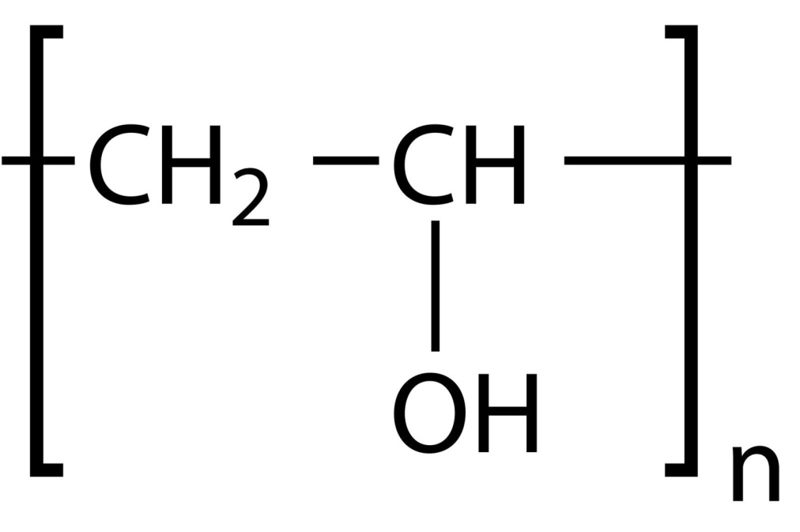
Figure(2-2) PVA

2-3 polymer crystallization effect:
The effect of polymer crystallization shows its internal effect on the following properties:
- Increasing its density, for example, polyethylene of low density (60%) crystallizes (density =91), while high-density polyethylene (95%) has a density of (97).
- Increasing the tensile strength of the polymer and improving other mechanical properties.
- Increasing the melting point of the polymer.
- Increasing the degree of resistance of the polymer to solvents and other chemicals (Piorkowska, E. and Rutledge, G.C. eds., 2013).

3- Optical properties
3-1 Transmittance
The transmittance ,T, of the sample is defined as the ratio of the incident power and the resulting power:
T= $\frac{P}{P_{o}}$
As defined , transmittance is always a numerical value between zero( all light absorbed) and one ( no light absorbed) . it is common to convert transmittance in to percent transmittance , %T, by multiplying the original definition by %100 , and Absorbance is defined as the negative bases -10 logarithm of the transmittance (Ball, D.W., 2001).
A=-log T =- log$\left(\frac{P}{P_{o}}\right)$
3-2 Absorption coefficient
When a photon has an interaction , only part of its energy is absorbed by the medium at the point where the interaction took place. Energy given by the photon to electrons and positrons is considered absorbed at the point of interaction because the range of this charged particles is short. However , X-rays, Compton-scattered photons, or annihilation gammas may escape. The fraction of photon energy that escaped is important when one wants to calculate heat generated due to gamma absorption in shielding materials or gamma radiation dose to humans. The gamma energy deposited in any material is calculated with the help of an energy absorption coefficient defined in the following way . the gamma energy absorption coefficient is , in general , that part of the total attenuation coefficient that, when multiplied by the gamma energy , will give the energy deposited at the point of interaction this equation gives the total attenuation coefficient . the energy absorption coefficient (Tsoulfanidis, N., Tsoulfanidis, N. and Landsberger, S., 2019).
$µ_{a}$=τ+ $\frac{T_{av}}{E_{γ}}$σ+k
Where $T_{av}$ is the average energy of the Compton electron and $µ_{a}$ may be a linear mass energy absorption coefficient(Tsoulfanidis, N., Tsoulfanidis, N. and Landsberger, S., 2019).
3-3 Optical band gap
The optical band gap is the value of optical energy gap $E_{g}^{opt}$ between the valance band and the conduction band. The optical band gap of the samples is determined from the absorption spectra near the absorption edges. The photon absorption in many amorphous materials is found to obey the Tauce relation (Tauc, J., Menth, A.,1970).which is of the form:
α (v)hv = B${(hv-E_{g}^{opt})}^{m}$
where α is the absorption coefficient , hv is the photon energy , the factor B depends on the transition probability and can be assumed to be constant within the optical frequency range (Dorranian, D., Abedini, Z.,2009).and the index (m) is related to the distribution of the density of states . the index (m) has discrete values like 1/2 ,3/2,2,3 depending on whether the transition is direct or indirect and allowed or forbidden , respectively (Reicha, F.M., Ishra, M.,2003). The usual method for calculating $E_{g}^{opt}$ is plotting (${αhv)}^{1/m}$ against hv, and the optical energy gap $E_{g}^{opt}$ can be estimated from the extrapolation of the line portion of the graph to the photon energy axis . The optical absorption coefficient α(v) near the band edge for many amorphous and crystalline materials, shows an exponential dependence on photon energy (hv) and obeys an empirical relation given by Urbach (Urbach, F., 1953).
α( v) =$α_{o}$exp(hv/∆$E_{t}$)
where $α_{o}$ is a constant and ∆$E_{t}$ is related to width of the band tails of localized states in the normally forbidden band gap that associated with the amorphous nature material . it should be mentioned that this equation is applicable only in the low absorption (α=${10}^{3}$-${10}^{4}{cm}^{-1}$).
3-4 refractive index
refractive index is defined as the ratio of the velocity of propagation of radio energy in the vacuum to velocity in a specified medium. Hence the radio refractive index may be measured directly if the measuring instrument is sensitive to the velocity of propagation . the refractive index is measured indirectly by measuring temperature, pressure, and humidity with consequent conversion to refractive index by means of :
N= (n-1)${10}^{6}$= $\frac{K_{1}}{T}$(p+$\frac{K_{2}}{T}e$)
N= refractivity
N= refractive index
T= temperature
P= total atmospheric pressure
e = partial water vapor pressure.
$k_{1}$and $k_{2}$ = Smith and Weintraub constants $k_{1}=77.6$ and $k_{2}=4810$ (Smith, E.K. and Weintraub, S., 1953). And other optical properties such real and imaginary part of dielectric constant.

References

Abdullah, O.G. and Saber, D.R., 2012. Optical absorption of polyvinyl alcohol films doped with nickel chloride. In Applied Mechanics and materials (Vol. 110, pp. 177-182). Trans Tech Publications Ltd.
Ahmed, H., Rabee, B.H., Hussein Hakim, A.H. and Salman, S.R., Preparation and Study of Optical Properties of (Polymer-Nickel Nitrate) Composite.
Ahmed, Z.S., Hashim, A., Rabee, B.H. and Jewad, A., 2012. Study of Optical Properties of (PVA-BaSO4. 5H2O) Composites.American Journal of Scientific Research, (76), pp.5-9.
Aisida, S.O., Ahmad, I. and Ezema, F.I., 2020. Effect of calcination on the microstructural and magnetic properties of PVA, PVP and PEG assisted zinc ferrite nanoparticles. Physica B: Condensed Matter, 579, p.411907.
Ball, D.W., 2001. The basics of spectroscopy (Vol. 49). Spie press.
Bovey, F., 2012. Chain structure and conformation of macromolecules. Elsevier.
Carraher Jr, C.E. and Seymour, R.B., 2012. Structure—Property Relationships in Polymers. Springer Science & Business Media.

CarraherJr, C.E., 2007. Seymour/ Carraher's polymer chemistry.CRC press.
Dorranian, D., Abedini, Z., Hojabri, A. and Ghoranneviss, M., 2009. Structural and optical characterization of PMMA surface treated in low power nitrogen and oxygen RF plasmas. Journal of Non-Oxide Glasses, 1(3), pp.217-229.
Gedde, U.L.F., 1995. Polymer physics.Springer Science & Business Media.
Habeeb, M.A., Ridha, A.R.A. and Hashim, A., Characterization of (PVP-KCl) Composites.
Hamad, T.K. and Musa, W.A., 2011. The optical properties of Poly methyl methacrylate (PMMA) polymers doped by Potassium Iodide with different thickness.Baghdad Science Journal, 8(2عددخاصبمؤتمرالفيزياء).

Kadajji, V.G. and Betageri, G.V., 2011. Water soluble polymers for pharmaceutical applications.Polymers, 3(4), pp.1972-2009.
Khalil, M.M., El-Sayed, A.H., Masoud, M.S., Mahmoud, E.M. and Hamad, M.A., 2021. Synthesis and optical properties of alizarin yellow GG-Cu (II)-PVA nanocomposite film as a selective filter for optical applications. Journal of Materials Research and Technology, 11, pp.33-39.
kota C .,2020.chemistry for class 11th,published by :career point Ltd , CP Tower,No CPP-425.
Mishra, S.P., 2016. Fibre structure. Woodhead Publishing India Pvt. Limited.
Mustafa, F.A., 2013. Optical properties of NaI doped polyvinyl alcohol films. Physical Sciences Research International, 1(1), pp.1-9.
Piorkowska, E. and Rutledge, G.C. eds., 2013. Handbook of polymer crystallization. John Wiley & Sons.
Reicha, F.M., Ishra, M. and Gabr, M.M., 2003. On the physical and electrical properties of poly propenal prepared by electropolymerization technique. Journal of Physics and Chemistry of Solids, 64(7), pp.1157-1161.
Smith, E.K. and Weintraub, S., 1953. The constants in the equation for atmospheric refractive index at radio frequencies. Proceedings of the IRE, 41(8), pp.1035-1037.
Tauc, J., Menth, A. and Wood, D.L., 1970. Optical and magnetic investigations of the localized states in semiconducting glasses. Physical Review Letters, 25(11), p.749.
Tsoulfanidis, N., Tsoulfanidis, N. and Landsberger, S., 2019. Measurement and detection of radiation. CRC press.
Urbach, F., 1953. The long-wavelength edge of photographic sensitivity and of the electronic absorption of solids. Physical Review, 92(5), p.1324.
Webster, O.W., 1991. Living polymerization methods.Science, 251(4996), pp.887-893.
Wu, Z., Wu, J., Peng, T., Li, Y., Lin, D., Xing, B., Li, C., Yang, Y., Yang, L., Zhang, L. and Ma, R., 2017. Preparation and application of starch/polyvinyl alcohol/citric acid ternary blend antimicrobial functional food packaging films. Polymers, 9(3), p.102.

Young, R.J. and Lovell, P.A., 2011. Introduction to polymers.CRC press.

