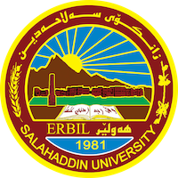
Academic Curriculum Vitae
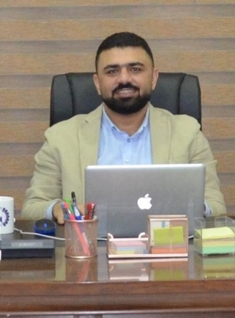
Personal Information:
Full Name: Zana Farhad Abdulqadr Doghramachi
Academic Title: Assistant Lecturer
Email: (university email): zana.farhad@su.edu.krd
Mobile:+964 750 460 2965

Education:
- Software Engineering from Engineering College, Salahaddin University, Erbil, Kurdistan-Iraq.
Bachelor of Engineering in Software Engineering, July 2007, Average: 72.3.
Honors: 2nd top out of 44 students in the final graduating class.
Capstone Project: Wireless Network using Microsoft Visual Basic.
Thesis: Interactive wireless Network Monitoring System.

- IEC College of Engineering & Technology affiliated to Uttar Pradesh Technical University, New Delhi, India.
Master of Technology in Computer Science Engineering, July 2011.
Honors: First Division.
Graduate Courses: security, programming, cloud computing.
Thesis: Designing a highly secure Cloud Computing.
Areas of Interest: web programming, data security, data structure.

Employment:
- Assistant lecturer University of Salahaddin, College of Engineering, Software Engineering Department, Erbil, Kurdistan-Iraq. (August 2008 – Present).
- Assistant lecturer Lebanese French University, Information Technology Department, Erbil, Kurdistan-Iraq. (December 2012 – July 2017).
- Director National Technical Institute, Erbil, Kurdistan-Iraq. (November 2014 – November 2022).
- Assistant lecturer University of Tishk, College of Engineering, Computer Engineering Department, Erbil, Kurdistan-Iraq. (December 2012 – February 2014).
- Director Lavin Institute, Erbil, Kurdistan-Iraq. (July 2012 – December 2014).
- IT Manager MAG (Mines Advisory Group) Iraq program, Erbil, Kurdistan-Iraq. (July 2012 – September 2013).
- Software Engineer University of Kurdistan-Hawler, IT Department, Erbil, Kurdistan-Iraq. (November 2007 – July 2008).
- IT Manager Alwaseet Company, Erbil, Kurdistan-Iraq. (Augest 2007 – April 2008).
- Computer Maintenance and Internet Service Ram Center for computer's service, Erbil, Kurdistan-Iraq. (July 2004 – September 2006).

Qualifications
- Computer Certification Test, 3rd Sep, 2007, Salahaddin University, Erbil, Iraq.
- English Certification Test, 2nd Oct, 2007, Salahaddin University, Erbil, Iraq.
- Rational Application Developer (RAD), 13th Nov, 2009, IBM Workshop, Greater
Noida, India.
- IELTS Course, 3rd June 2011, British Council, New Delhi, India.

Teaching experience:
- Programming (Java, C++, C#).
- Data security.
- Web Design (HTML, CSS, JavaScript, jQuery, ASP.net).
- Data Structure.
- Database (Access, Oracle).

Professional memberships
- Kurdistan Engineering Union 2007, Erbil, Iraq.
- IEEE, Institute of Electrical and Electronics Engineers, 2010, India.
- Kurdistan Teacher Union 2014, Erbil, Iraq.

Professional Social Network Accounts:

- LinkedIn profile: - https://www.linkedin.com/in/zana-doghramachi-880a15141/

