Ministry of higher education &scientific research Salahaddin University Engineering college Architectural department
Subject: Building Material
Final exam
Time:- Date:
hours
Lecturer: Lana Abubakr Ali
Nashmil shwan

Nashmil shwan

Q1/A) Fill the blank with the written words in the following Sentences below: - (15 Marks)
- Geological Classification of stones Based on their origin of formation are classified into three main groups a) ……………. b) …………….c) ………….
- There are two kinds of concrete hollow blocks a)………….b)…………..
- Engineering bricks are bricks manufactured at extremely high temperatures, forming a ……… and brick.
Q2) Define Cement, Concrete, and mortar, then mention the differences between them. Q3) Mention the Standard Brick dimension; clarify your answer by Sketch.
Q4) What are the Engineering Properties of Glass? Q5) what are the Advantages of wood in construction.
Q6) Numerate types of natural stone finishes, then describe one of them. Q7) Why Is Brick Construction So Popular?
Draw the following below
Q8) Types of (Cross-Section) of Steel.
Q9) Type of Joints by Mortar, with their names
Q10) Header bond in Brick construction (plan & Elevation)
Q11) Define Granit, Limestone, and Marble, then mention the differences between them.
Q12) Name each type of Block below, then mention the position of using them in construction.

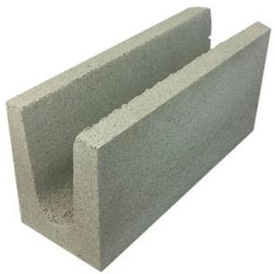
……………………………………………………………
……………………………………………………………
……………………………………………………………
……………………………………………………………
……………………………………………………………
……………………………………………………………

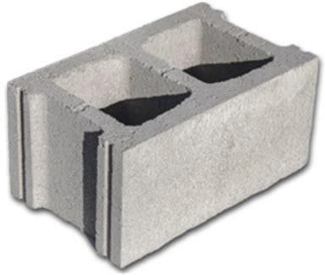
……………………………………………………………
……………………………………………………………
……………………………………………………………
……………………………………………………………
……………………………………………………………
……………………………………………………………

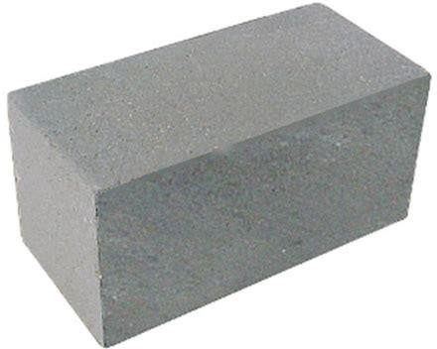
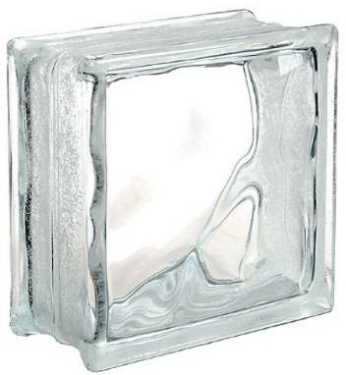
……………………………………………………………
……………………………………………………………
……………………………………………………………
……………………………………………………………
……………………………………………………………
……………………………………………………………
……………………………………………………………
……………………………………………………………
……………………………………………………………
……………………………………………………………
……………………………………………………………
……………………………………………………………

Q13 - 18) /Match the titles on the left side to the correct answer on the right side.

1. Polished finish stone | A. Gives the stone a distinctive rustic appearance
2. Flamed finish stone | B. makes the stone lighter and gives it a matte tone, it is available for  external paving mostly
3. A leather finish stone | C. Highlights the color and properties of the natural stone
4. Mushroom finish stone | D. generates a thin roughness and protects the material for outdoor

 | installation
5. Sawn finish stone | E. slightly undulating surface, very soft, warm, and smooth to the touch.

Q19/ Define Granit, Limestone, and Marble, then mention (Five) differences between them.
Q20/ What is Brick? Draw a brick with its standard dimension on a scale of 1:100.

Q21/ Draw (plan & Elevation) of a corner wall with a length, width, and height of about (1m*1m*1m) on a scale of 1:100. The wall should be in Stretcher bond with Brick construction material.
Q22) Why is it important to study the properties of building materials? Q23) List and define the physical properties of building materials.
Q24) What are the factors influencing the choice of a building material? Q25) Why is it important to make standards for building materials?
Q26 -32) Define the following:
(a) Density (b) Bulk density
(c) Density index (d) Specific weight
(e) Porosity (f) Void ratio
Q33 -37) Write short notes on the following:
(a) Refractoriness (b) Heat conductivity
(c) Selection of building materials (d) Fire resistive materials
Q38) What are the requirements of soil suitable for burning bricks? Q39) How can good bricks be made from black cotton soil?
Q40) What are the substances which harm the qualities of good bricks, in their manufacture

and as a finished product.
Q41) Enumerate the chief characteristics of clay the material used for the manufacture of bricks.
Q42) Describe its behavior under varying climatic conditions.
Q43) Describe the qualities of first-class building bricks and indicate how are they influenced by the:-
- nature of clay used
- process of manufacture
- manner of firing
Q44) What are the properties of first-class bricks? Q45) Describe how bricks are classified?
Q46) What are the constituents of good brick-earth? Q47) Describe the common defects in bricks.
Q48) What are the factors to be considered while selecting a site for the manufacture of bricks?
Q49) What constituents render brick-earth unsuitable for manufacturing bricks?
Q50) How does excess of each of the constituents of brick-earth affect the quality of bricks?
Q51) Differentiate between
Q52) Perforated and hollow bricks.
Q53) Acid refractory and basic refractory bricks. Q54) Over-burnt and under-burnt bricks.
Q55) Earthenware and stoneware.
Q56) Slop-moulded and sand-molded bricks.
Q57) Describe the tests performed to check the quality of bricks.

Q58) What do you understand by glazing? How is it done? Q59-65) Write short notes on:
  - Clay Jallis (b) Defects in bricks
(c) Clamp burning of bricks (d) Glazing
(e) Efflorescence (f) Heavy-duty bricks
Q66) What is a frog? State its importance in clay bricks. Q67) What are the characteristics of good bricks?
Q68) Describe briefly the tests to which bricks may be put before using them for engineering
purposes.
Q69) What is efflorescence in bricks? What are its causes and remedies? Q70) What are fire clays? State there constituents and importance.
Q71) Describe the process of manufacturing clay tiles. Q72-78) Write short notes on:
(a) Refractory bricks (b) Earthenware
(c) Majolica (d) Over-burnt bricks.
(e) Ceiling tiles (f) Testing of tiles Q79-80) Write short notes on:
(a) Paving bricks (b) Roofing tiles

