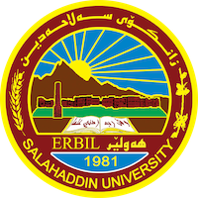
Academic Curriculum Vitae
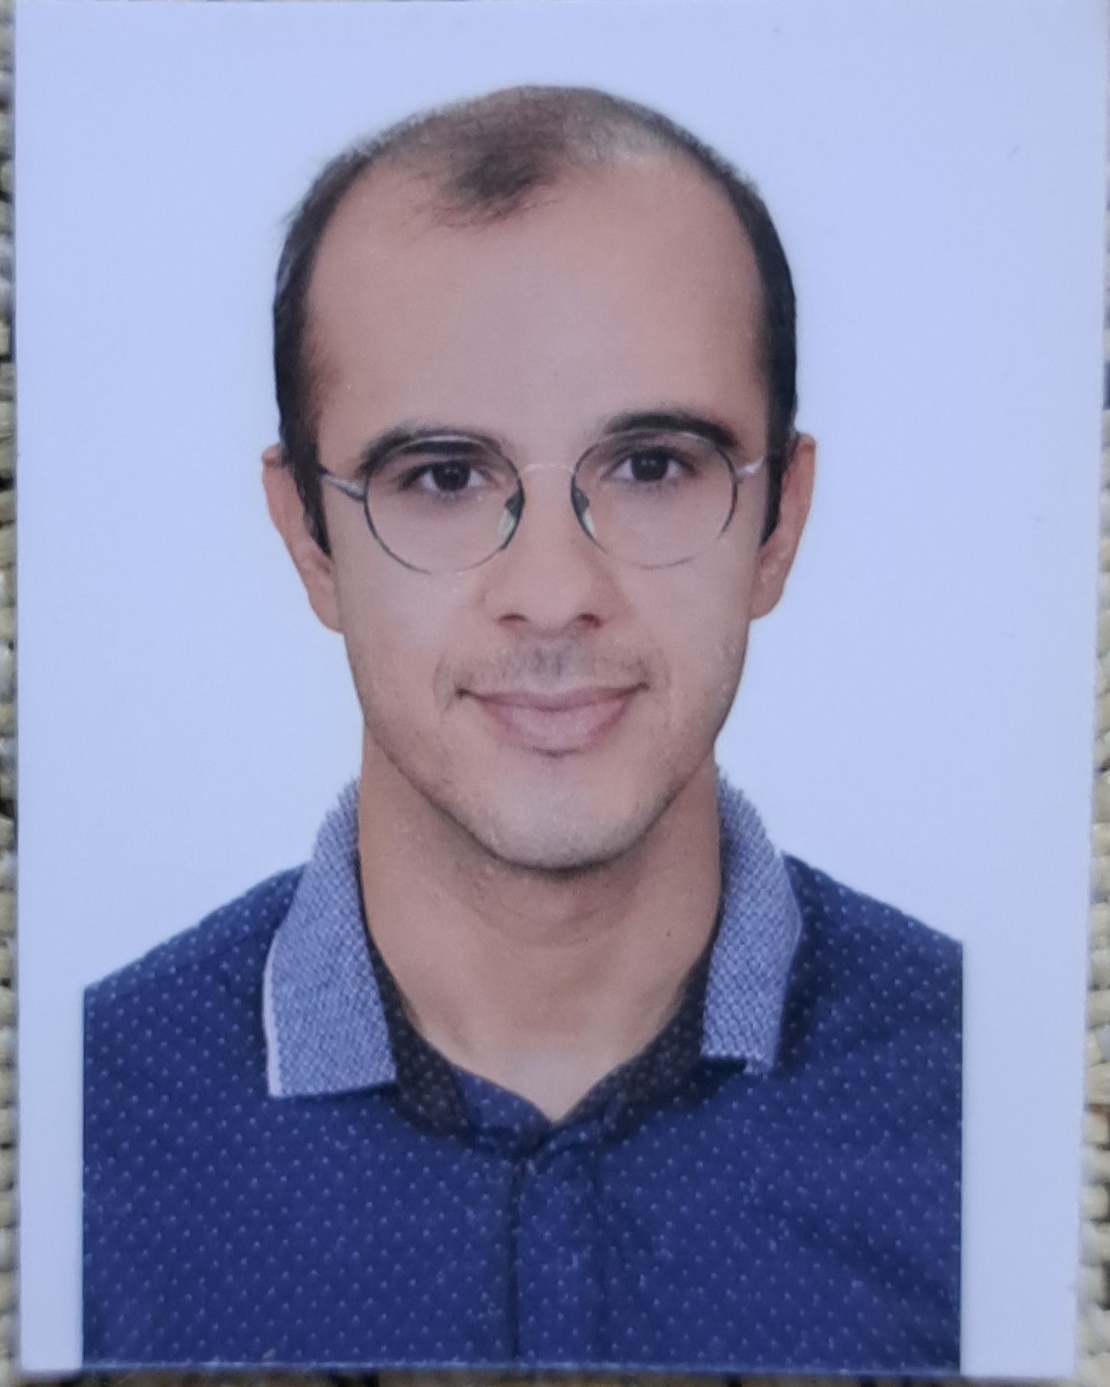
Personal Information
Full Name: Jiyar Othman Hamadamin
Academic Title: Assistant Lecturer
Email: Zeyar.hamadamin1@su.edu.krd
Mobile:

Education:
Certificate | Field of Specialization | Name of Institution | Average | Date Received
MA | Linguistics | University of Southern Illinois/ Carbondale | Distinction | 2016
BA | English Language & Literature | University of Salahaddin / College of Languages | Very good | July, 2010

Employment:
Title of Position | Field of Specialization | Date |  | Name of Institution
 |  | From | To
Assistant Translator |  | 2011 | 2016 | Salahaddin University College of Languages – English Dept.
Lecturer | Assistant Literature | 2019 | present | Salahaddin University/College of Languages – English Dept.

Qualifications & Experience
- Teaching Methods at Salahaddin University

- Translating articles and documents from English into Kurdish and vice versa.

Teaching experience:
A. Undergraduate Studies
I have taught a diverse range of undergraduate English courses including Comprehension, Conversation, Translation, Sociolinguistics, English Grammar, Vocabulary, General English, and English for Specific Purposes
Conferences and Courses Attended
- THE GENOCIDE OF FAILY KURDS Conference 2023, “Reveal The Facts to Achieve Justice”, (2023) - Salahaddin University
- Conference on Best Research Projects and Academic Posters (2023)

Professional Social Network Accounts

https://www.researchgate.net/profile/Jiyar-Othman

https://scholar.google.com/citations?user=zMe_NQUAAAAJ&hl=en

https://orcid.org/0000-0001-5576-2262

Languages

Kurdish: Native, Arabic: Good, English: Very good

