Academic Curriculum Vitae

Personal Information: 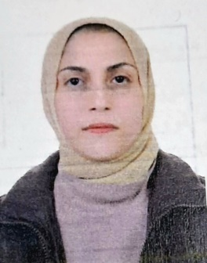
Full Name: Zhala Muhammad Ameen Hama Rashed
Academic Title: Assistant Lecturer
Email: zhala.ameen@su.edu.krd
Mobile: +9647504650151

Education:
- B.SC: University of Salahaddin College of Agriculture 2003. Plant Department.
- M.SC: Salahaddin University-Erbil 2012. A -Crop Physiological.

Employment:
- Permanent employment at the College of Agricultural Engineering Sciences/Salahaddin University – Erbil (since 2004 unit now).
- Currently l work as an academic staff of Salahaddin University – Erbil.

Qualifications
- Teaching qualifications (Physiology, Crop Physiological)
- IT qualifications
- Microsoft Office Word
- Microsoft Office Excel
- IBM – SPPS – Statistics
- Microsoft Office PowerPoint

- Language qualifications
- IELTS
- Language Writing Speaking Comprehension
Kurdish very good very good very good
Arabic very good very good very good
- Academic writing courses/ Language and Translation Centre – Salahaddin University-Erbil

Teaching experience:
- Undergraduate:
- Plant Physiology, Two-stage students
- Genetics, Third-stage students
- Plant Ecophysiology, Fourth-stage students

Research and publications
- State all researches, publication you made.

Conferences and courses attended
- Give details of any conferences you have attended, and those at which you have presented delivered poster presentations.

Funding and academic awards
- List any bursaries, scholarships, travel grants or other sources of funding that you were awarded for research projects or to attend meetings or conferences.

Professional memberships
- List any membership you hold of any professional body or learned society relevant to your research or other life activities.

Professional Social Network Accounts:

- List your profile links of ReserchGate, LinkedIn, etc.

It is also recommended to create an academic cover letter for your CV, for further information about the cover letter, please visit below link:
https://career-advice.jobs.ac.uk/cv-and-cover-letter-advice/academic-cover-letter/

