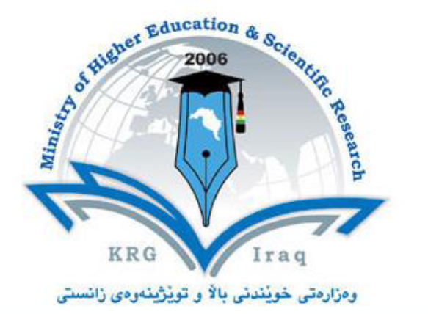

Department of Biology
College of Education
Salahaddin University – Hawler
Subject: General English
Course Book –Year 1
Lecturer's name: ZheenHamad Amin Abdullah
Academic Year: 2022 -2023

Course Book
1. Course name |  | General English for University Students
2. Lecturer in charge |  | ZheenHamad Amin Abdullah
3. Department/ College |  | College of Education/ BiologyDept.
4. Contact |  | Zheen.abdullah@su.edu.krd
5. Time (in hours) per week |  | Integrated Skills: 3
6. Office hours |  | Availability of the lecturer to the student during the week
7. Course overview:
This course (English for university students) builds academic and proficiency language skills of language required for lectures, tutorials, reading research and written assignments. It is designed to be taught to freshmen in order to develop their ability to communicate; comprehend new concepts. It involves a variety of elements like new vocabulary, pronunciation, grammar structure and texts for reading…etc., which enables them to speak fluently in an academic way. The first course focuses more on a general English and the first theme “Education” of the course book “General English for University Students” specified for the university freshers.

8. Course Objective:
This course aims at providing the freshmen with a number of real based language aspects and topics so as to make them have a better background knowledge of English language and develop their communication ability using the English language and expressing their own field or major.
9. Student's Obligation

- Regular attendance is required according to the university rules.
- The use of mobile phone during the class is prohibited.
- Only the students who are officially enrolled can attend the class, guests and children are not admitted.
- Daily participation and conducting assignments are required.

10. Forms of Teaching
-Communicative Approach (Integrated Skills), Lexical Approach, Task-based –An approach will be Implemented taking the student's Multiple-Intelligences in to considerations.
-Massive teaching leads to group, pair and individual independence. Students' presentations.
-The technical terms are going to be chosen by the English language instructor and the scientific department in which they are used in real contexts in the second semester.
11. Assessment Scheme
Students are assessed depending on their exam results. Marks are given on the basis of students’ performance in the exams as follows:
1. Monthly exam 40% (Listening 5M, Speaking 15M, Reading, Writing, and Vocabulary 20M)
2. Final course exam 60% (Speaking 20M, Listening 10 M and Reading, Vocabulary and Writing 30M)

Total average: 40 + 60 =100 % marks
12. Course Reading List: Face2Face Elementary Course book; General English for University Students by Terry Phillips and Anna Phillips

13 Weeks: From the 22nd of September to 2nd of February
1st Week | Welcome and all about you  Self-introduction  (Saying Hello and Goodbye)
2nd Week | Personal details  Countries and Nationalities  Numbers  Jobs; a and an
3rd Week | Personal possessions  Have got/ has got  Time and money  clothes
4th Week | Prepositions of place  Family  Describing people’s characteristics and appearance
5th Week | 1.1 Vocabulary for listening  1.2 Real-time listening
6th Week | 1.3 Learning new listening skills  1.4 Grammar for listening  1.5 Applying new listening skills
7th Week | 1.6 Vocabulary for speaking  1.7 Real-time speaking  1.8 Learning new speaking skills
8th Week | Examination (Mid-term exams)
9th We | 1.9 Grammar for speaking  1.10 Applying new speaking skills
10th Week | 1.11 Vocabulary for reading  1.12 Real-time reading  1.13 Learning new reading skills
11th Week | 1.14 Grammar for reading  1.16 Vocabulary for writing
12th Week | 1.17 Real-time writing  1.18 Learning new listening skills
13th Week | 1.19 Grammar for writing  1.20 Applying new writing skills

