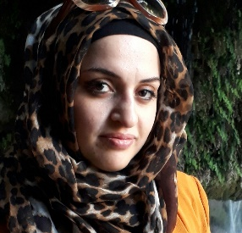
“My name is Zhin Saeb Abdulrehman, I born in Baghdad, Iraq in 1983. I graduated from Geology Department / College of Science in Salahaddin University-Erbil in 2005-2006, in Erbil, Iraq. I got Master of Science in Geochemistry in 2014. I am working as a lecturer in Geology department / college of science / Salahaddin University-Erbil”.
Curriculum Vitae (CV)
Biography
First Name: | Zhin
Middle Name: | Saeb
Family/Last Name: | Abdulrehman
Gender: | Female
Date of Birth: | 17th August, 1983
Marital Status: | Married
Nationality: | Iraqi
Academic Title: | Assistant Lecturer
Address: | Roshmbere, Kerkuk Street,  Kori Substation / House No. 15  Erbil, Kurdistan Region, Iraq
Mobile Number: | +964 750 7068442
E-mail: | zhin.abdulrehman@su.edu.krd  zhin.abdulrehman@gmail.com  zheengeo@yahoo.com
Education:

- 20th March,2014 Awarded M.Sc. in Geology (Geochemistry), Department of Geology, College of Science , Salahaddin University/ Erbil, Iraq
        - M.Sc. Thesis: Impact of wastewater irrigation in soils from selected location Kurdistan-region.Iraq
- 1st July, 2006 Awarded B.Sc. in Geology, Department of Geology, College of Science Salahaddin University/ Erbil, Iraq
- 2002- 2003 Awarded High School, Adamiea Secondary School, Baghdad, Iraq.
Employment History:

- 20th March, 2014 to date : Assistant Lecturer in Department of Geology, College of Science , Salahaddin University/ Erbil, Iraq.
- 14th August, 2007 – 1 Nov., 2012: Assistant geologist in Geology Department, College of Science, Salahaddin University/ Erbil, Iraq.
- 2006-2007: employed in earthquake services
Subjects of Interest:

    - Mineral science
    - Industrial Geology.
    - Environmental issue
Computer Skills:

- Microsoft Office ( Word, Excel and Power Point)
- Windows System
Languages:

- Kurdish: Native
- Arabic: Excellent
- English: Good

