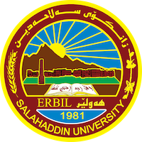
Academic Curriculum Vitae
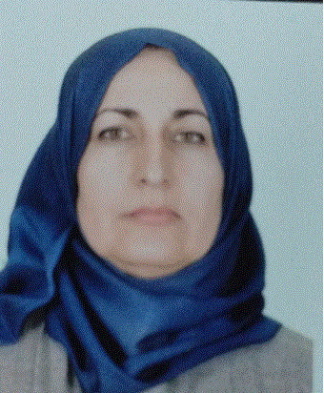
Personal Information:
Full Name: Zhyan Rafaat Ali Alkaki.
Academic Title: Lecturer
Email: zhyan.ali@su.edu.krd
Mobile:00964+7504243782

Education:
- B.Sc. in Mathematics. Mathematics Department- College of Education- Salahaddin University- Erbil in 1997.
- M.Sc. in Mathematics. Mathematics Department- College of Science - Salahaddin University- Erbil in 2010.
Employment:
- Teaching assistant at the College of Agriculture / Salahuddin University, Erbil, on 11/29/1998.
- Transferred to the College of Basic Education on 10/13/2004.
- I started a master's degree in 2007-2009 at Salahaddin University / College of Science / Department of Mathematics.
- I have been teaching in the Department of Mathematics, College of Basic Education, Salahaddin University, Erbil, since 2010 until now.

Teaching experience:
- Working as Teacher in University of Salahaddin Erbil– College of basic education – Mathematics Department since 2010.
Lessons taught:
- Axiomatic system and geometry/ fourth stage
- Statistical Inference/ fourth stage
- Linear programming/ third stage
- Probability and Statistics/ second stage
- Principle of Statistics/ Second stage
- Calculus/ first stage
- Finite Mathematics/ first stage
- Academic Skill/ first stage
- IT/ first stage
- Worked as instructor in Bayan University (2016-2017) .Lesson taught (Principles of Statistics)

Research and publications
- A comparison between certain repeated measures model and some ANOVA models, by using simulation. (Title of MA Thesis).
- Application of Binary Logistic Regression Model to Cancer Patients: a case study of data from Erbil in Kurdistan region of Iraq.
- Estimation of Non-Linear Regression Parameters by Newton Raphson’s Method of Nonlinear Equations.
Other Qualifications
- Teaching methods course 2010
- English language course 2013

LANGUAGES
Good on English, very good in Arabic, and Kurdish (Mother Language).

AREA OF INTERESTS:
- Computer, mathematical statistics, linear programing, and so on.
Professional Social Network Accounts:

- https://www.researchgate.net/profile/Zhyan-Ali
- https://www.linkedin.com/in/zhyan-ali-b767b1157/
- https://scholar.google.com/citations?hl=en&user=fSp2InYAAAAJ
- https://orcid.org/my-orcid?orcid=0009-0002-7257-4532

