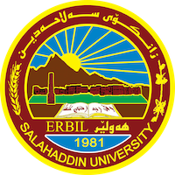
Academic Curriculum Vitae
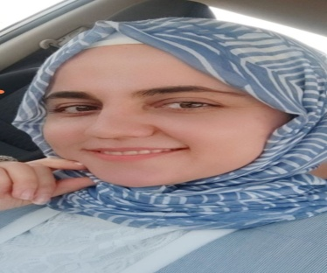
Personal Information:
Full Name: Zhyan Othman hamasadek
Academic Title: Assistant lecturer
Email: (university email) zhyan.hamasadeq@su.edu.krd
Mobile:07504086185

Education:
- Bachelors degree in Food technology Department / Agricultural engineering science in 2010 from Salahaddin University (Ranked 2 ed in Department )
- M.Sc. degree In food technology in 2016.

Employment:
- Employed in April 2010 until now.
- I have been working as an assistant lecturer at Salahaddin University
in Agriculture/Food Technology Department since 2016.

Qualifications
Teaching qualifications: IT qualifications: Computer course – (2011) Windows XP/7/8
-MS word 2016, MS Excel
- MS PowerPoint
- Certification available in IT
Biochemistry, microbiology, food analysis, food packaging, food processing, analytic chemistry ,Dairy processing, Dairy microbiology, Biotechnology, Human Nutrition, quality control, food safety, food poising, and Meat science…etc ).

Study advance for Msc in:
(Human Nutrition, Biotechnology, Biochemistry, micro- physiology, food analysis, Biopolymers, scientific research and food package)
Obtained the research project with (Excellent) degree a thesis.
Language qualifications: IELTS band 6, English Proficiency Certificate, Language Centre, Salahddin University. (2011, 2016,2023) equivalent
Any professional qualification
You could put any professional courses you have attended

Teaching experience:
-Analytic Chemistry, Biotechnology,fermentation,
- Organic Chemistry, Dairy Microbiology, Academic skill, principle of microbiology and biochemistry.
- Member of Committee of Health and Safety (2021-2022)
-Member of Committee of Health and Safety (2022-2023)
Member of Committee of welcome of the first year of Student in Salahaddin University (2021).
-Member of Committee of welcome of the first year of Student in Salahaddin University (2022).
- Member of Committee of Quality assurance in food technology Department.
- Member of organizing committee in festival in2019, 2021 and 2022.
-Member of Committee of microbiology Laboratory.
- Member of Committee food processing in department

Research and publications
- Effect of pumpkin powder establishes on the nutritional, texture and sensory characteristics of donuts compared with traditional donuts.

- antimicrobial activity of some herbs against pathogenic microorganisms in raw soft cheese ( Kurdish cheese)

Conferences and courses attended
- First conference to give the national grant for best research and ideas (Submitting a research).
-First international conference of agri science 2019(Participate as a guest).
-Nanotechnology and Application
-quality and university management, How to write and evaluate scientific research.
-cancer and oncology research endeavor/ Iraq.
Attended in International Conference on Clinical Research and Medical Science (ICCRAMS)
- CIC-BIOHES 2022 chyhan university, Iraq

-التقنيات الوقائية الصحية للانسان من الامراض الانتقالية جامعة المستنصرية/ , Iraq
- Second conference to give the national grant for best research and ideas
- There conference to give the national grant for best research and ideas
Funding and academic awards
National Grant for supervising of best idea and research/ Iraq.
-participate as member in Kurdistan COVID-19 research.
Professional memberships
-Engineers syndicate/Iraq
-Kurdistan teachers union
مركز ابتكار وابداع العراقي-
مجلس تصدير لصناعات الغدائية-
Professional Social Network Accounts:
ReserchGate,Googlescholar,ORCID.org:
https://www.researchgate.netpublication/367521706_The_Successfulness
https://scholar.google.com/citaions?user=LVVKDjQAAAAJ&hl=ar
https://orcid.org/0000-0001-5647-5601

