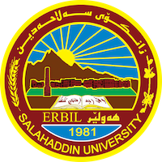
Academic Curriculum Vitae

Personal Information: 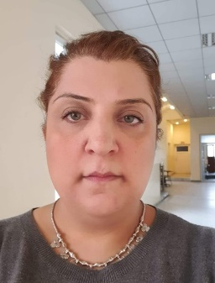
Full Name: Zozan Mohammed-Fuad Masum
Academic Title: Assistant Lecturer
Email: zozan.masum@su.edu.krd
Mobile: 07701515973

Education:
Education:
2020-Present: Salahaddin University, Erbil, Kurdistan.
English Department, College of Languages,
Currently undertaking a PhD in contemporary drama.
    - Brunel University, England, UK,
Department of English,
MA Creative and Transactional Writing.
    - Brunel University, England, UK,
Department of English,
BA English Literature (with a Minor in American Studies)
  - Ealing Tertiary College, England, UK,
A-Levels in English Literature, History and Government & Politics.
1990-1994 The Ellen Wilkinson School for Girls, England, UK,
GCSEs in: Art, English Language, English Literature, French, German, History, Mathematics, Science (Double Award).

Employment:
10/2011-Present: Assistant Lecturer.
Salahaddin University, Erbil.
2/2003-10/2011: Assistant Lecturer.
University of Sulaimani, Sulaimani.
7/2005-1/2009: Head of English Department,
Evening College of Languages, University of Sulaimani, Sulaimani.
  - Administrative Assistant,
Patriotic Union of Kurdistan Foreign Office, London, UK,
  - Data Entry
Victoria and Albert Museum, England, UK.

Qualifications
- Methodology: Methods of Teaching, University of Sulaimani, Iraq.
- Computer Literacy Certificate (obtained during the time of my A-Levels).
- Health and Safety Certificate.
- Participated in a Human Rights course held in America, organized by the Iraqi National Congress.
- EILTS Train a Trainer. Participated in a two-week EILTS programme in Amman, Jordan.

Teaching experience:
- Have taught the following subjects at both University of Sulaimani and Salahaddin University, at undergraduate level:
2nd, 3rd and 4th Year Drama
2nd, 3rd and 4th Year Novel
2nd, 3rd and 4th Year Poetry
3rd Year Essay and Research Paper Writing
1st, 2nd, and 3rd Year Conversation Classes
Literary Criticism
English Language at The Media Department at The University of Sulaimania.
English Language at The French Department and The German Department at Salahaddin University.

I taught at Millennium English Language Centre in Sulaimani, helping students prepare for the Toefl exam.
Have also taught English Language at The Canadian Institute, and Gasha Institute, in Erbil.

Research and publications

Conferences and courses attended

Funding and academic awards

Professional memberships

Professional Social Network Accounts:
https://www.researchgate.net/profile/Zozan_Masum

https://scholar.google.com/citations?user=Kv3_SaIAAAAJ&hl=en

https://academics.su.edu.krd/profile-admin/zozan.masum@su.edu.krd

